QUESTION 3: Host a website given below using app engine standard environment

<https://github.com/GoogleCloudPlatform/python-docs-samples/tree/main/appengine/standard/cloudsql>

ANSWER

<https://github.com/GoogleCloudPlatform/python-docs-samples/tree/main/appengine/standard/cloudsql>

git clone with the link .Created a SqL Instance , and generated the password 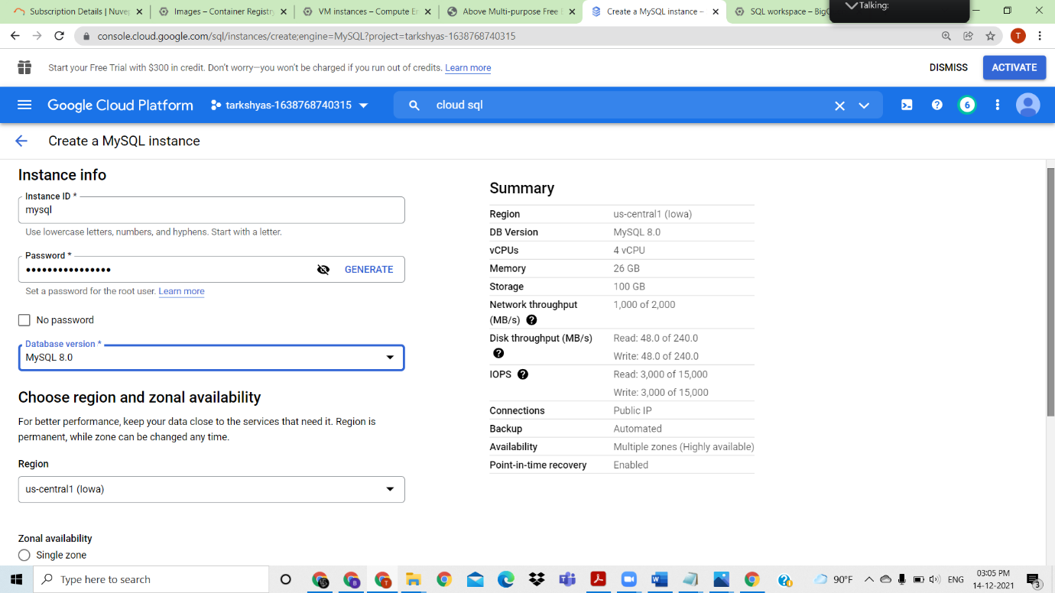

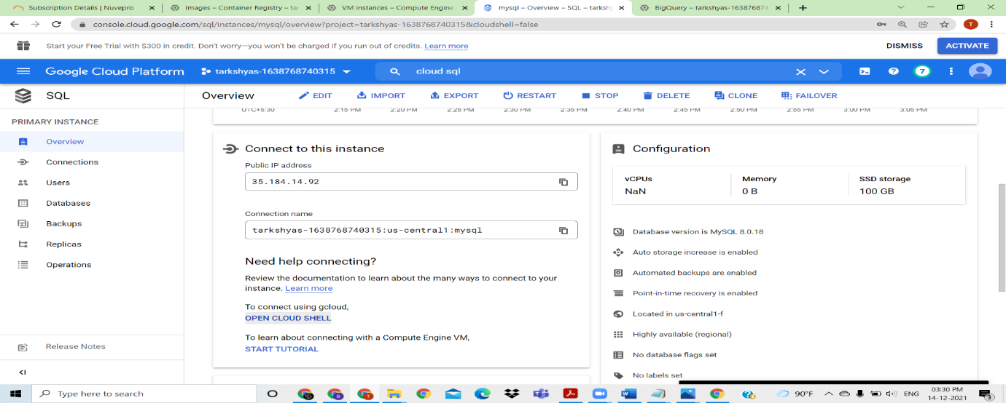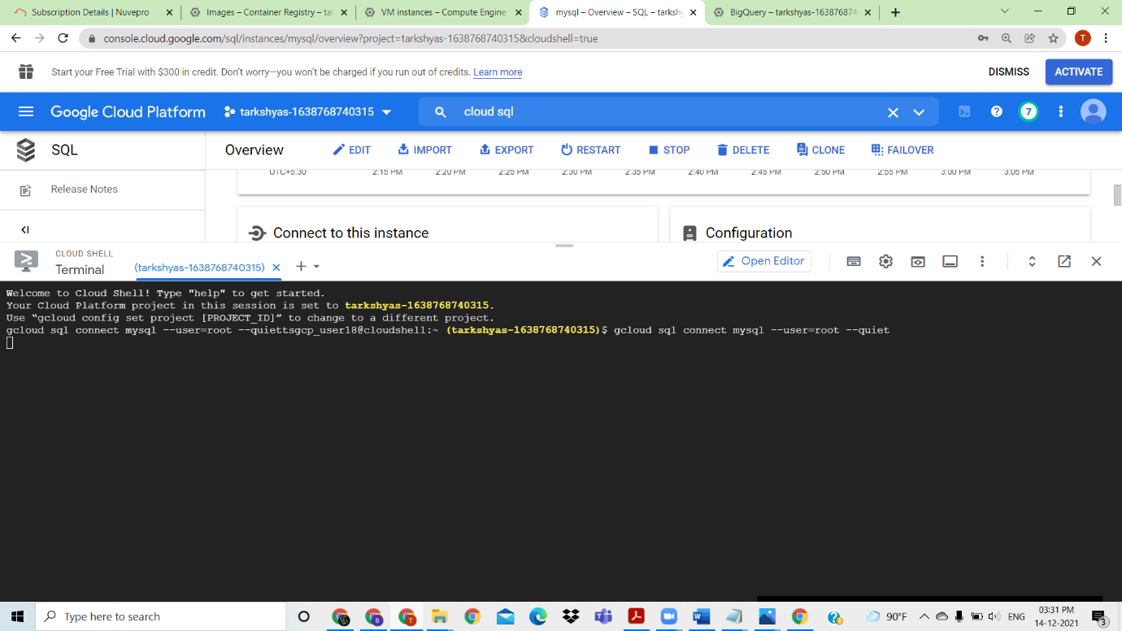

Inside cloud shell git clone with <https://github.com/GoogleCloudPlatform/python-docs-samples/tree/main/appengine/standard/cloudsql>

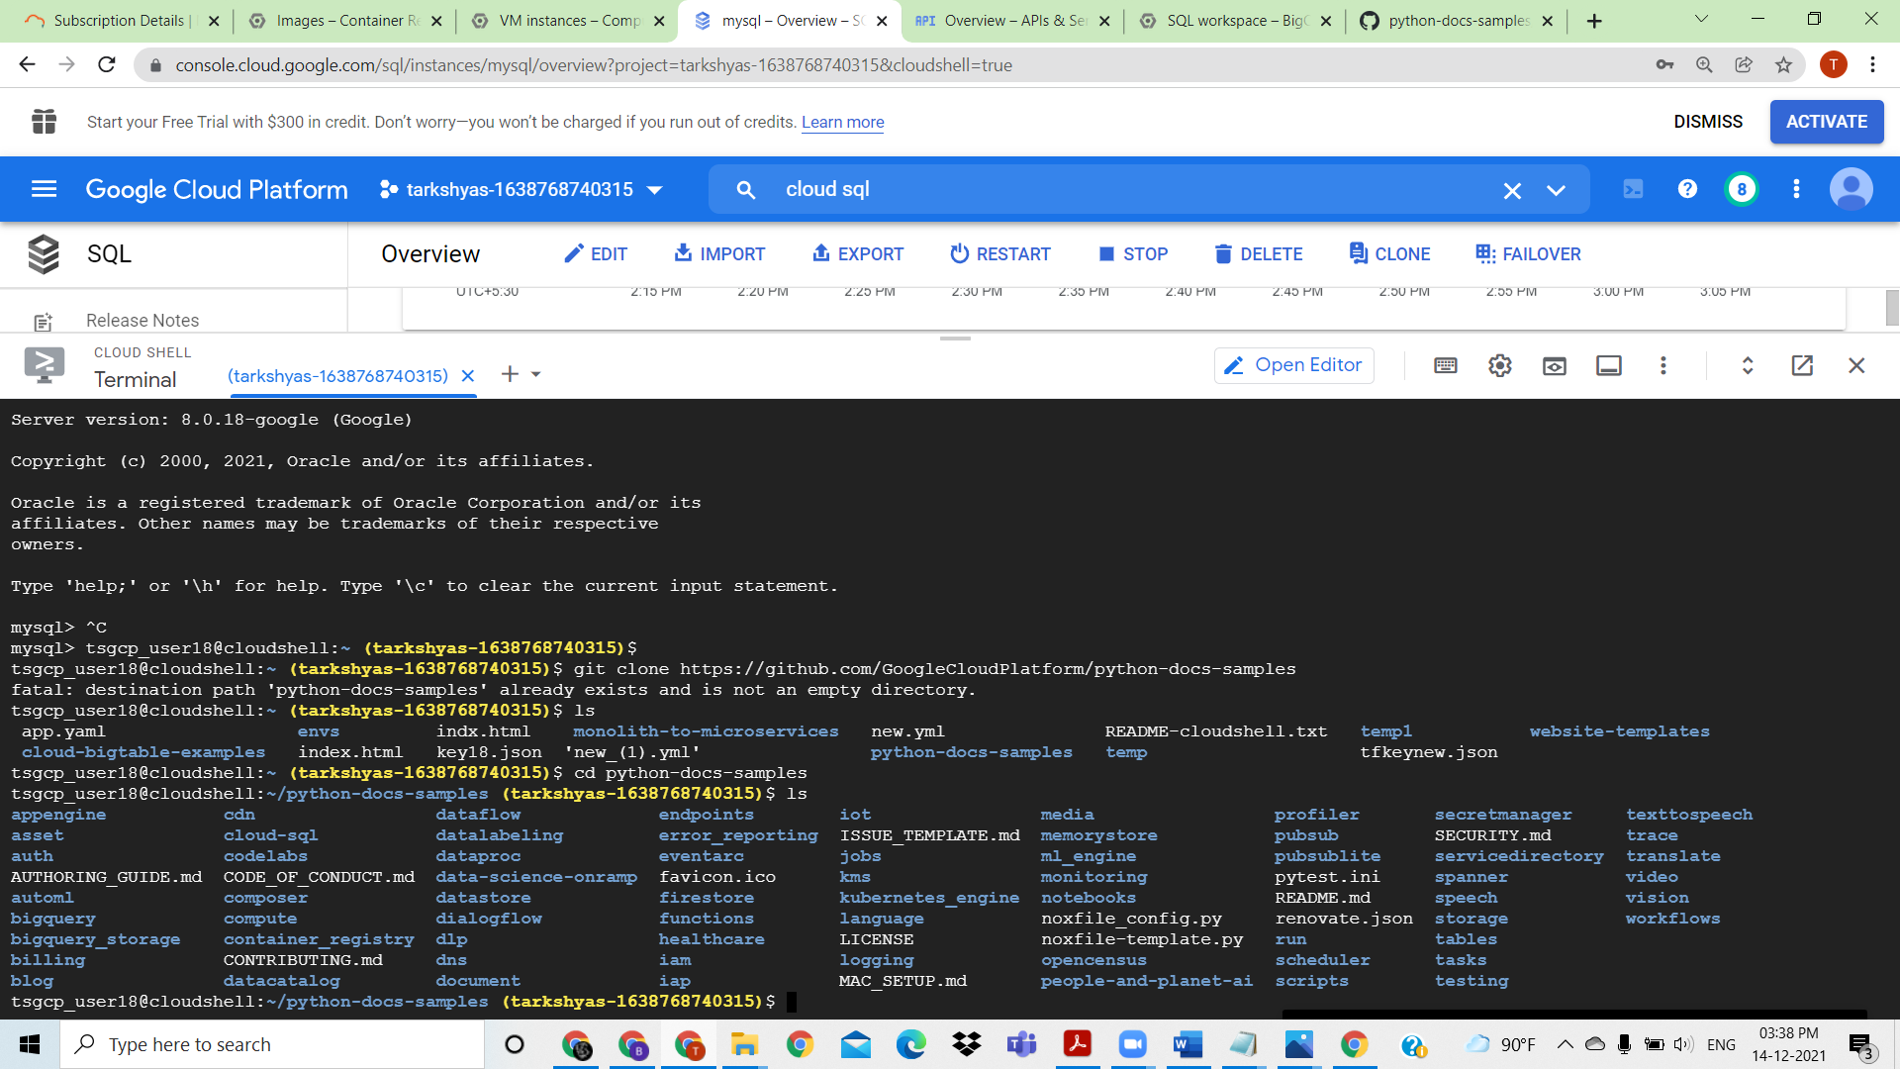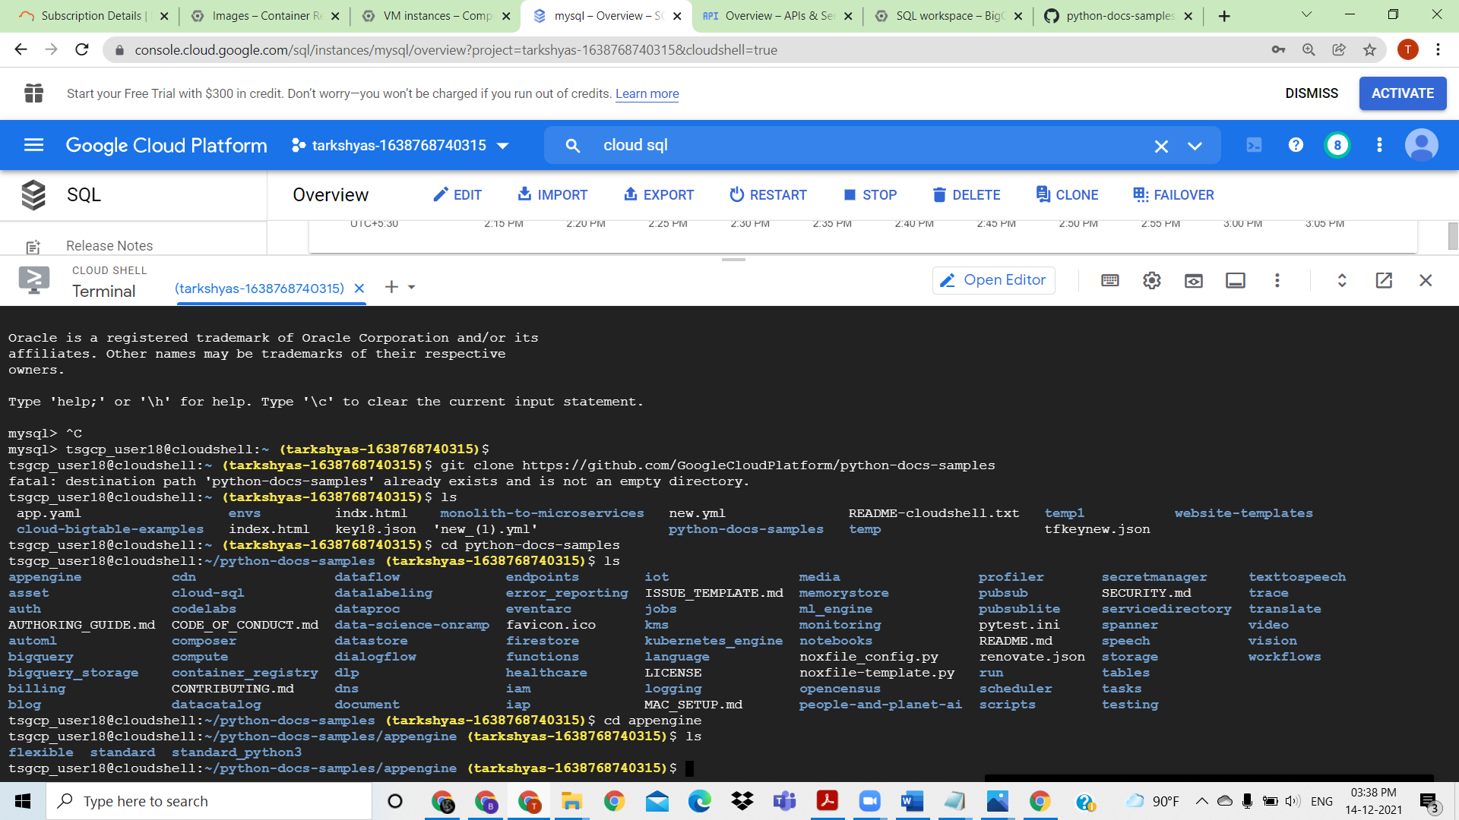

Edit the app.yaml file

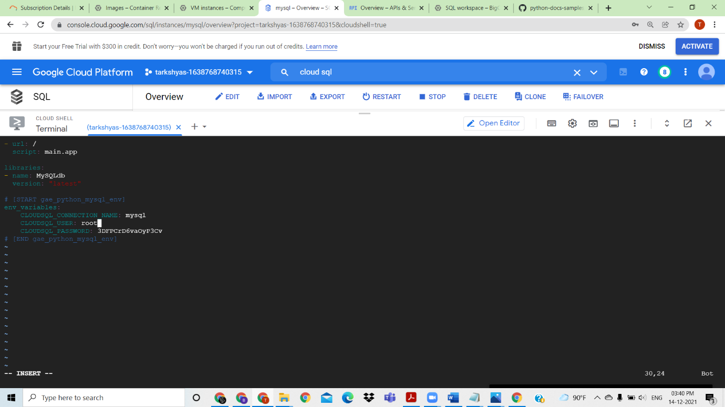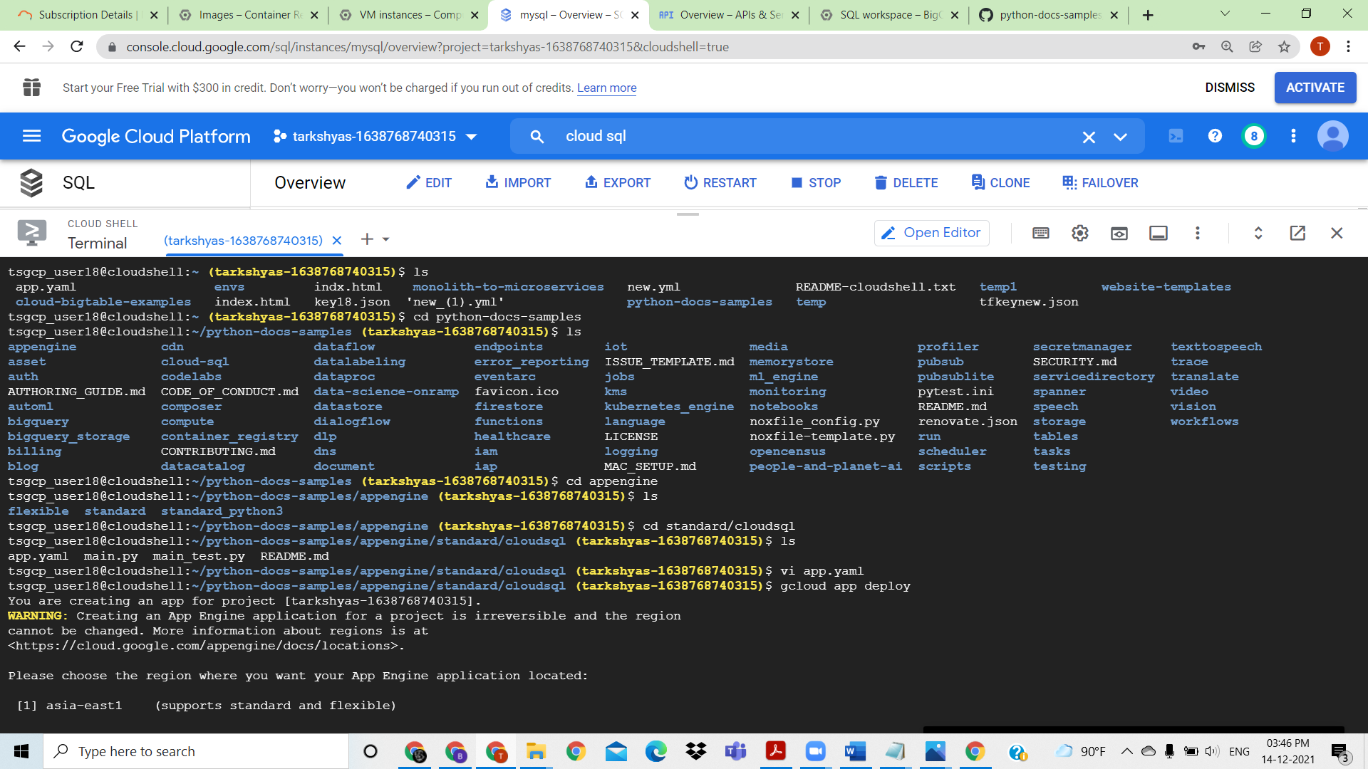Deploy the app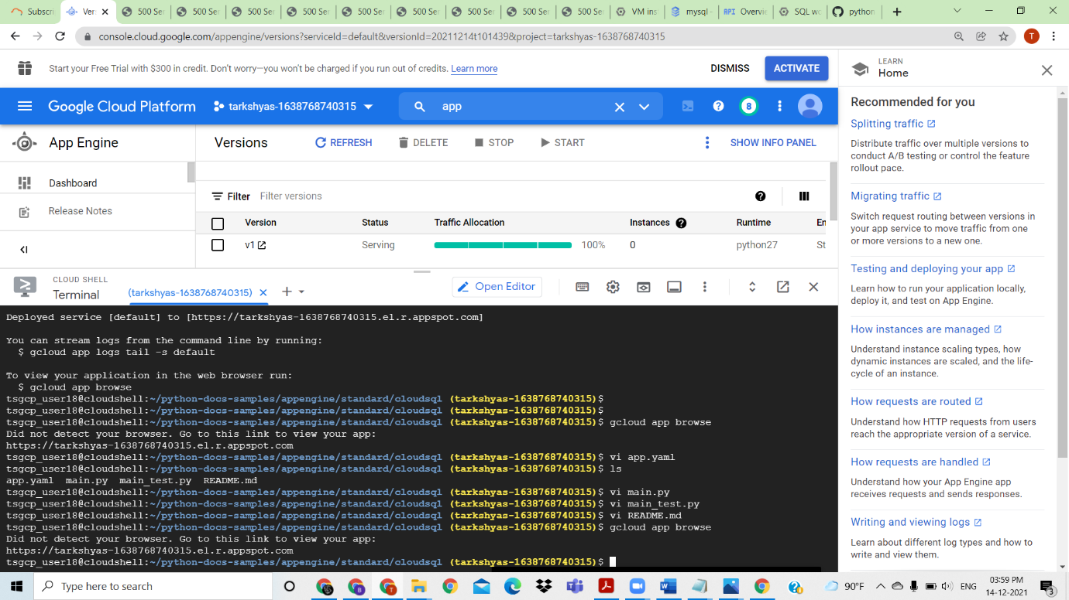

Deployed and click the link to view the preview

QUESTION 4) Host a website given below using app engine flexible environment <https://github.com/GoogleCloudPlatform/python-docs-samples/tree/main/appengine/flexible/django_cloudsql>

Answer

In cloud shell gitclone <https://github.com/GoogleCloudPlatform/python-docs-samples/tree/main/appengine/flexible/django_cloudsql>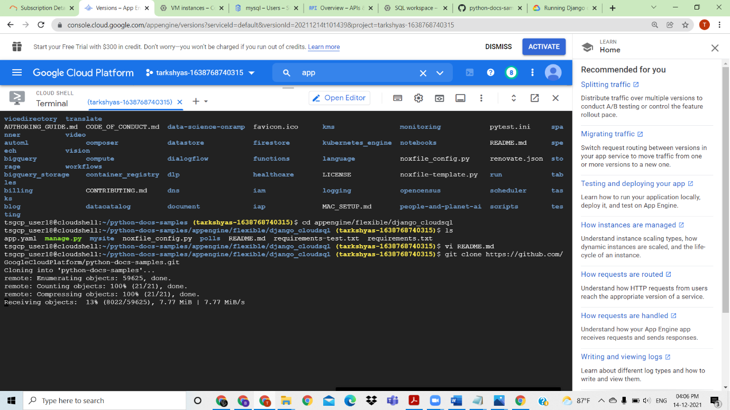

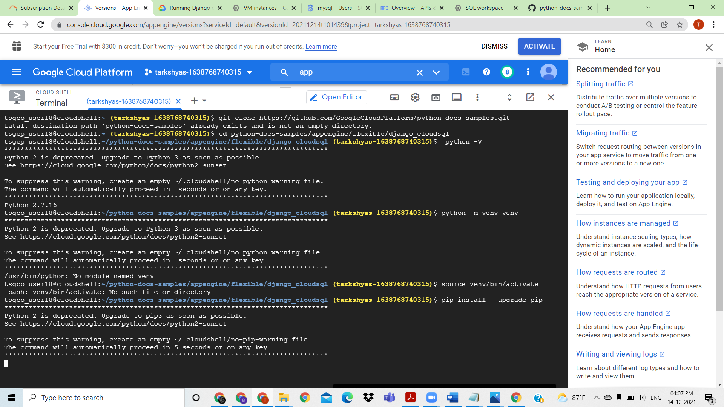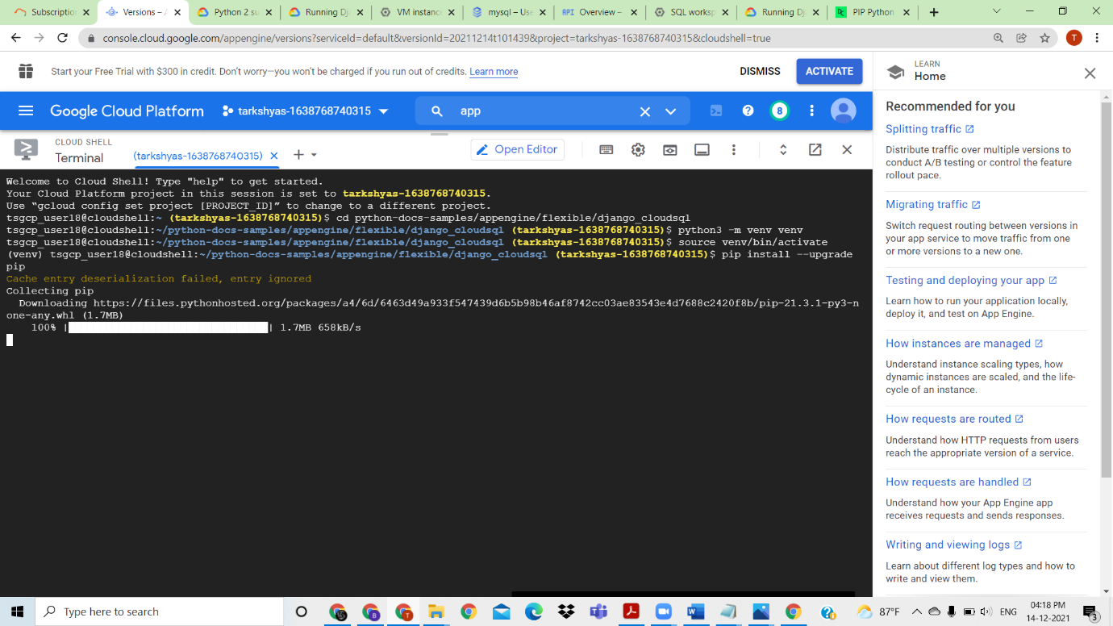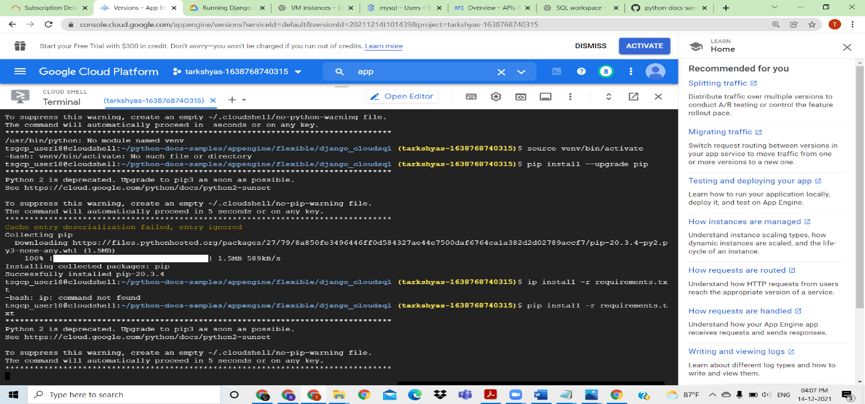

QUESTION 5: create a cloud function to host a http function

ANSWER: Create a cloud function ,and copy the url

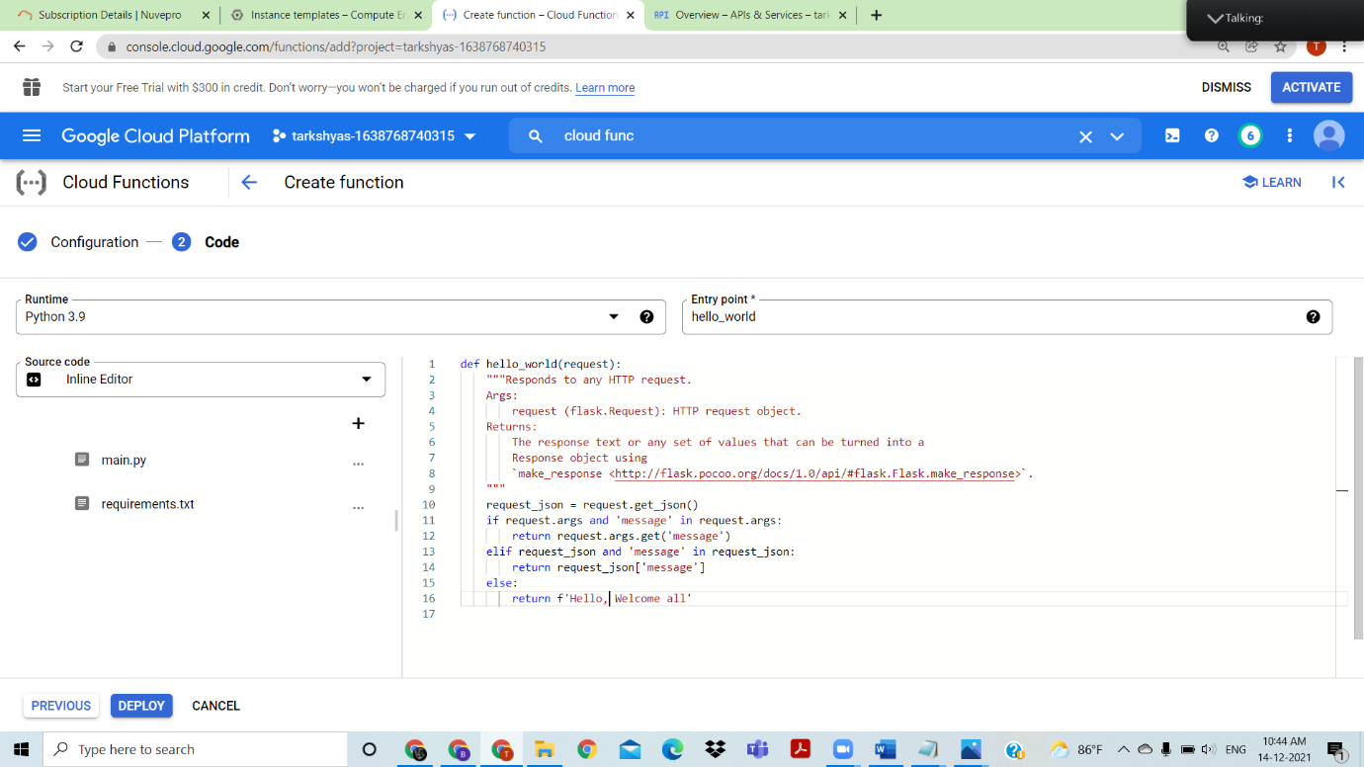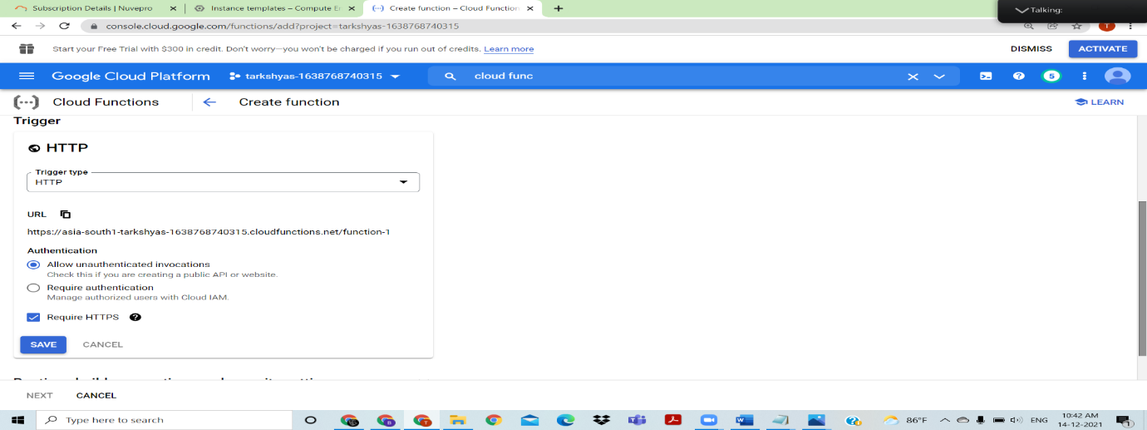Select runtime python and a function in helloworld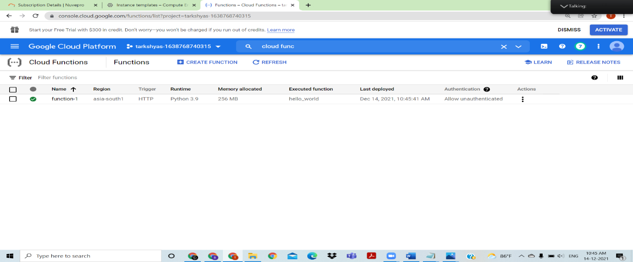

Deploy the function ,from trigger use the url to see the http function

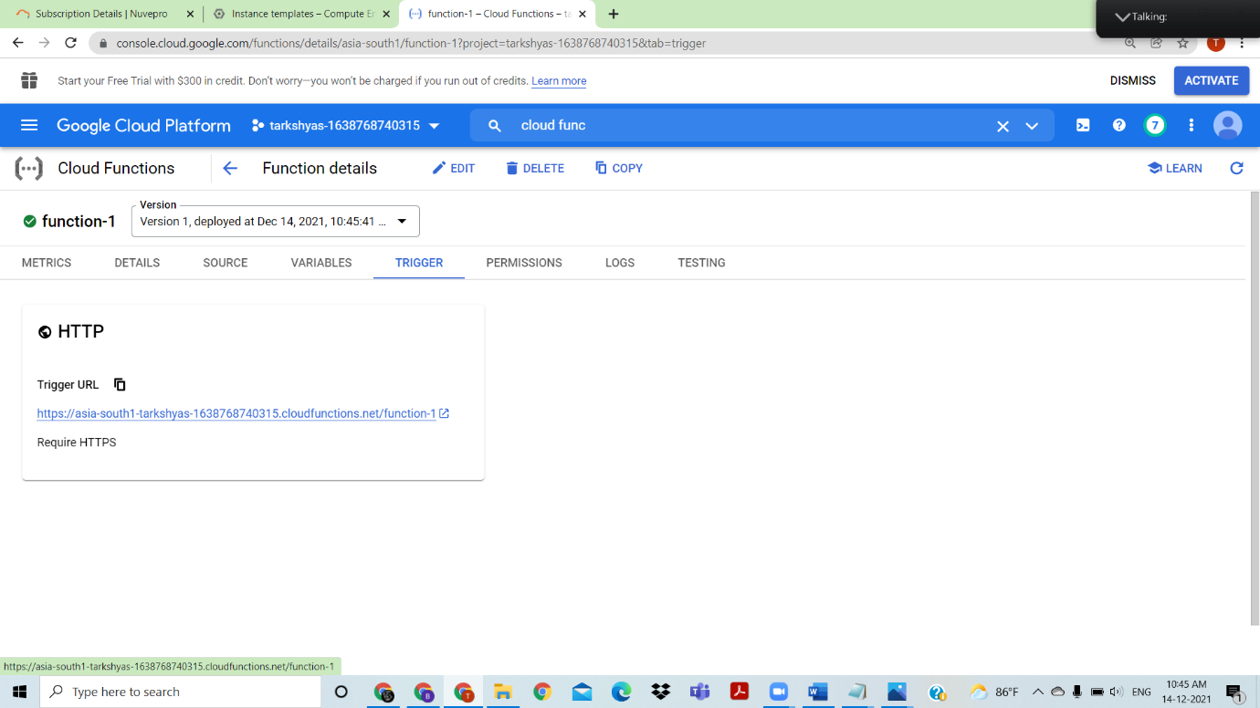

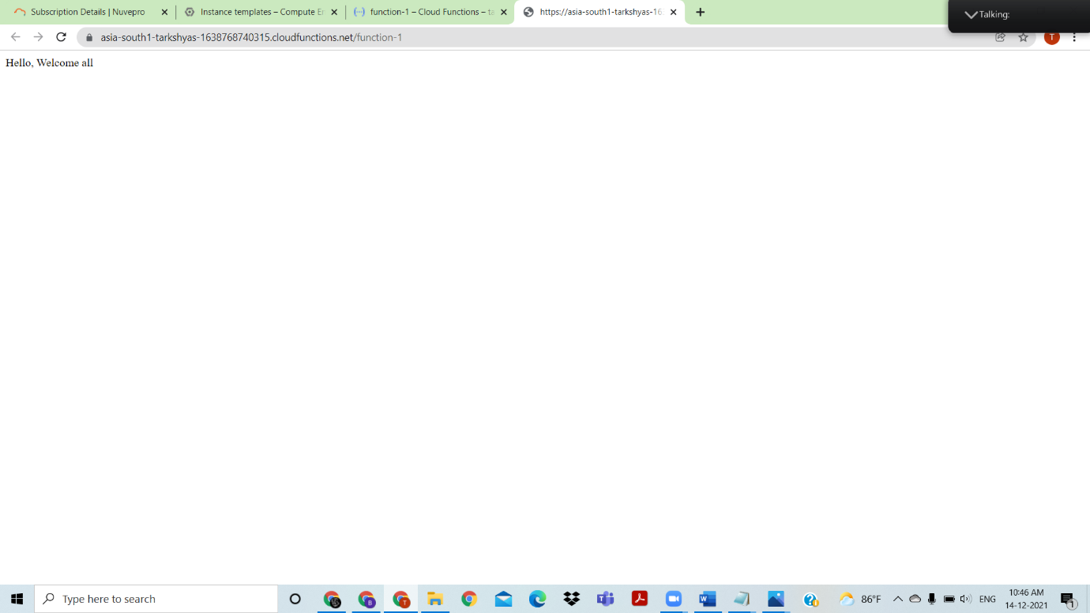

The url gives the output of cloud function

QUESTION 9) Load Balancing -http and TCP

ANSWER

1. Load Balancing with http

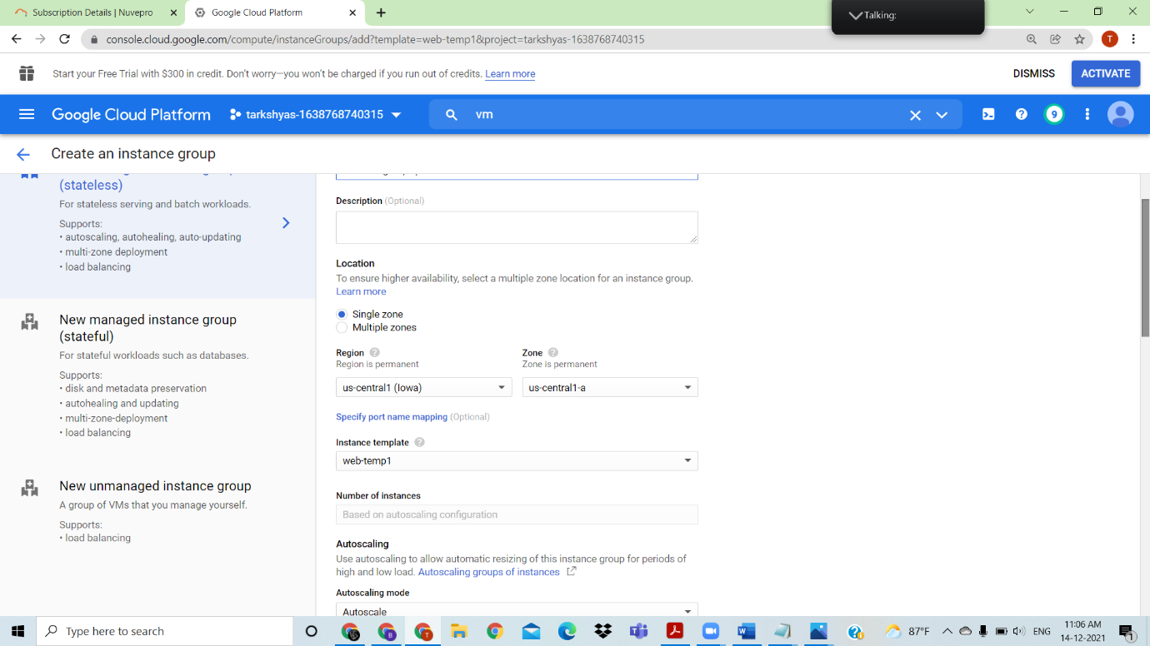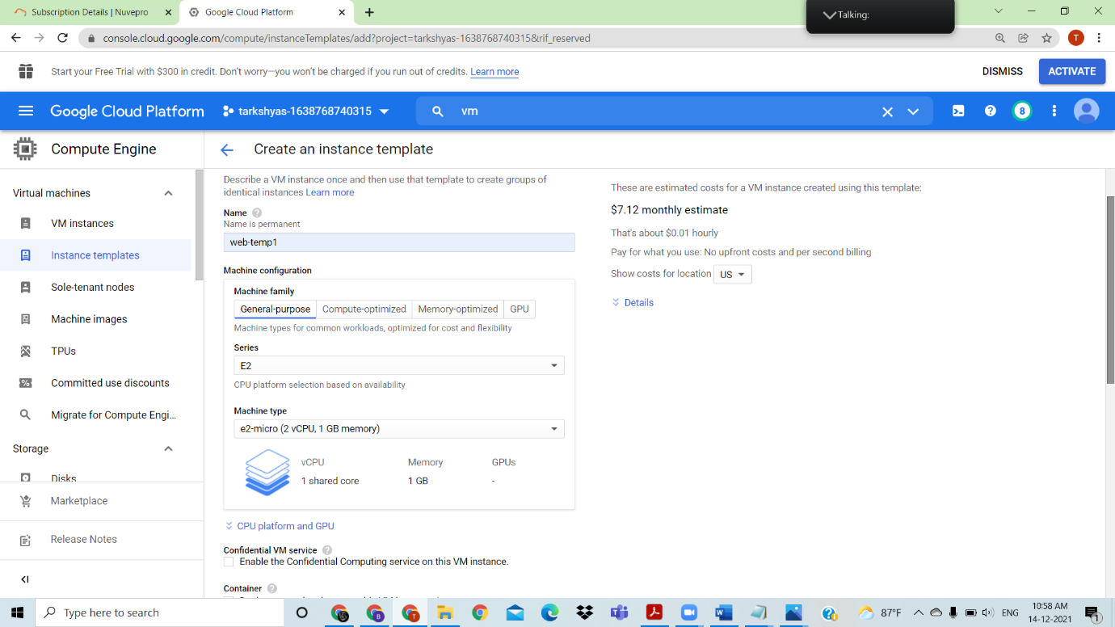Create an instance template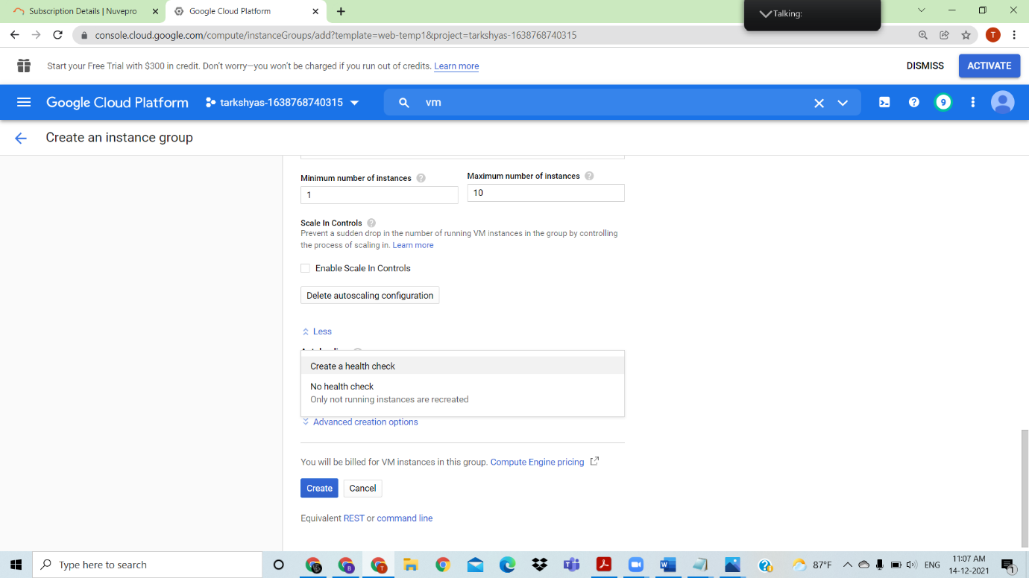

Create instance group to it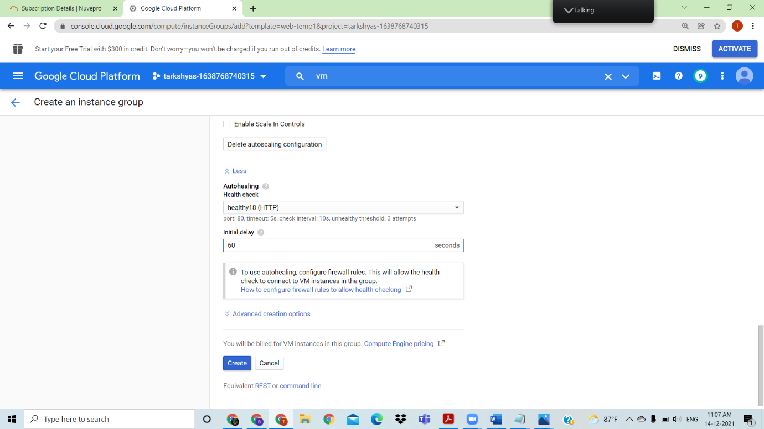

Instance group created, and its 100% healthy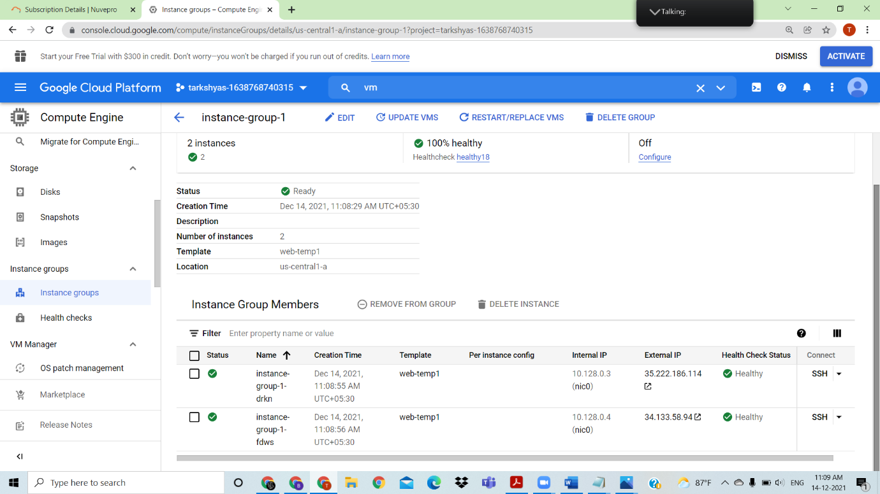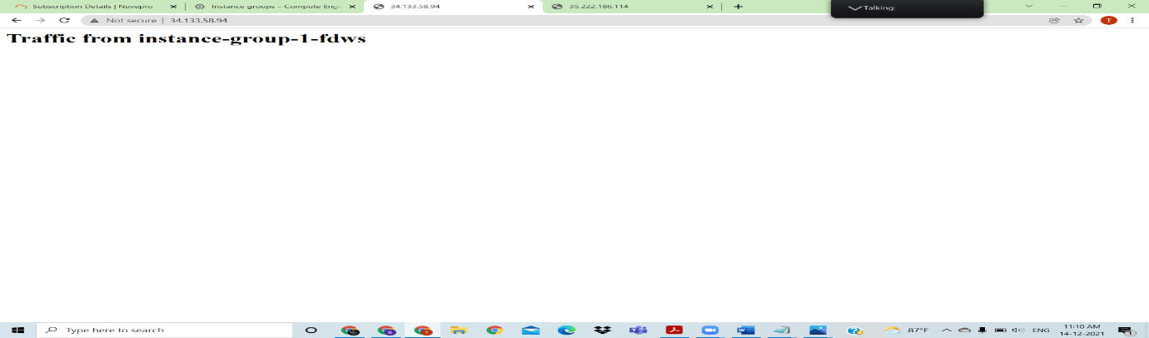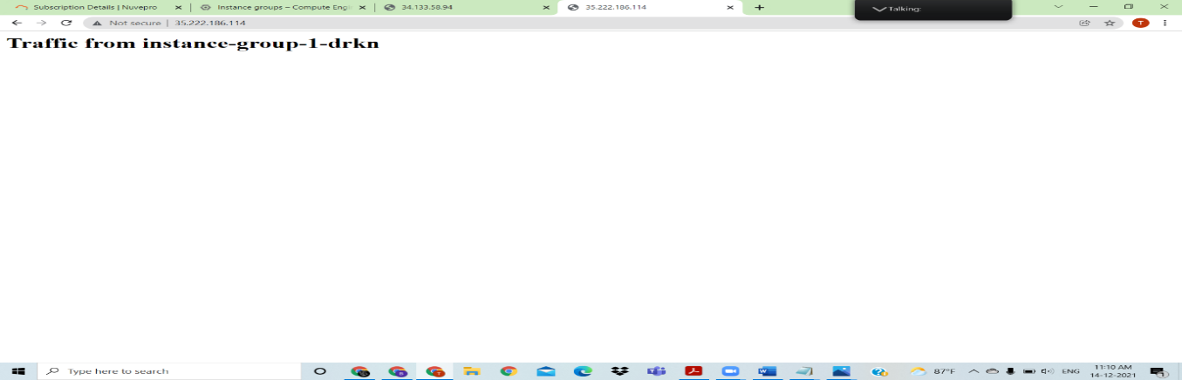

Click on the external ip to see the preview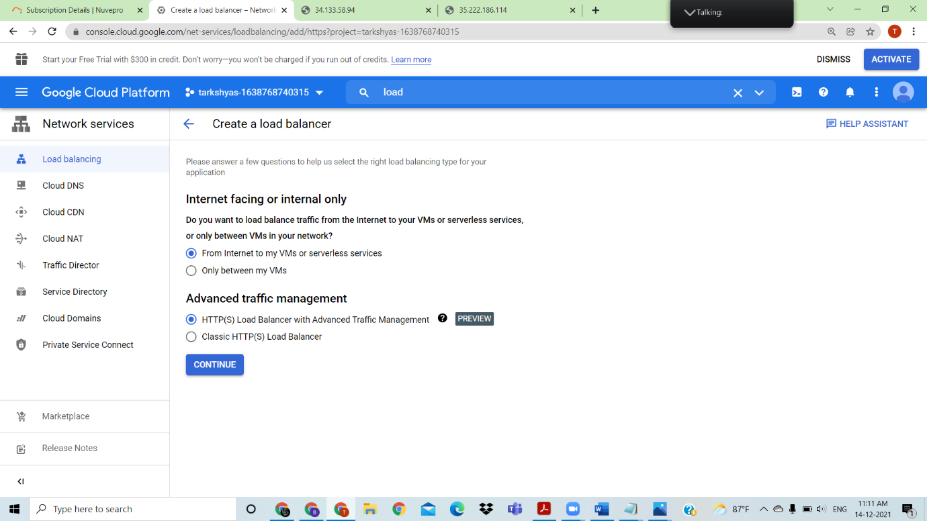Create the load balancing with http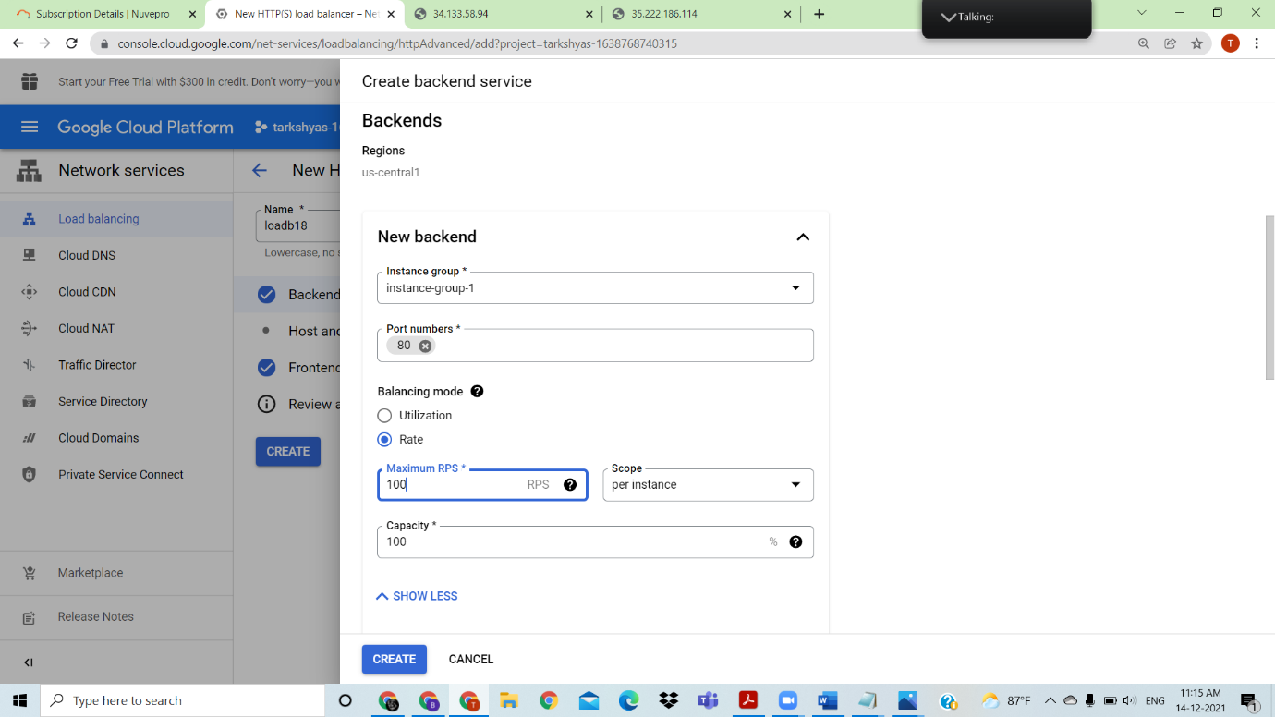

Create backend and frontend configuration and done

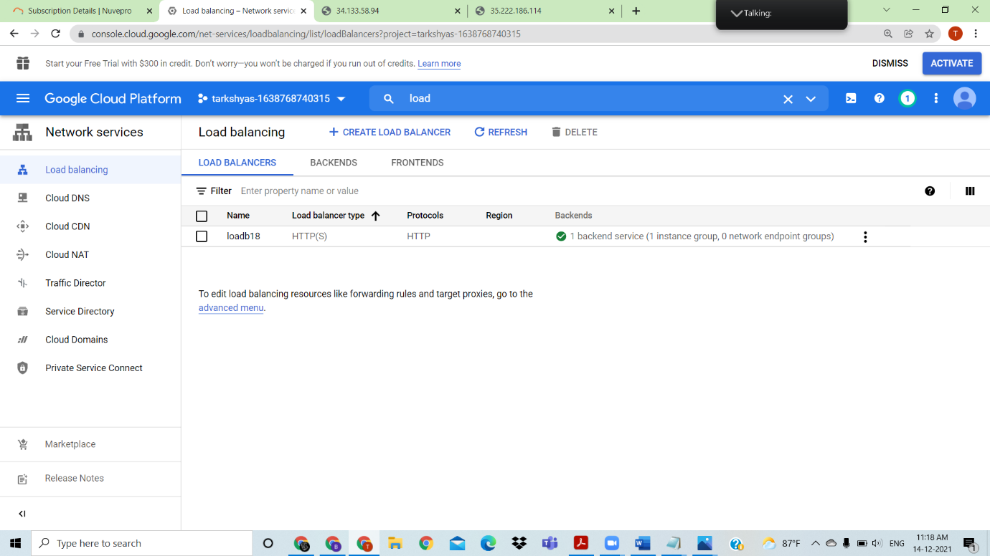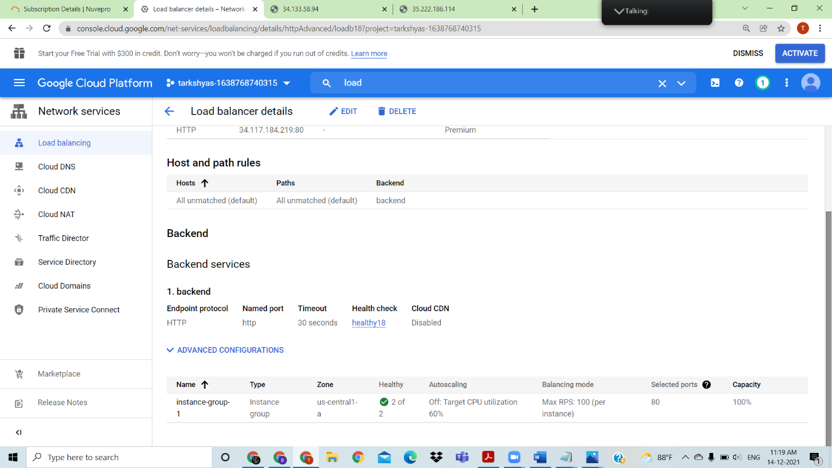

Check for external ip, and when load increased it shows another page ,use external ip from load balancer to check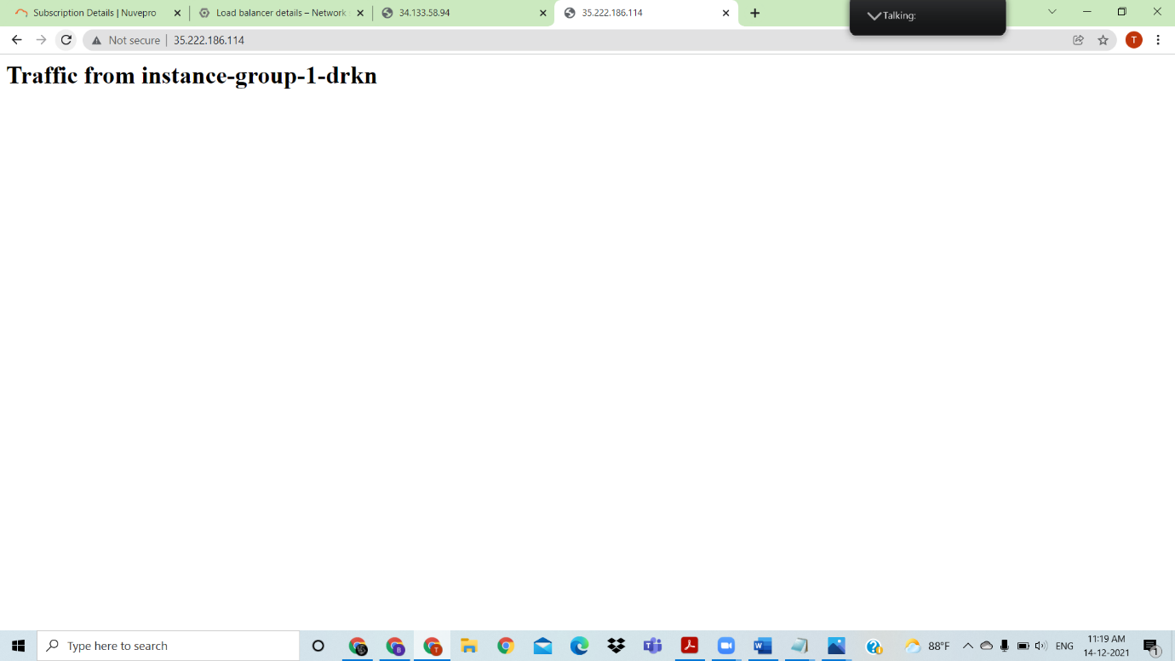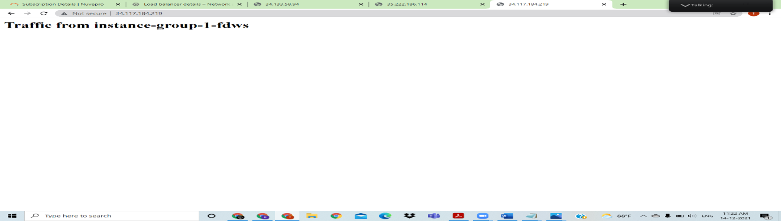

Created the Load balancer with http

1. TCP loab balancing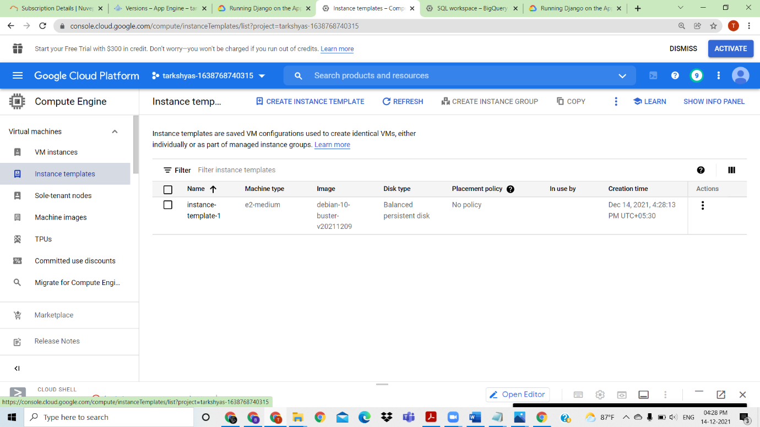

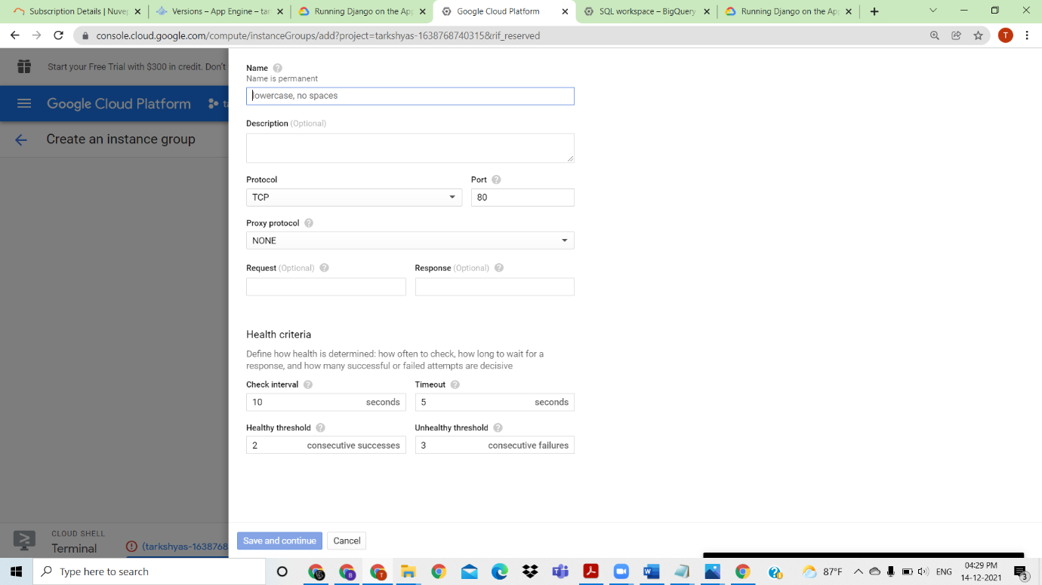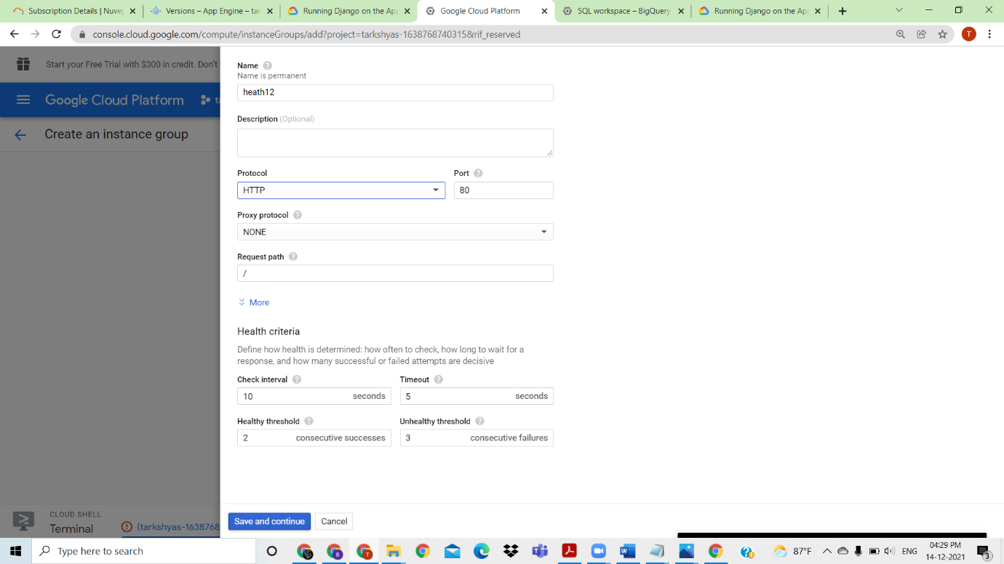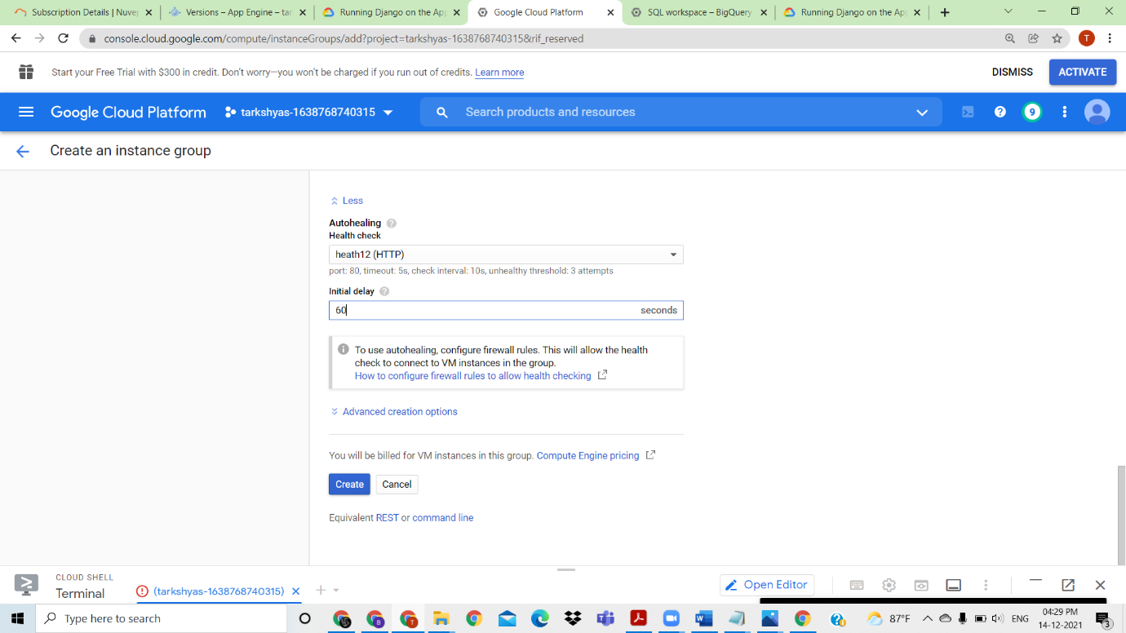

Create instance template ,instance group with health check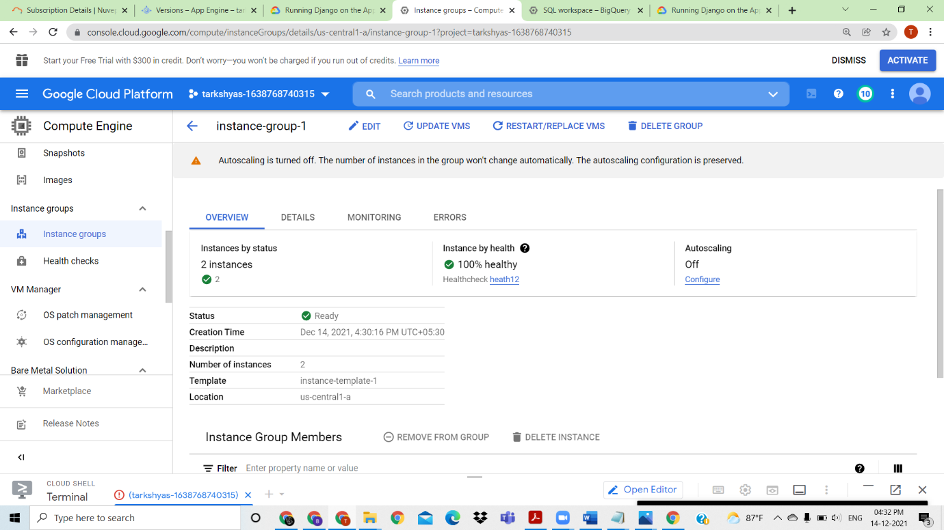Create a tcp loadbalancer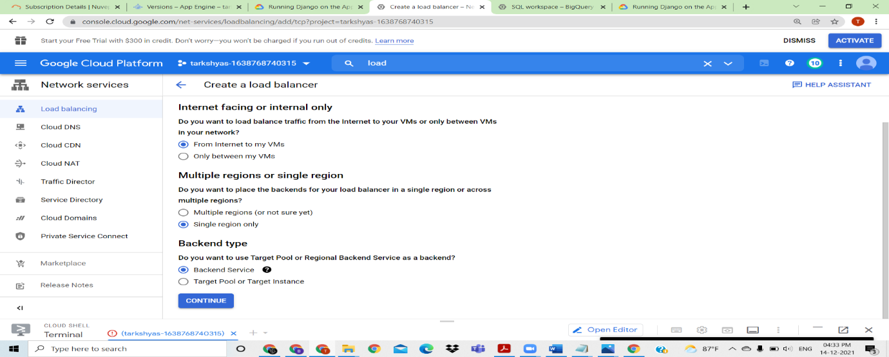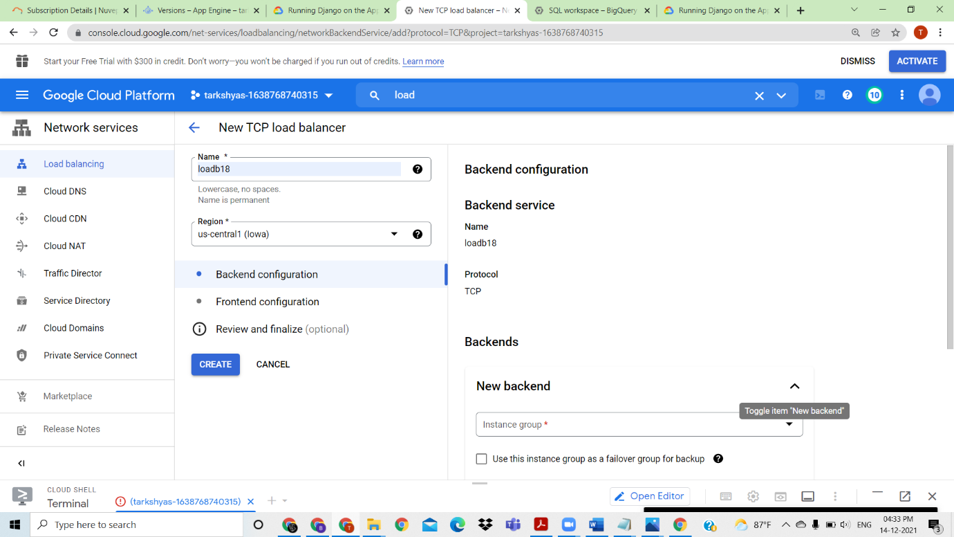

Create the frontend and backend configuration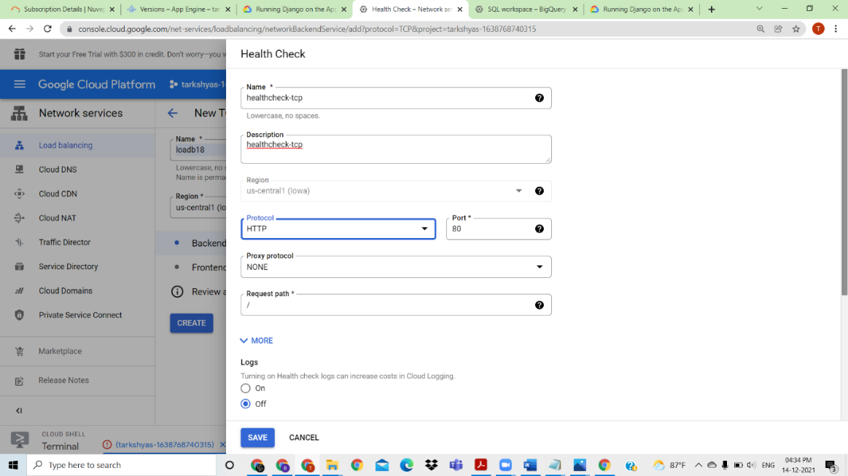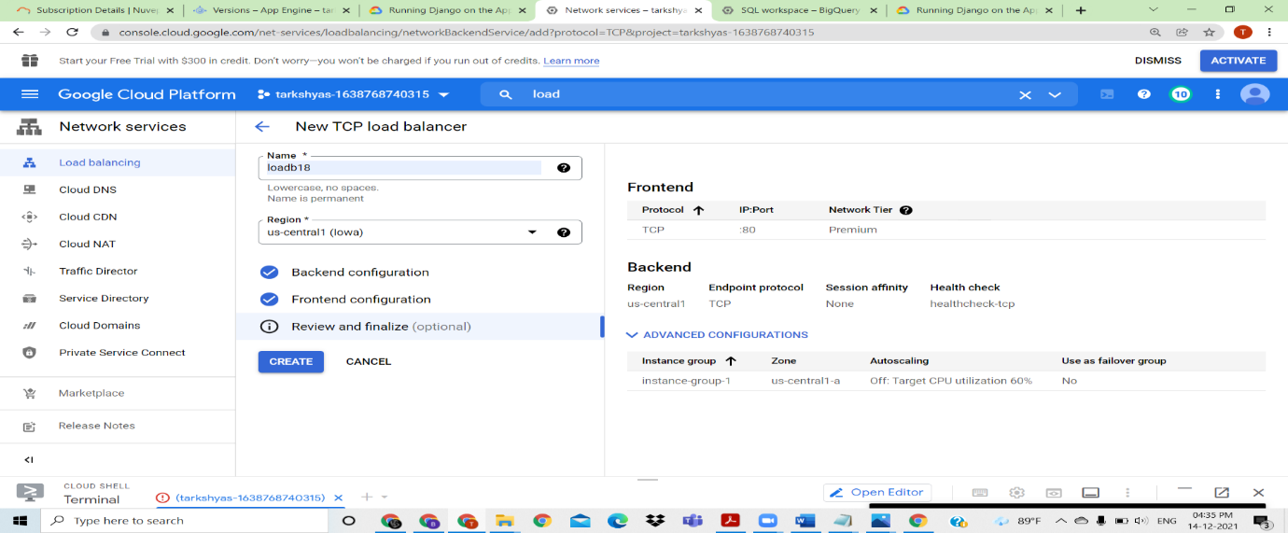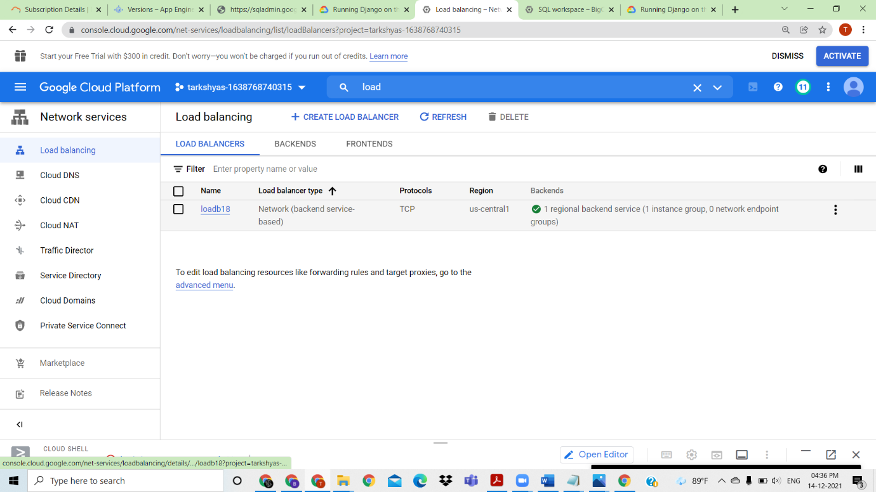

Created the tcp load balancer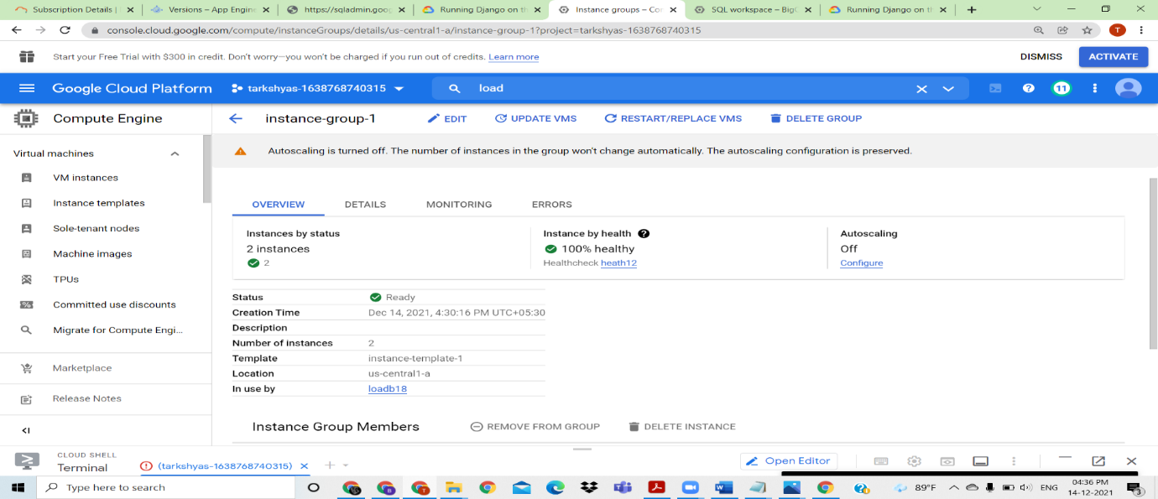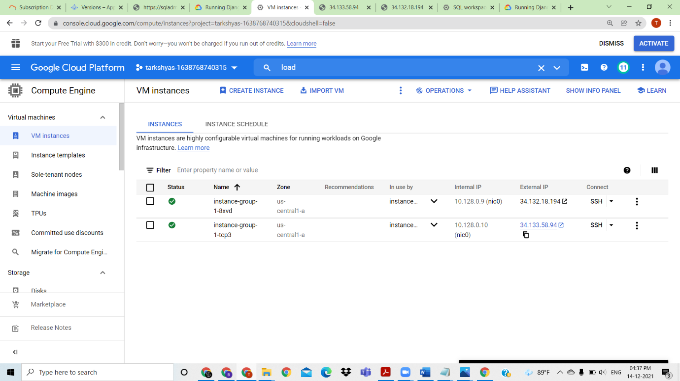

Click on external ip of the vm instance to see the webpage, and refresh one page to increase the load to that site 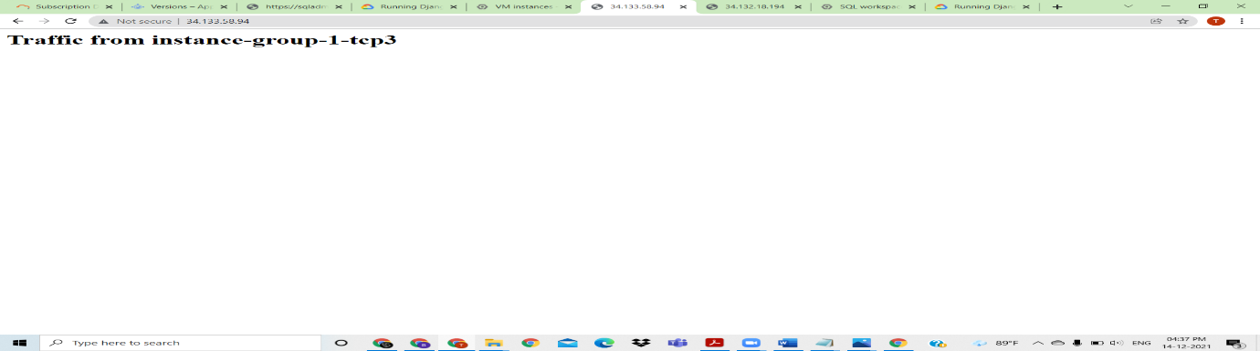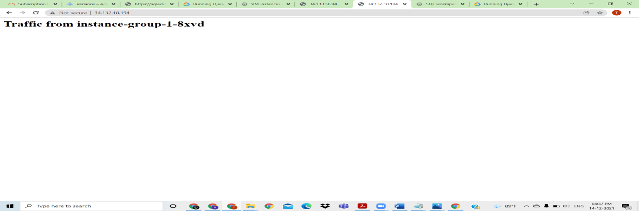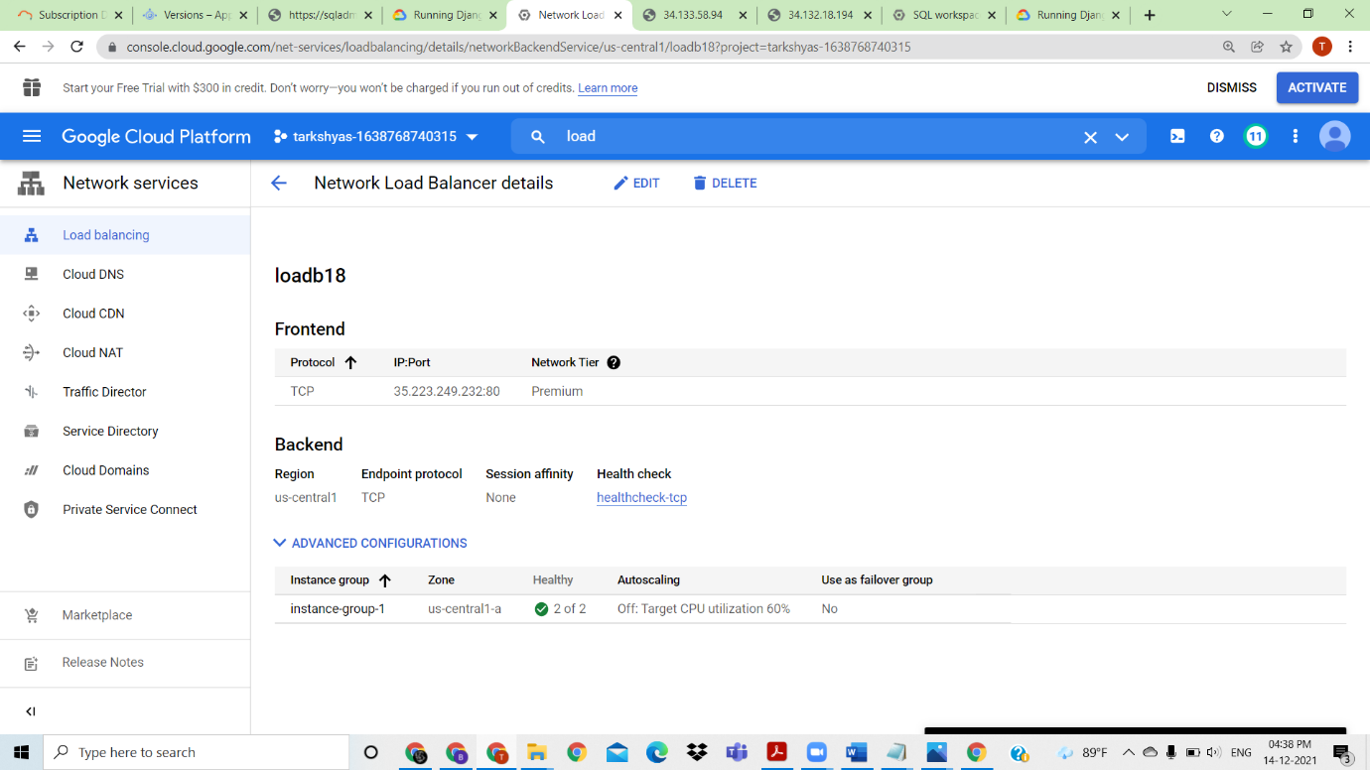

In loadbalancer ip is usedvwhen load increases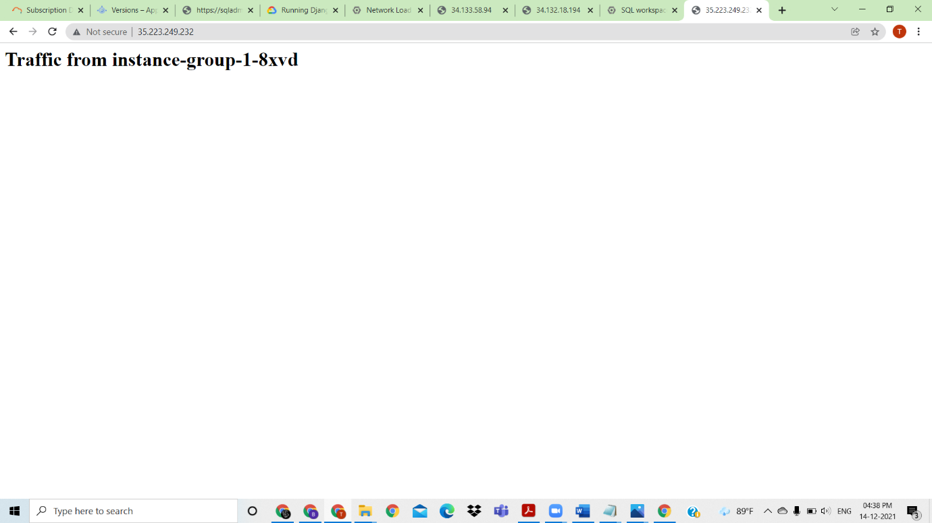

Created load balancing using TCP

QUESTION 11: Terraform and Ansible

ANSWER

TERRAFORM

IN IAM create a service account and generate a key

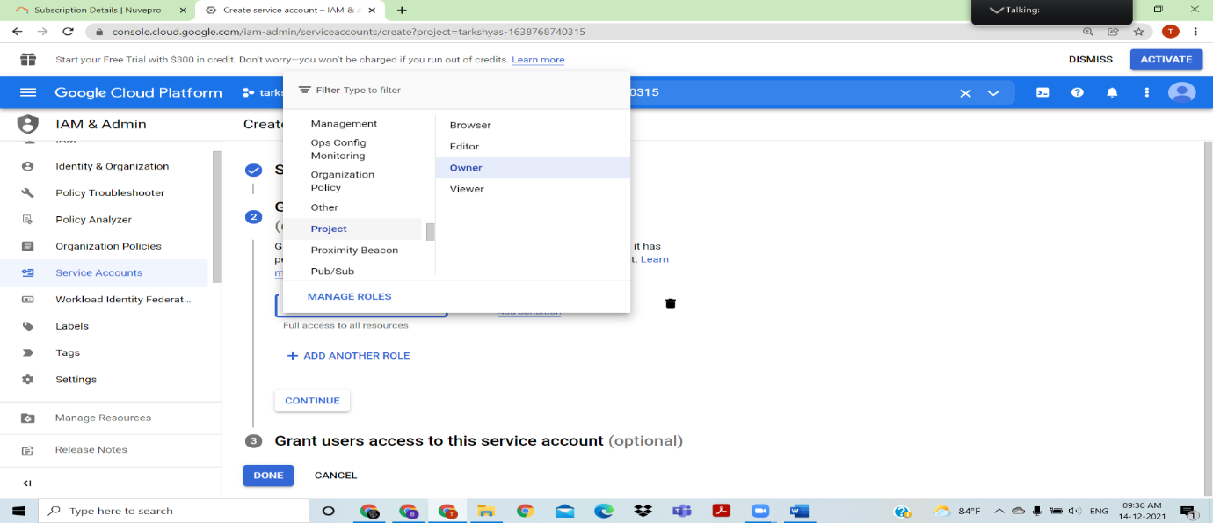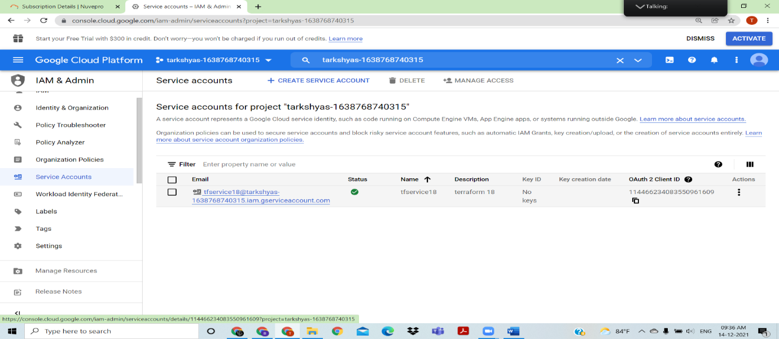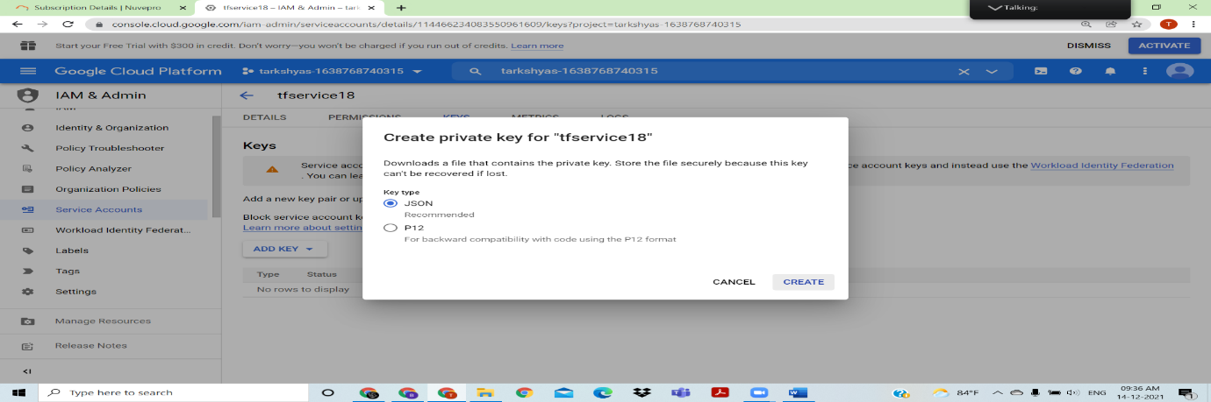

Keep terraform.exe and key inside a folder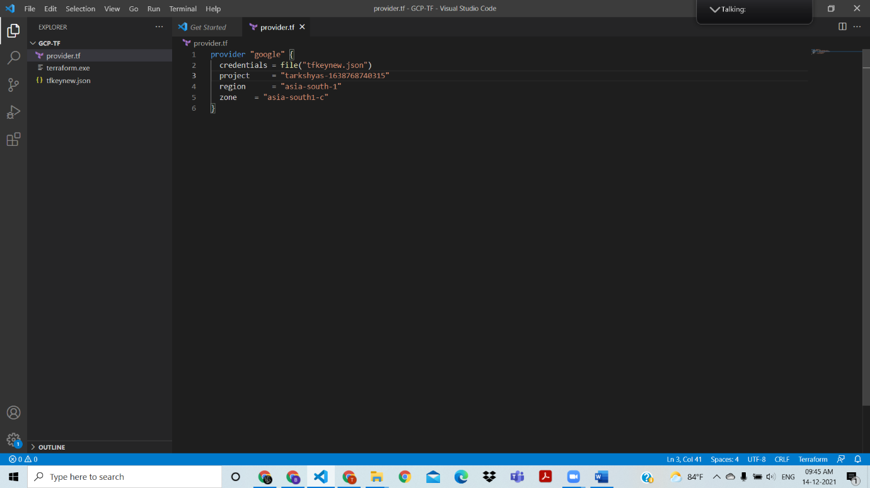

Create a provider file in visual studio, 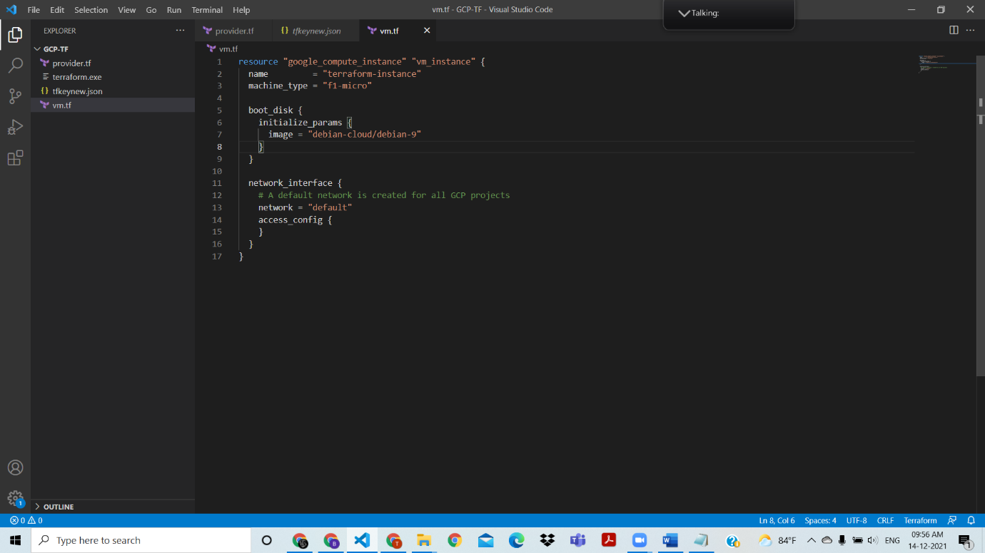

Create a vm instance using visual studio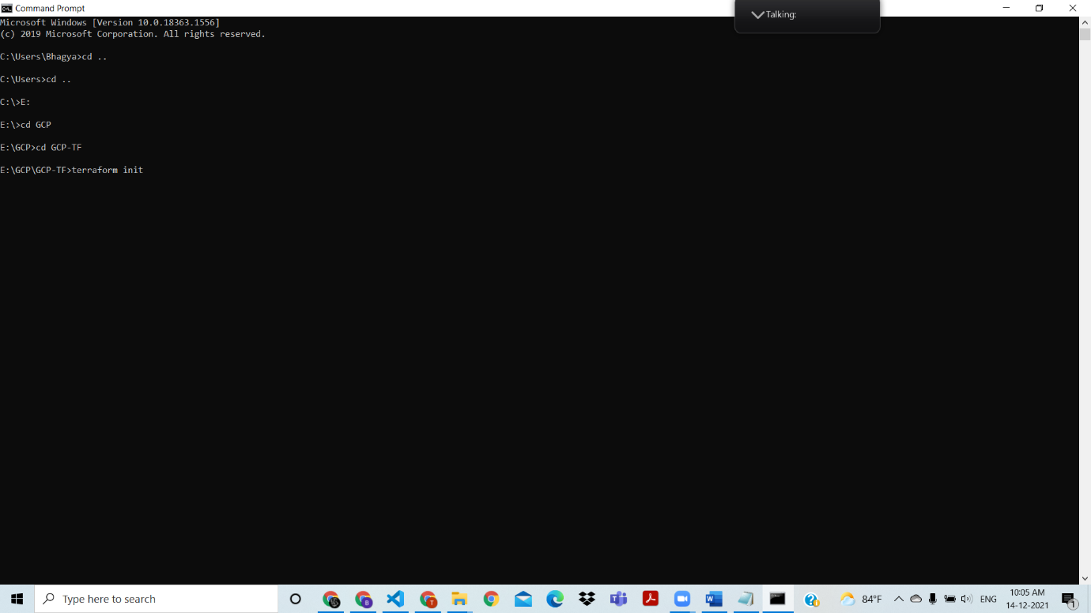

Open command prompt , and go to E directory , where I created the folder

Perform

terraform init;

terraform plan;

terraform apply; 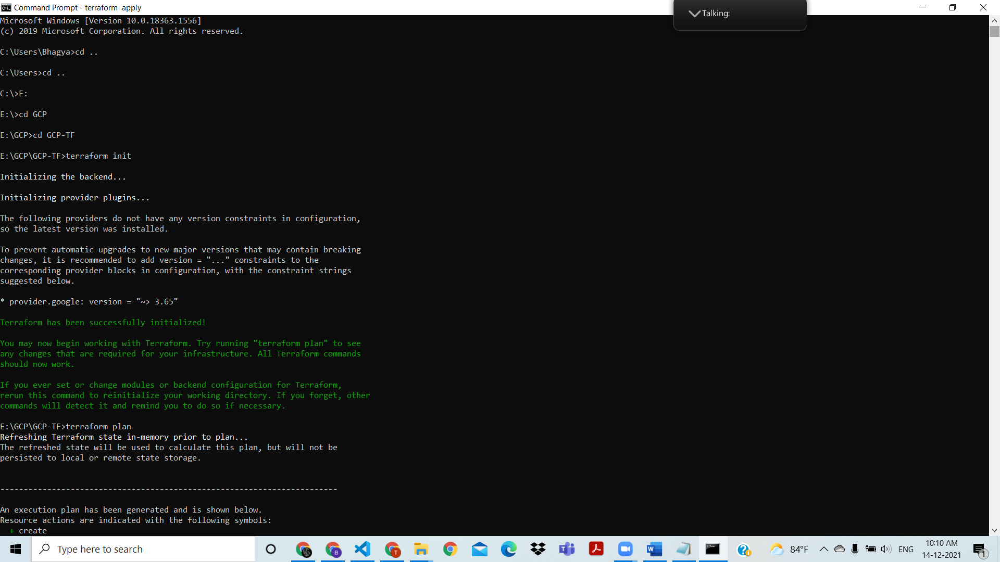

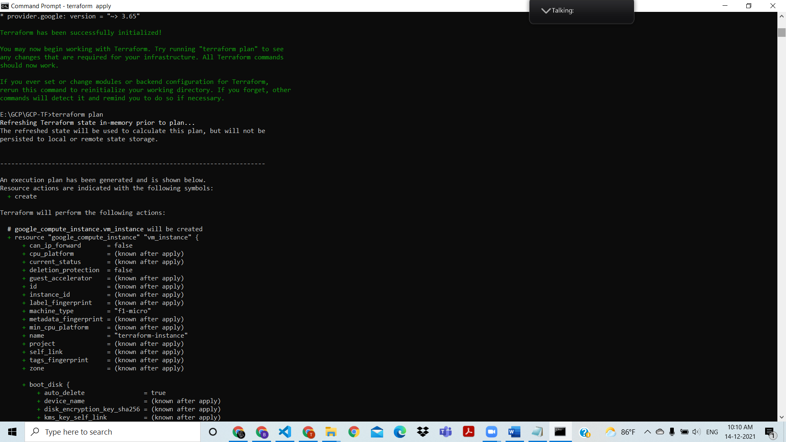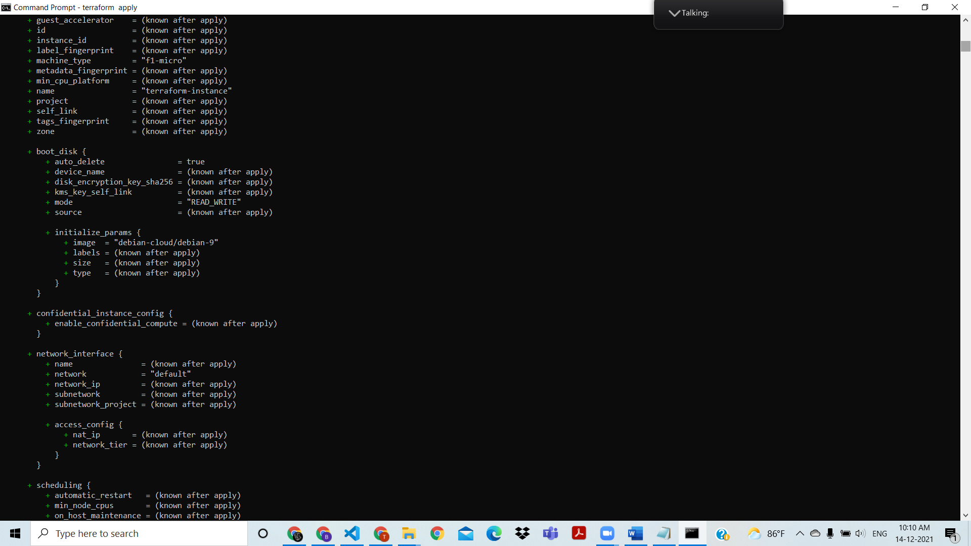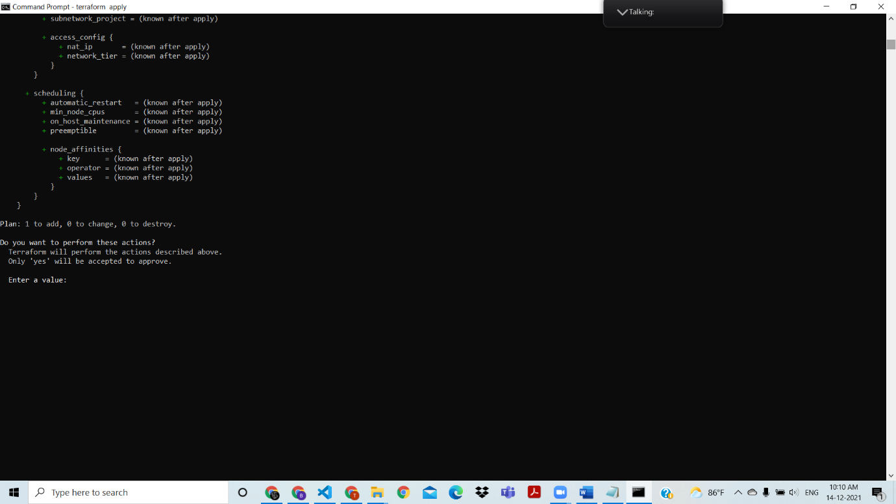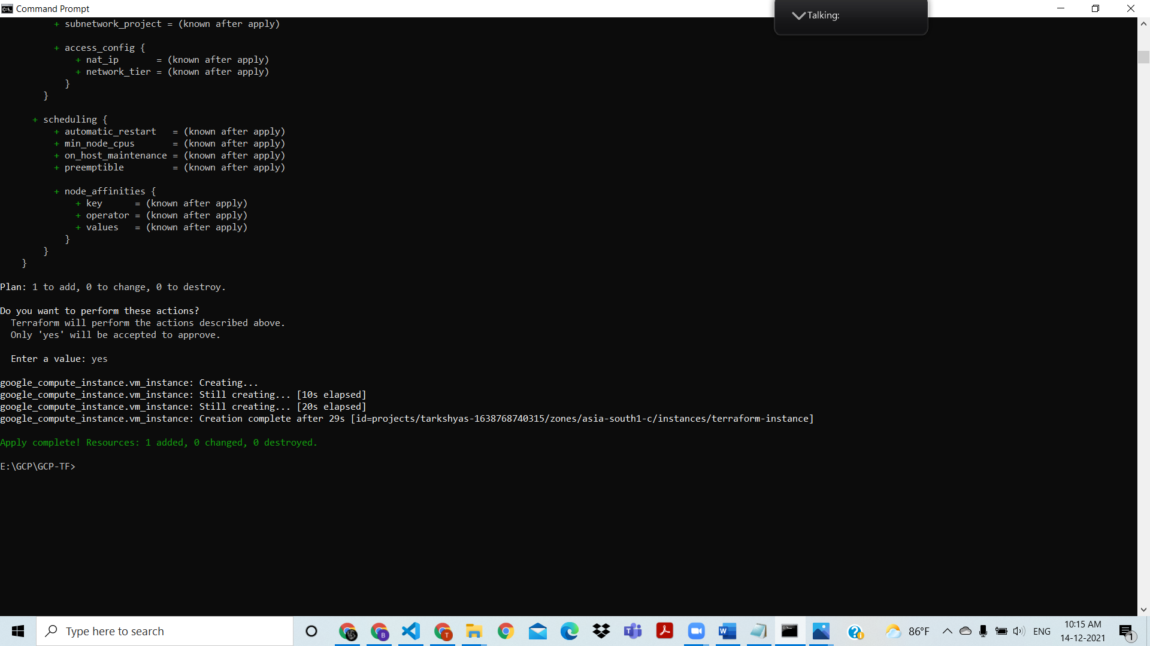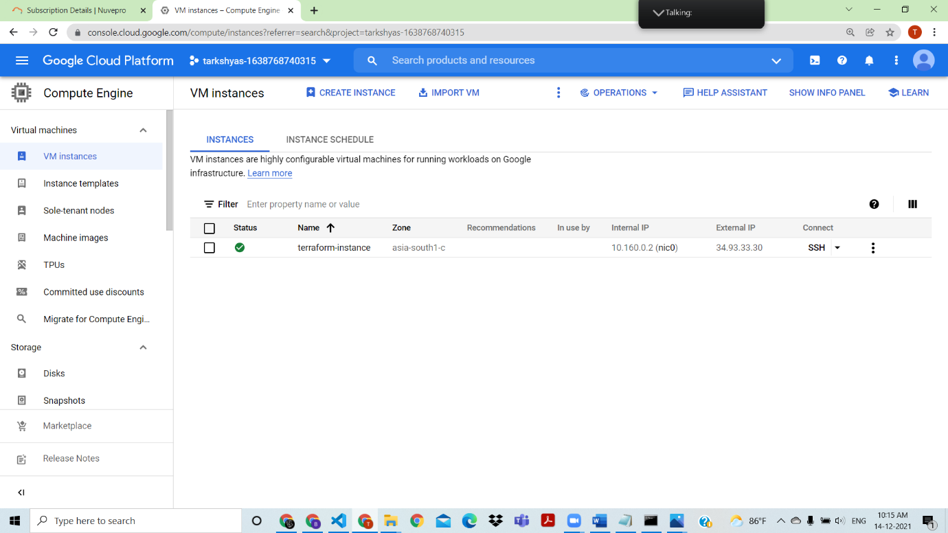

VM instance created with the terraform

ANSIBLE

Install ansible and python in cloud shell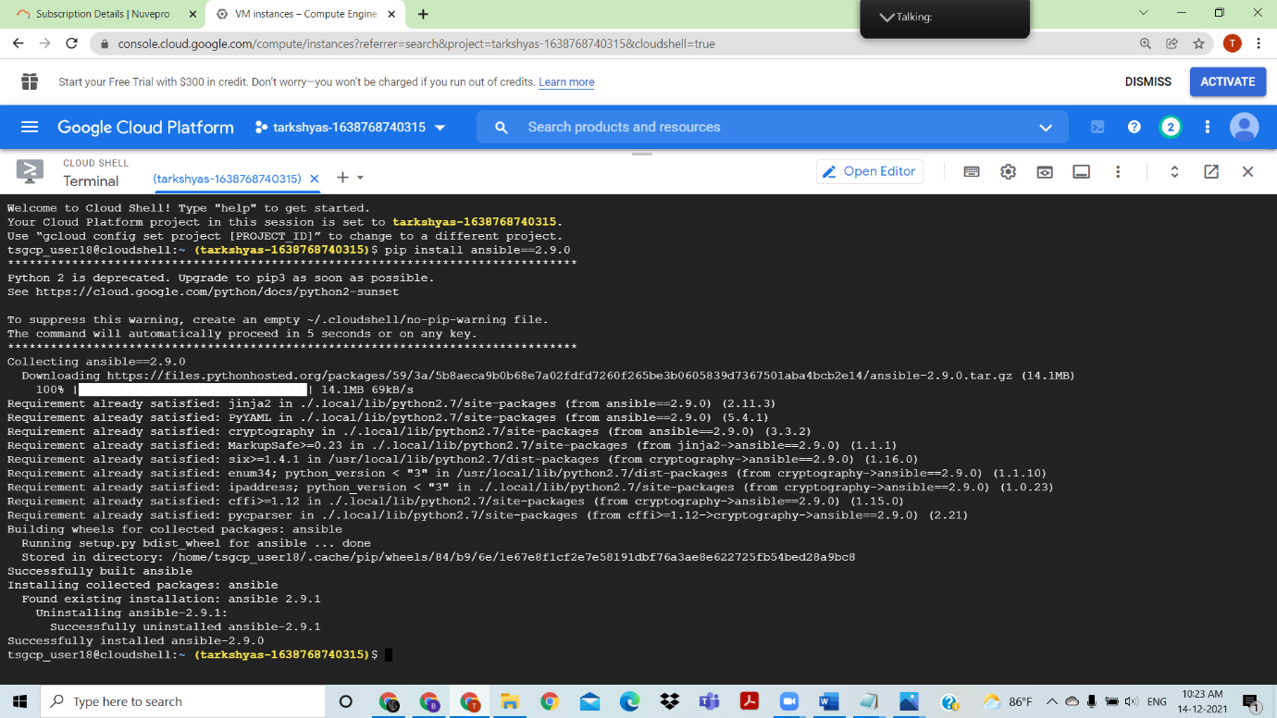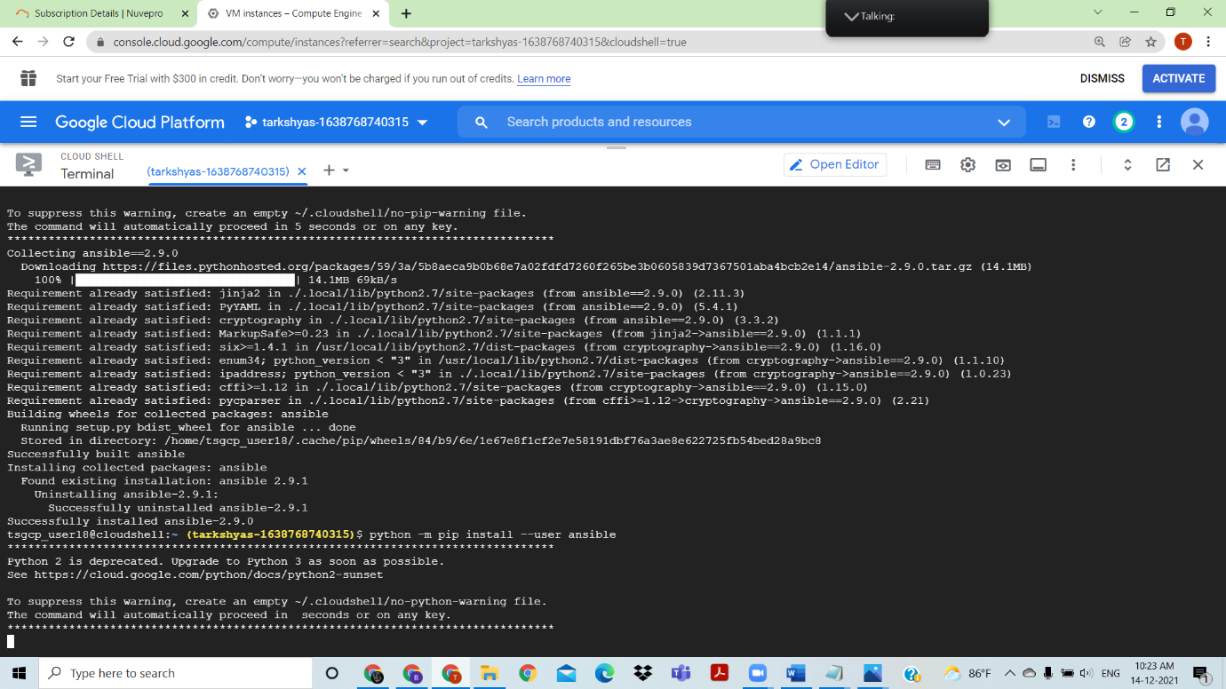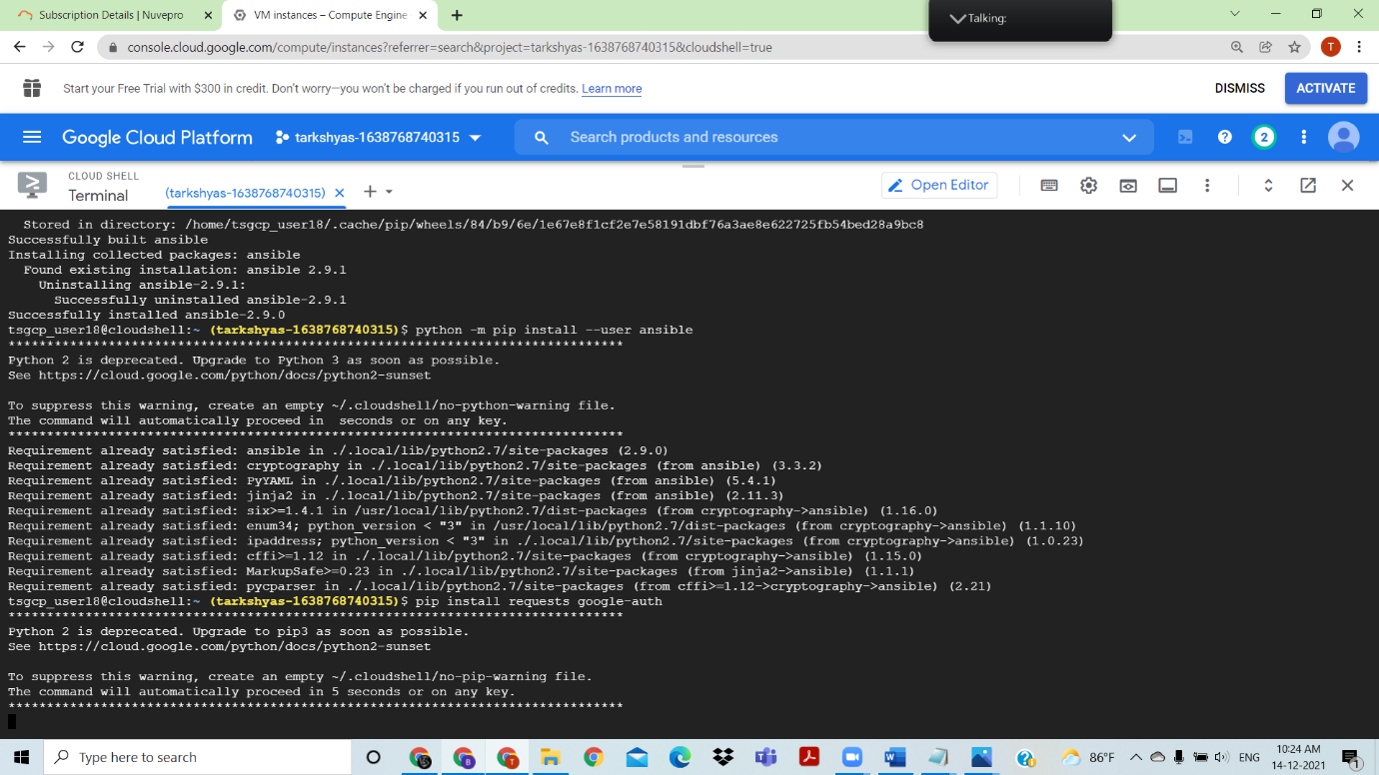

IN IAM create service account and generate key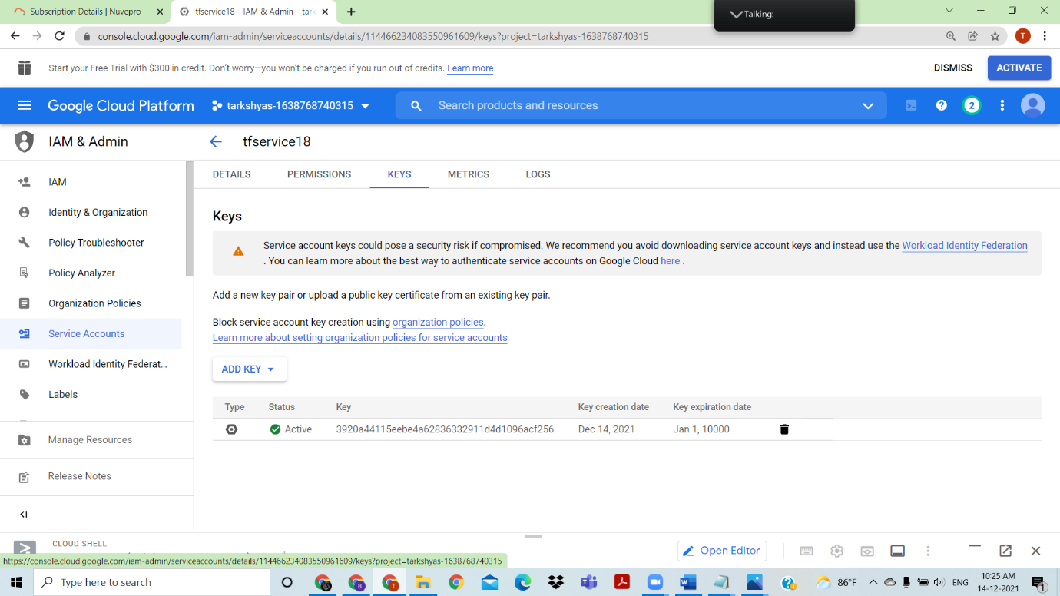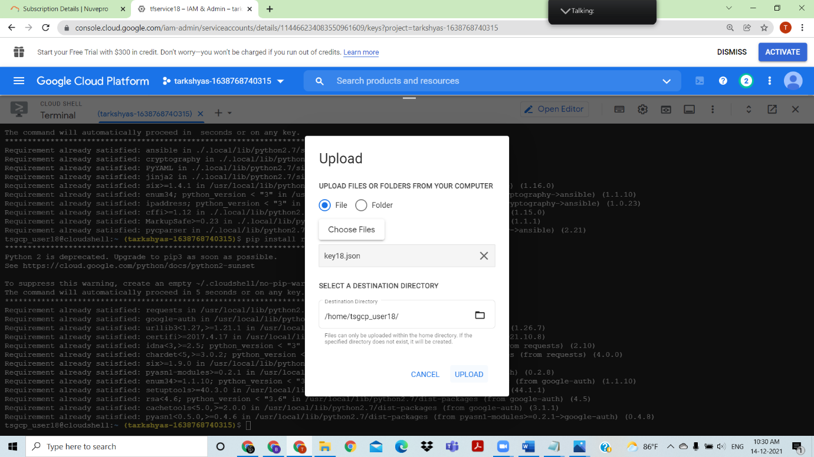

Upload key into cloud shell,and upload the ansible code to create a vm instance

new.yml

- name : "create and instace in GCP"

   hosts : localhost

   vars:

           instance_name : "my-first-instance"

           machine_type : "f1-micro"

   tasks:

          - name : "check if gcloud is present in out system"

            command: "gcloud version "

            register : gcloud_output

          - fail :

             msg : "please install gloud in your macihne "

            when : "gcloud_output is failed"

          - name : "create instance in gcp"

            command : "gcloud compute instances create {{instance_name}}  --image-family=rhel-8 --image-project=rhel-cloud  --zone=us-central1-a --machine-type={{machine_type}}"

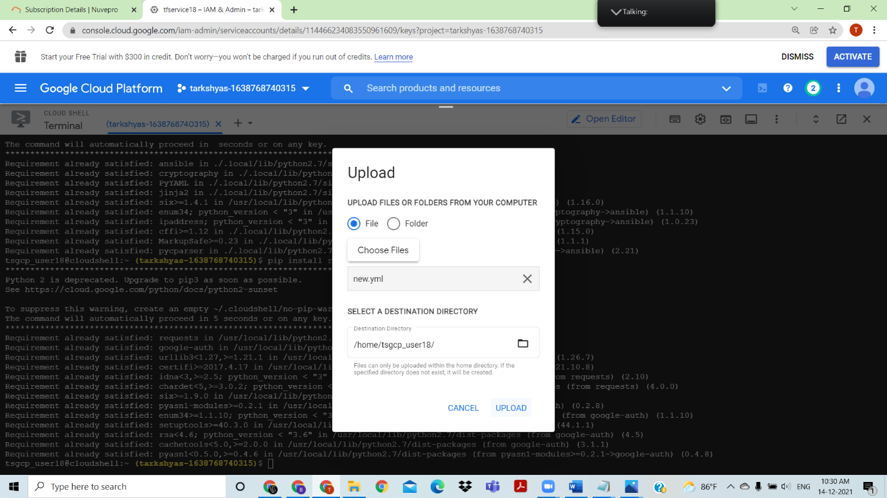

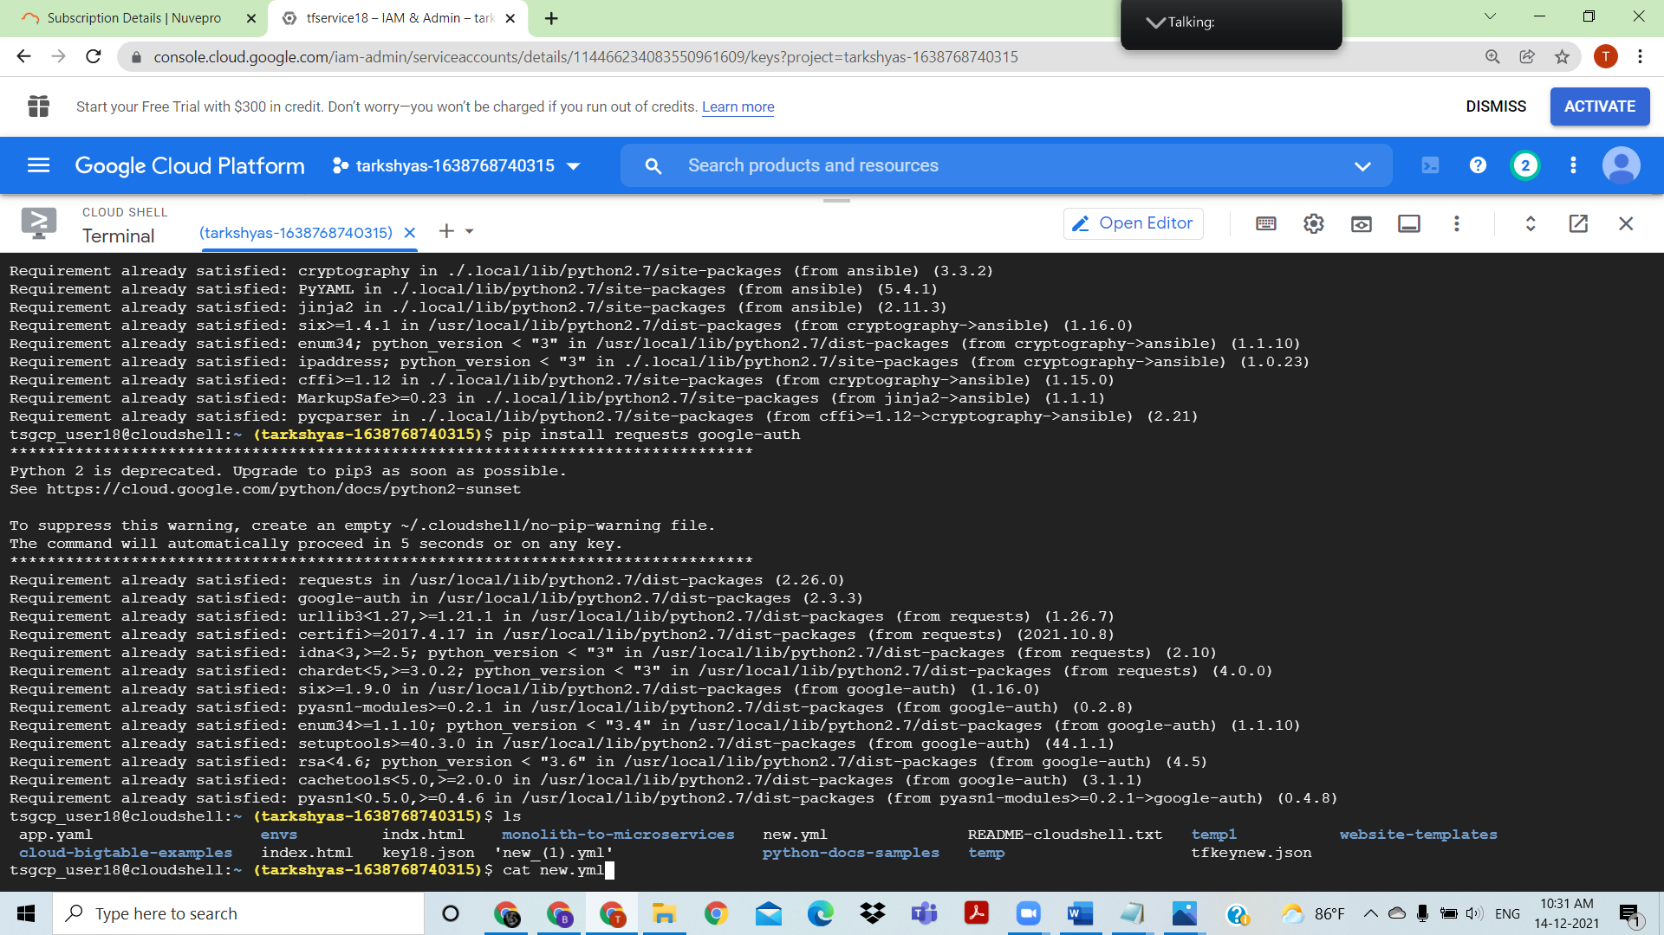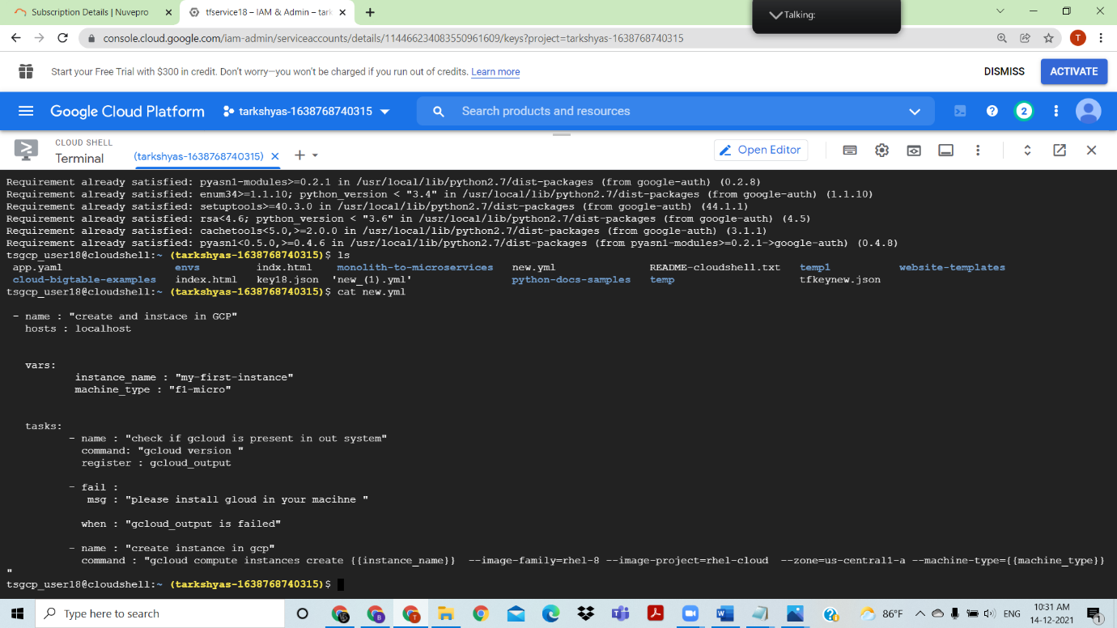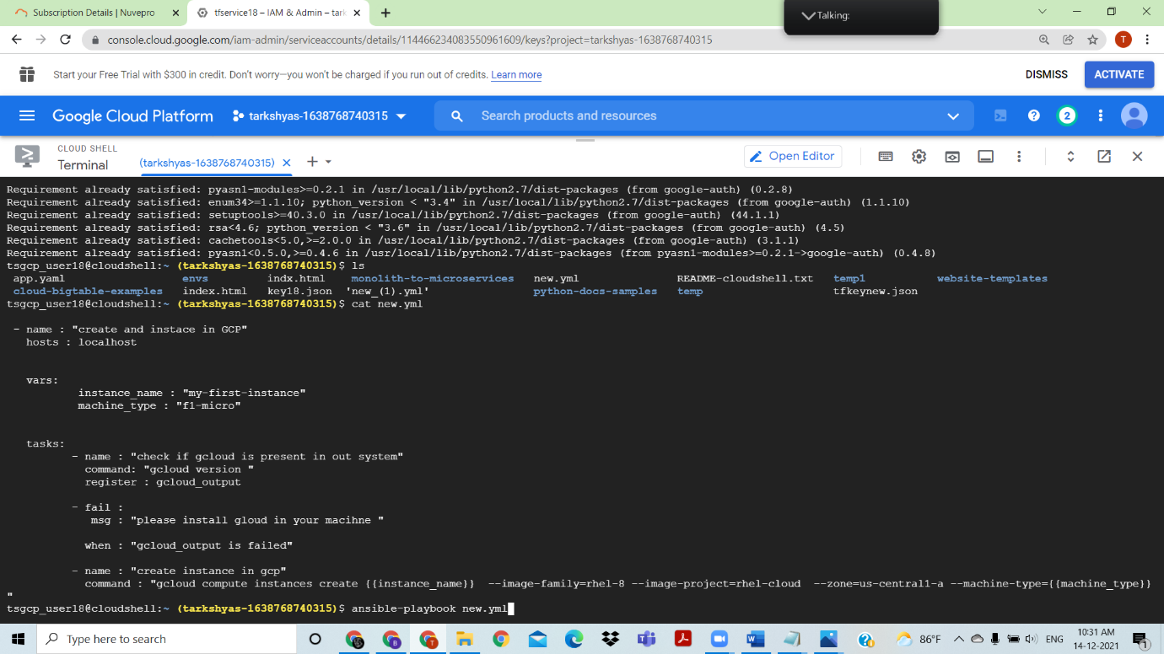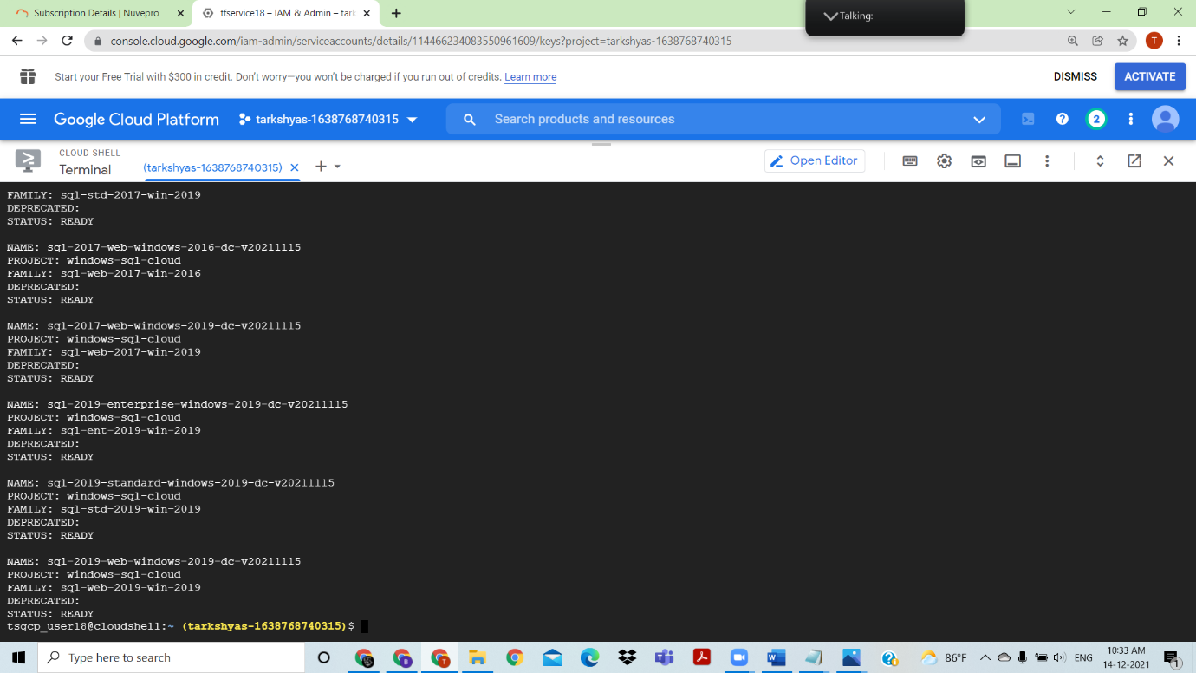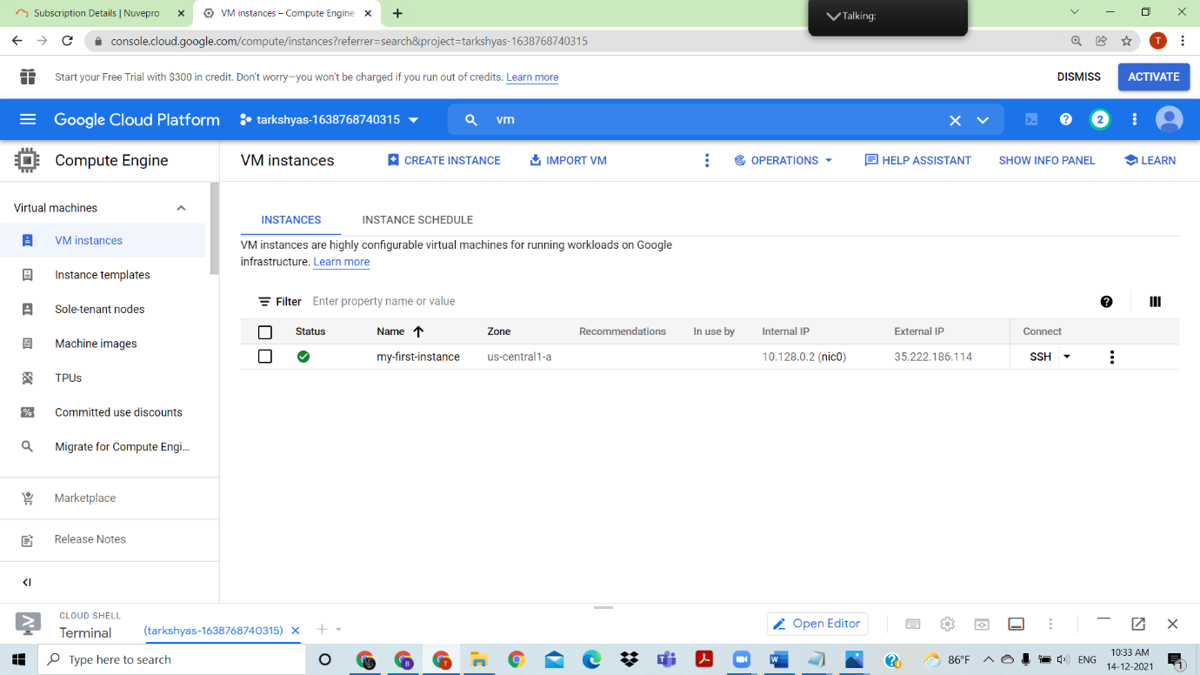

VM instance created

QUESTION6) CLOUD RUN

ANSWER

Github link

<https://github.com/googlecodelabs/monolith-to-microservices>

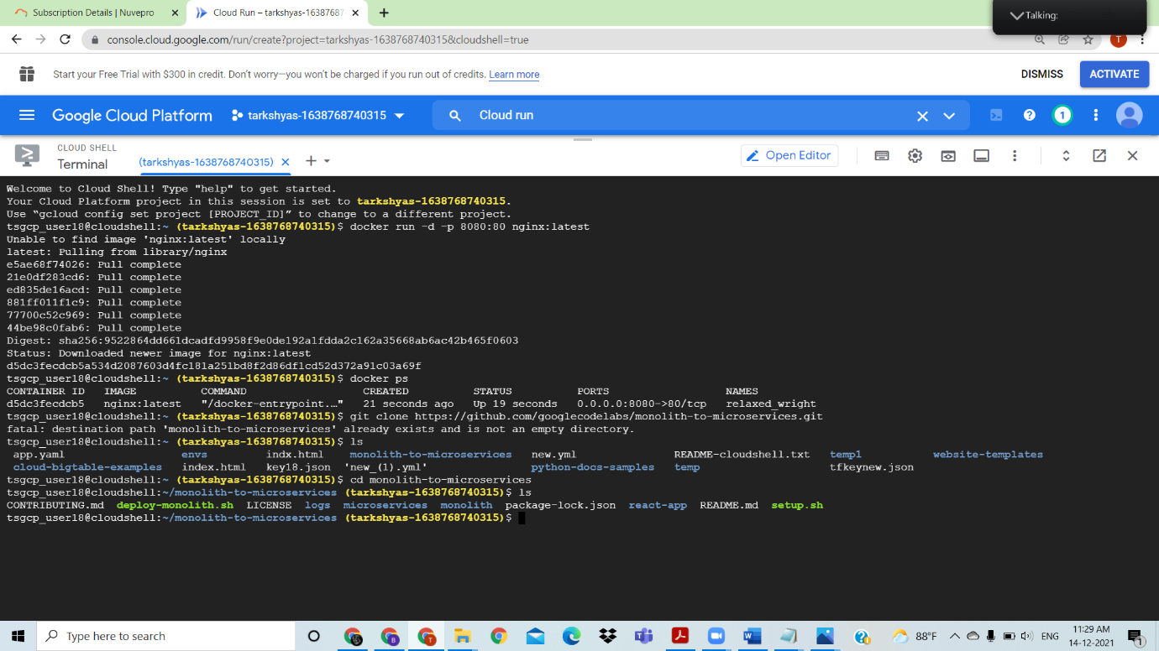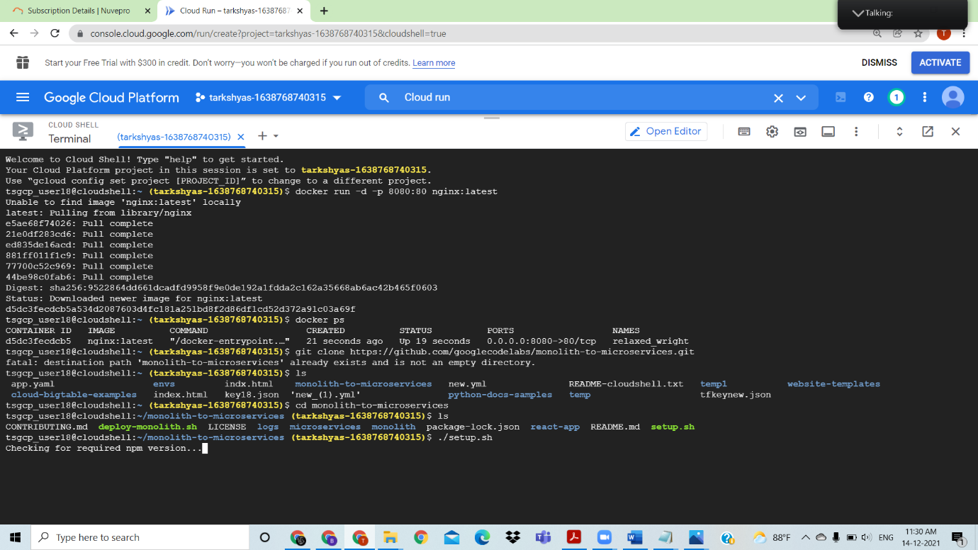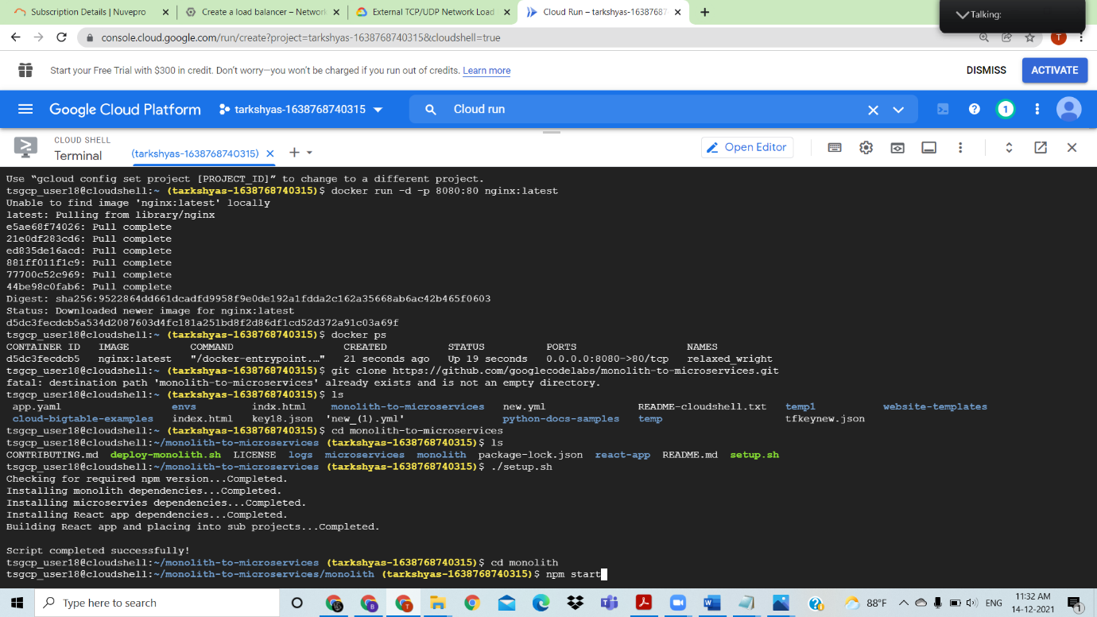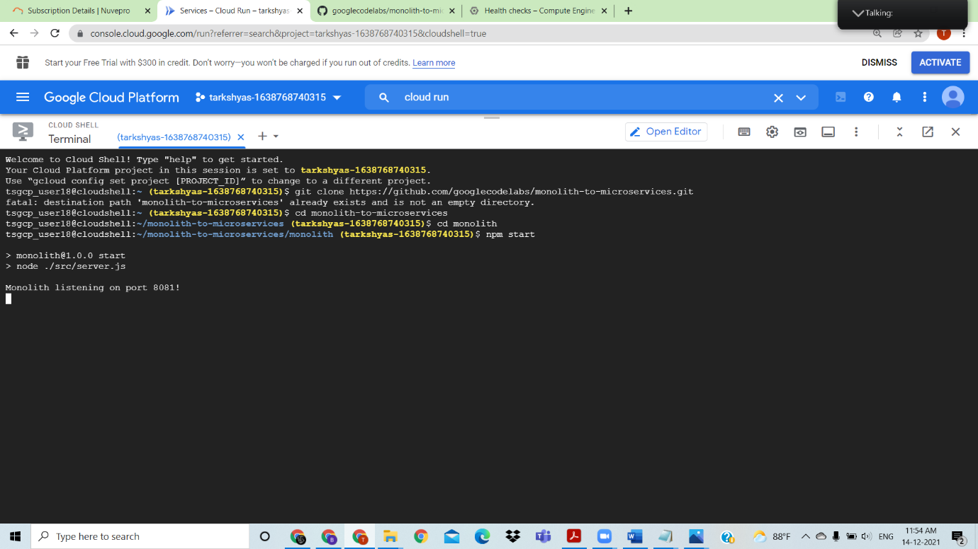

Web preview can see through port 8081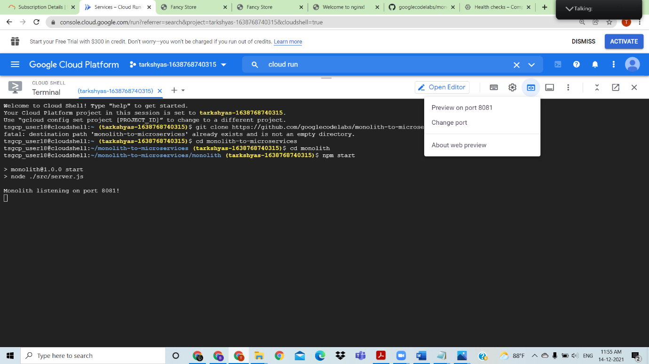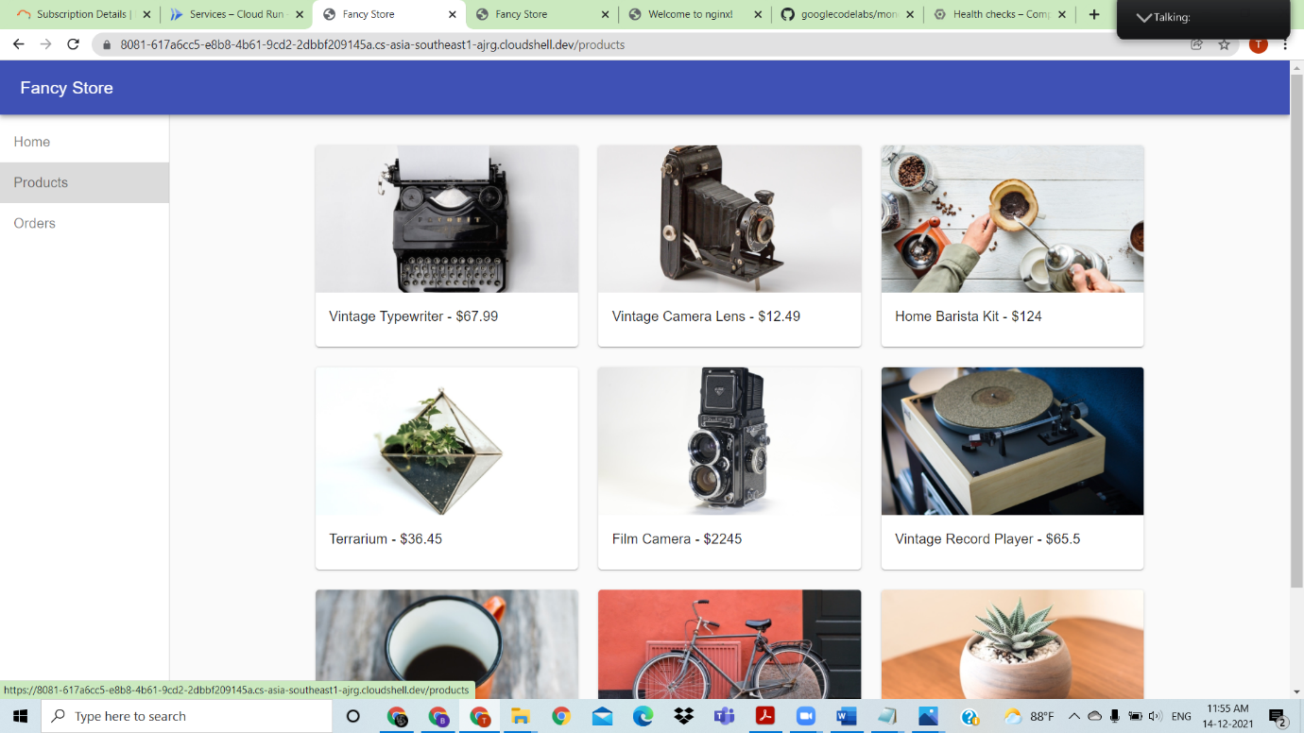

These are the output of webpreview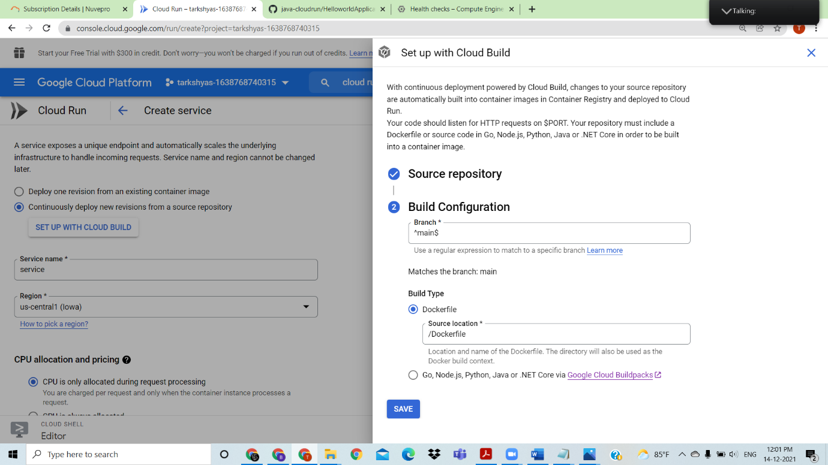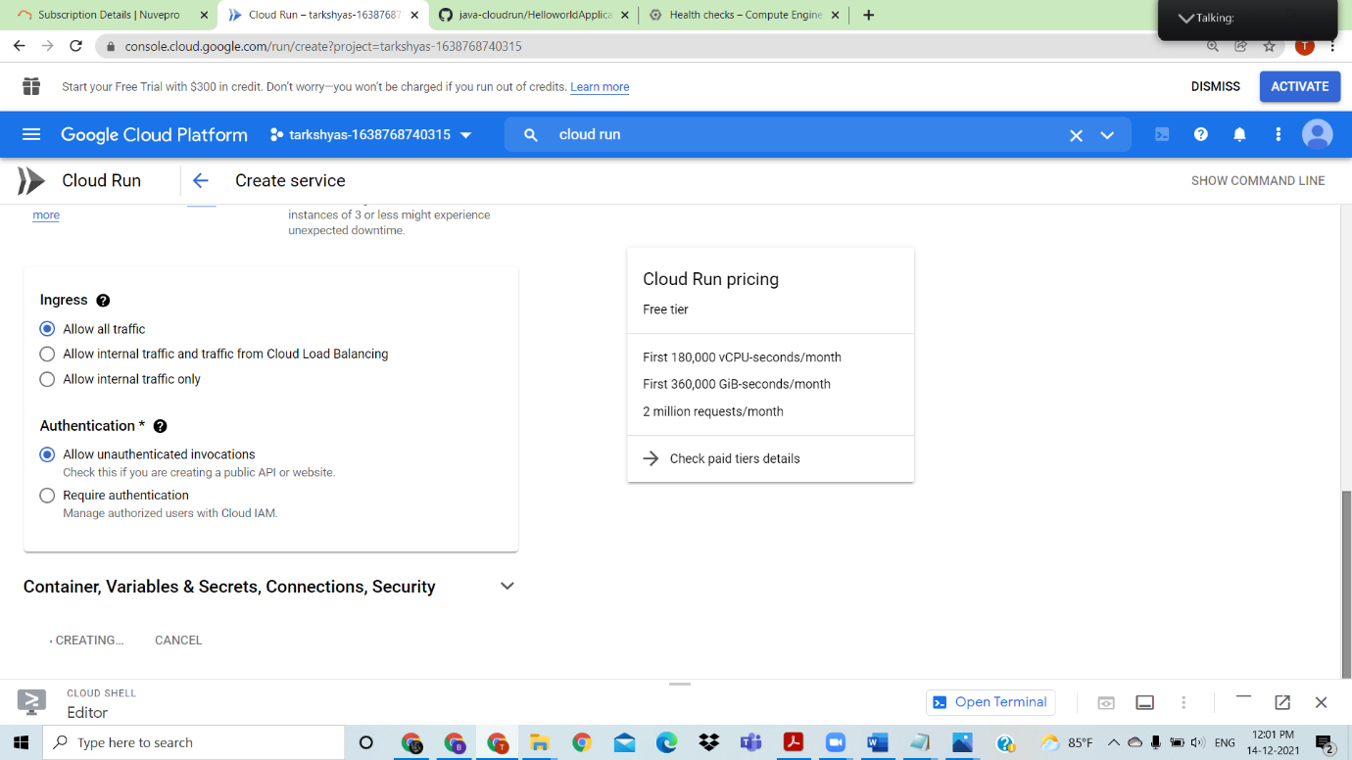

Create cloud run service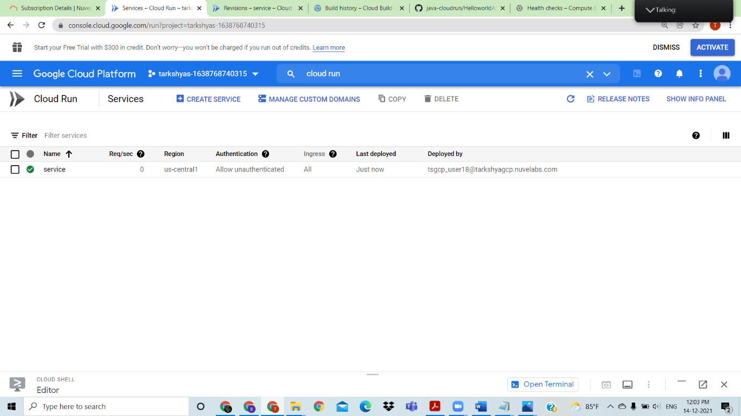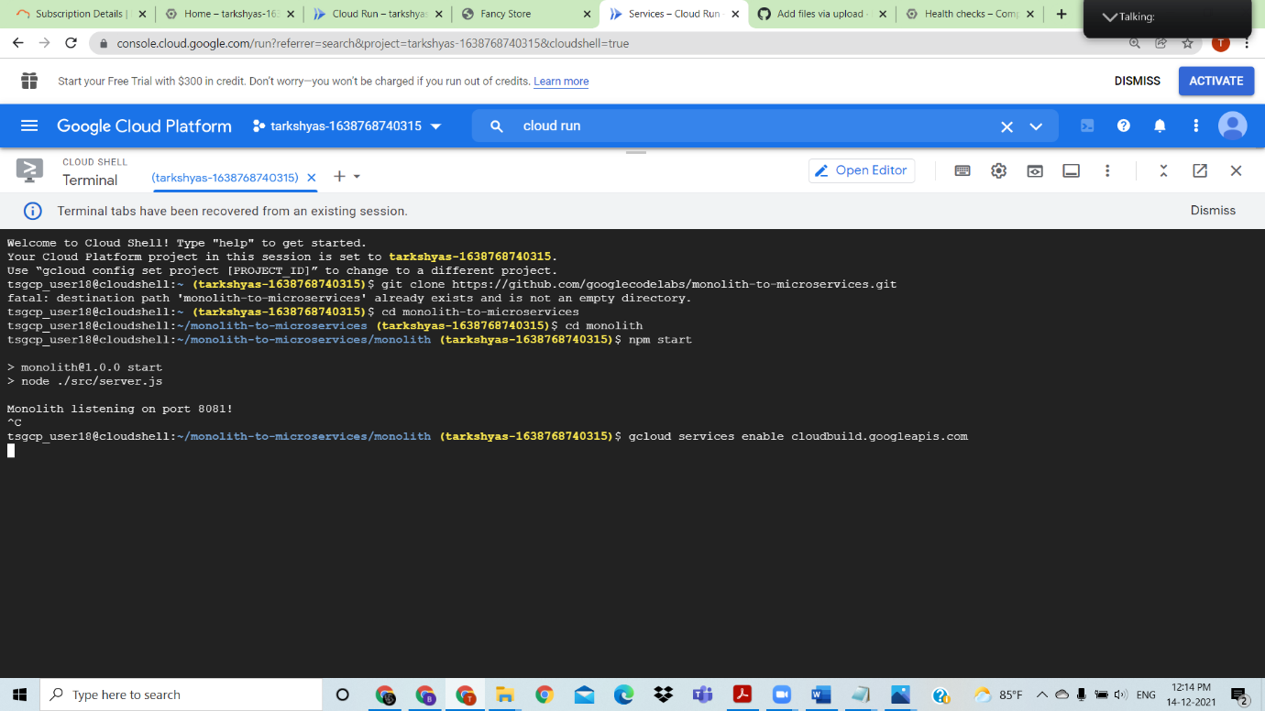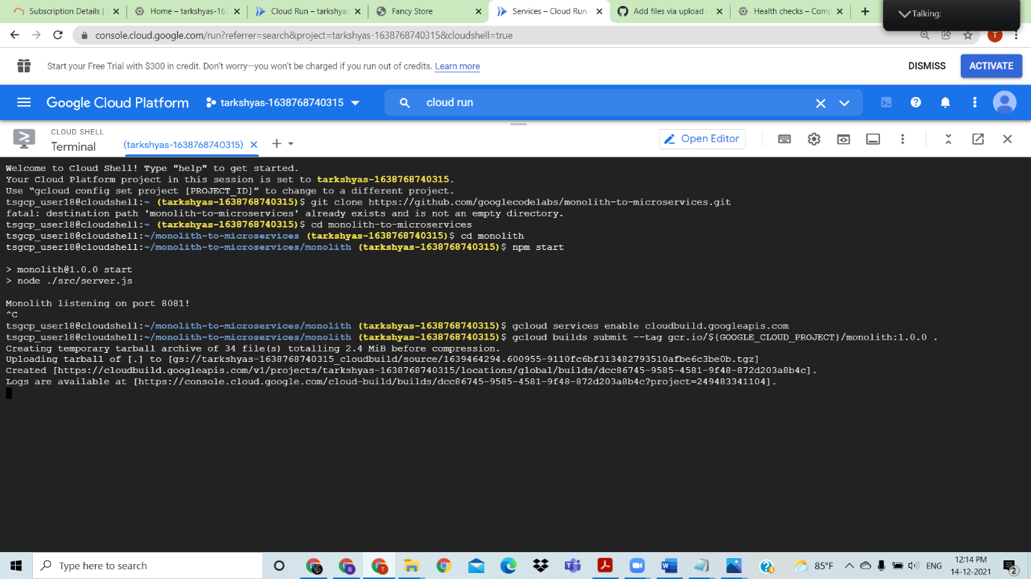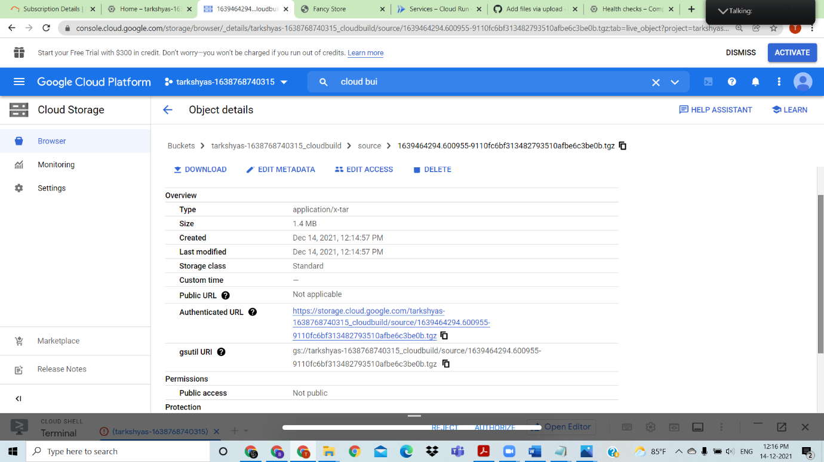

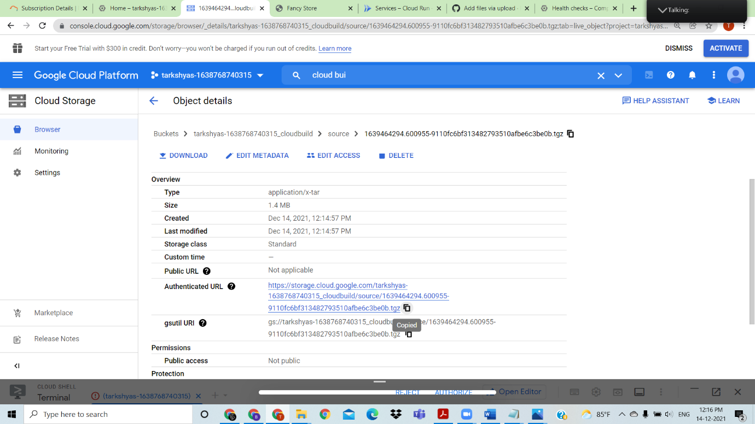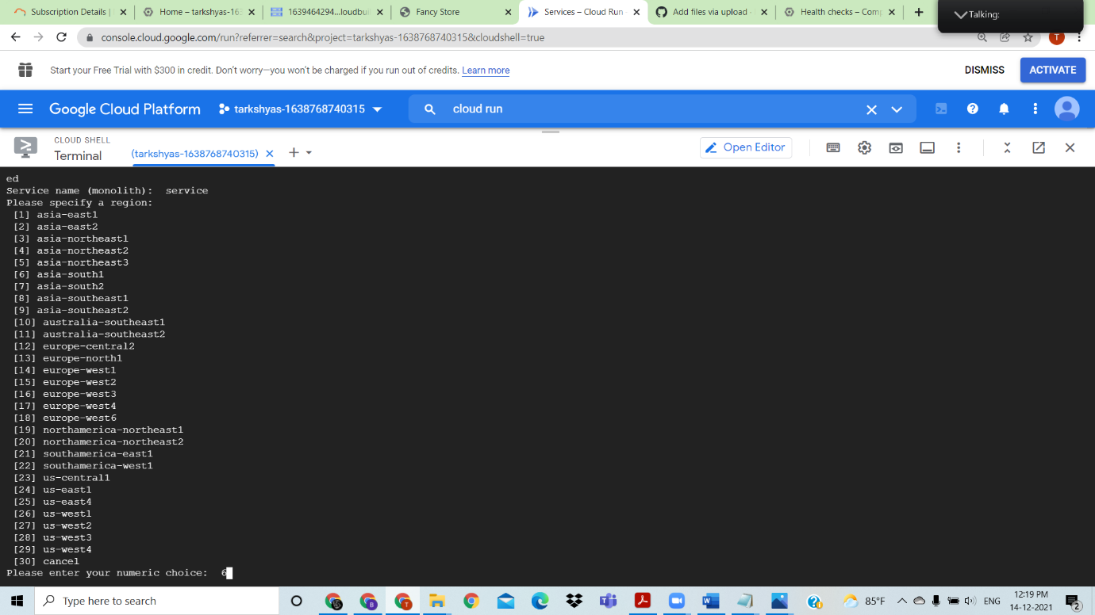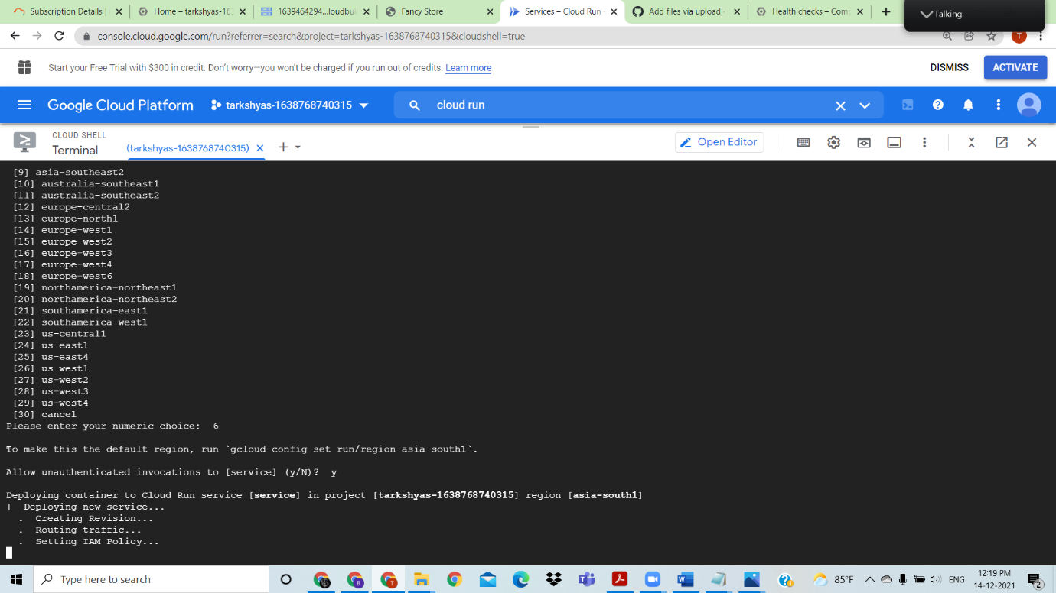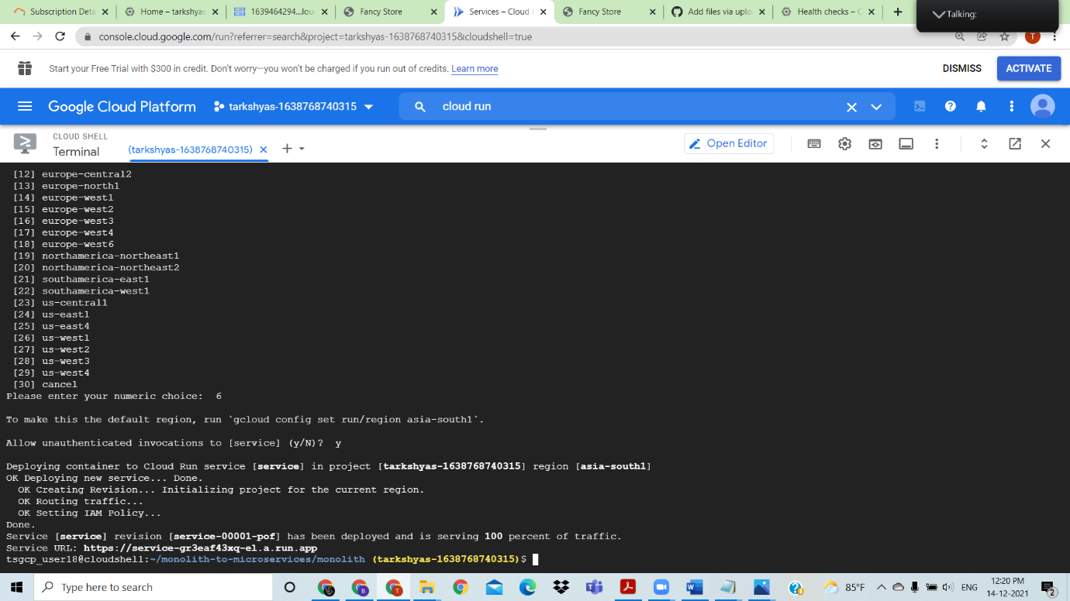

The page is then deployed and click on the link to see webpage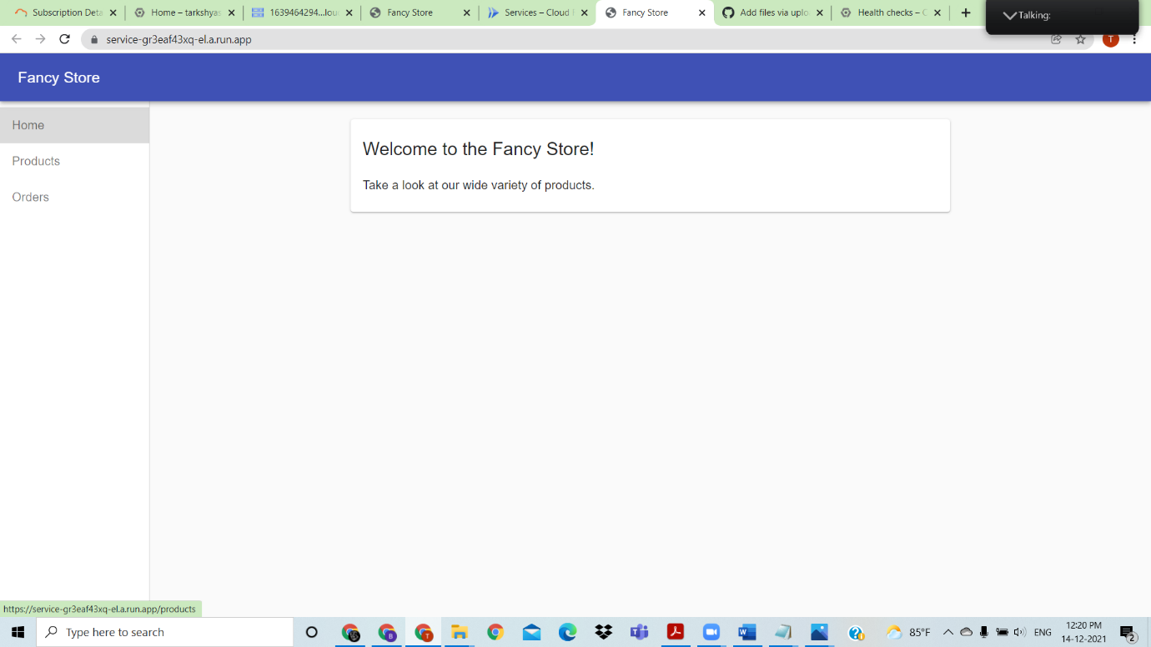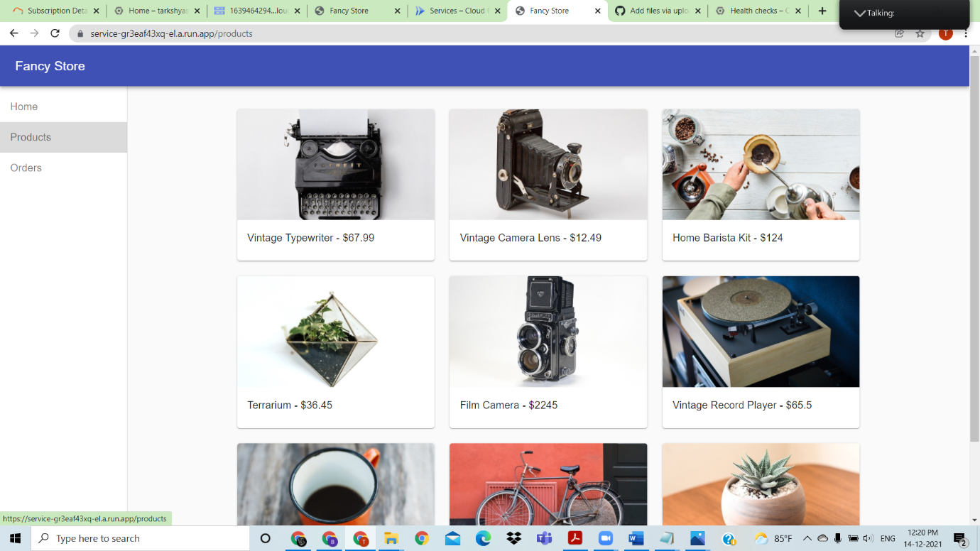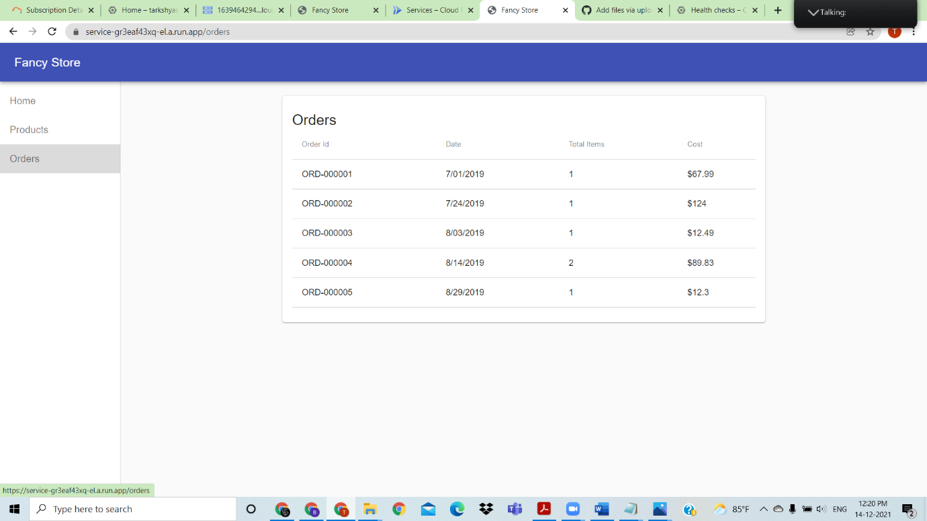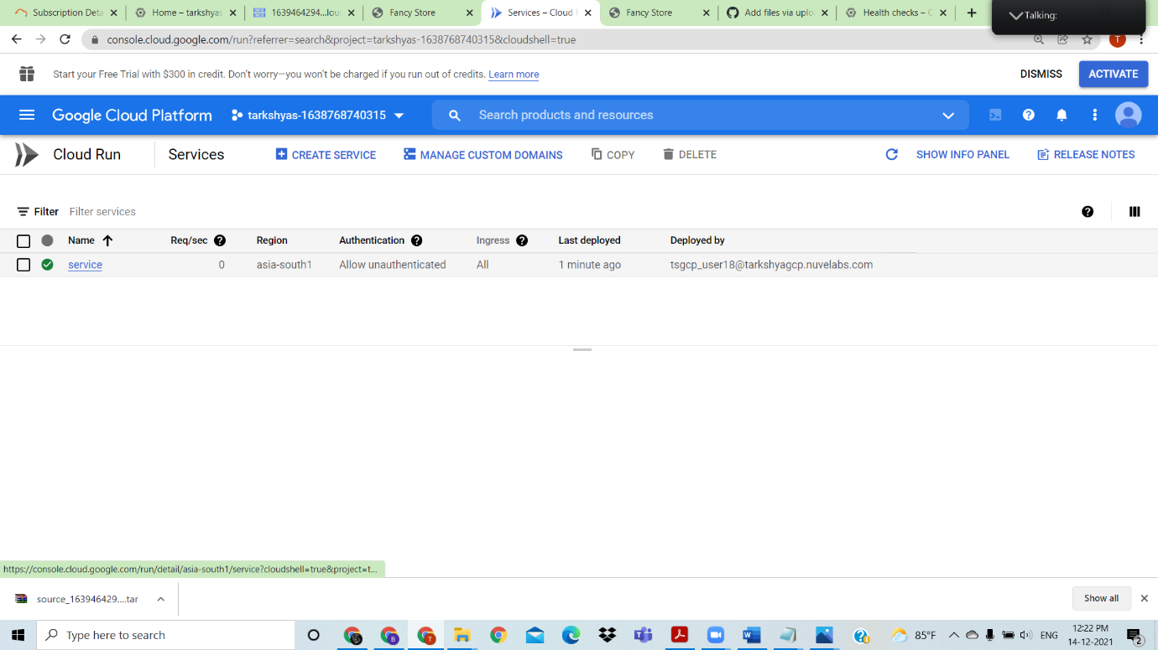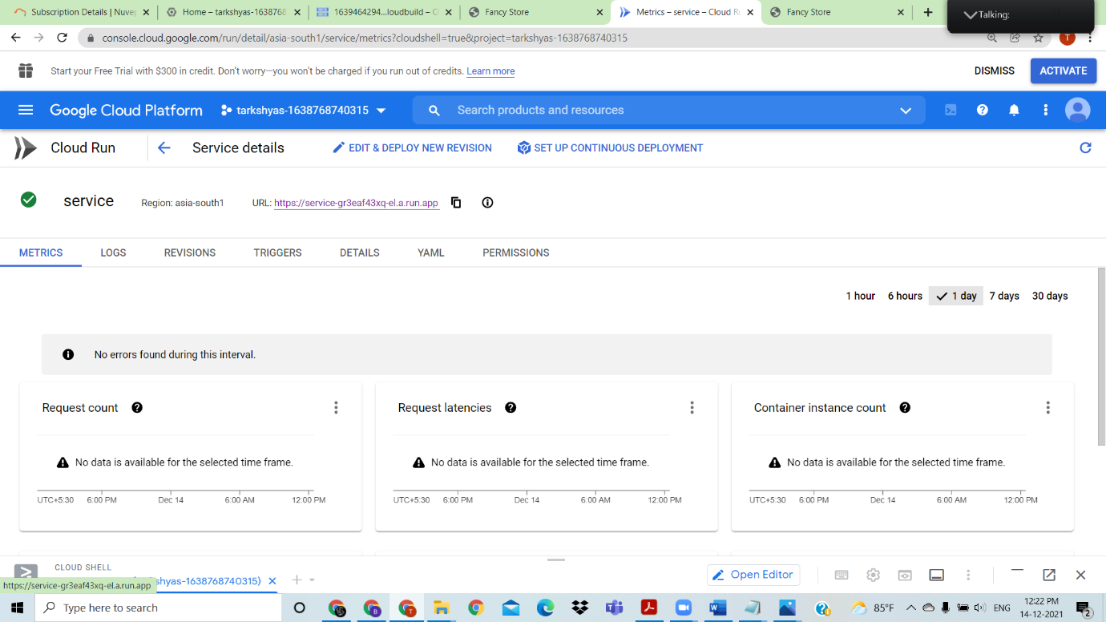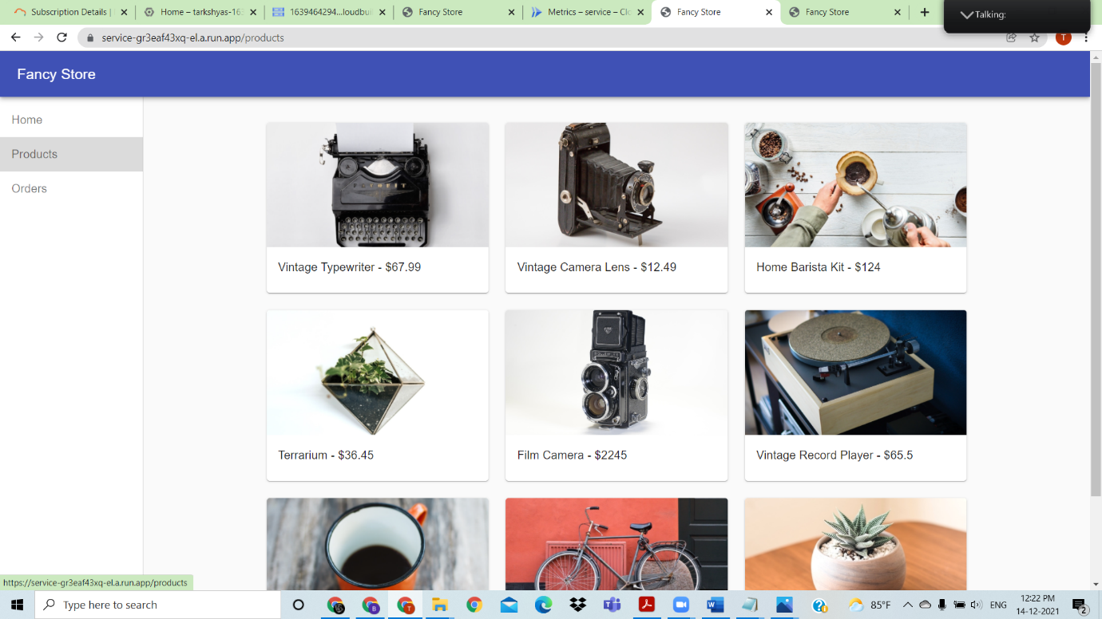

Used cloud run to deploy a web page

--------------------------------------------------------------------------------------------------------------------------------------

QUESTION 12) Understanding the concept of BigQuery, import your data into BigQuery and Cloud storage, SQL Basics (WHERE, GROUP BY, JOIN) tables

SQL BigQuery specific features (partitioned table, clustering)

BigQuery ML – create easily your machine learning models using SQL

ANSWER:

BigQuery

Created database and table inside bigquery

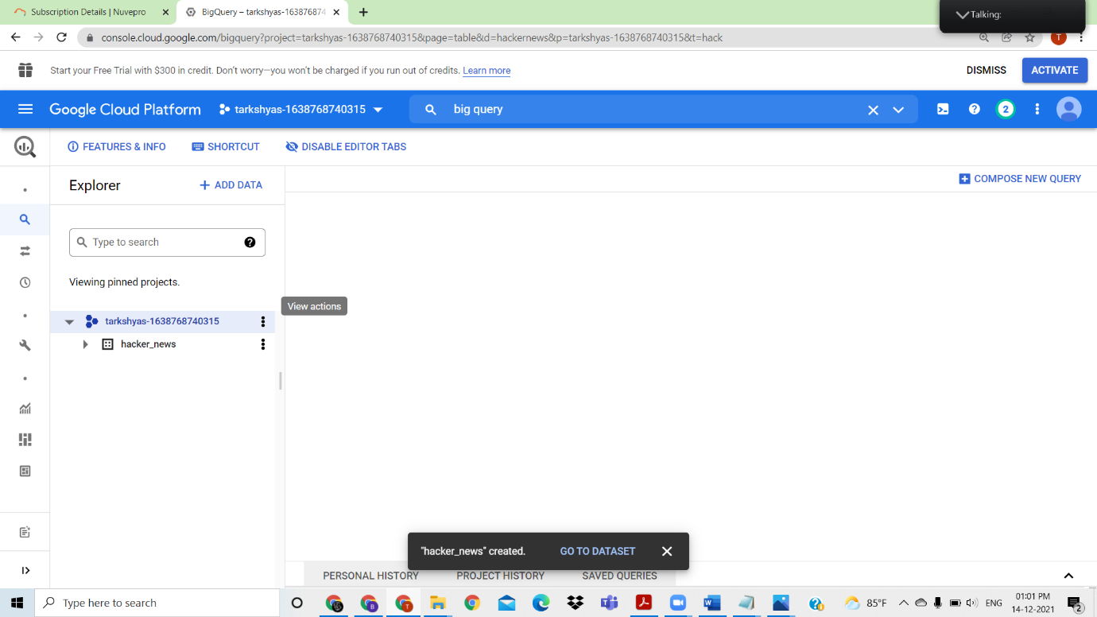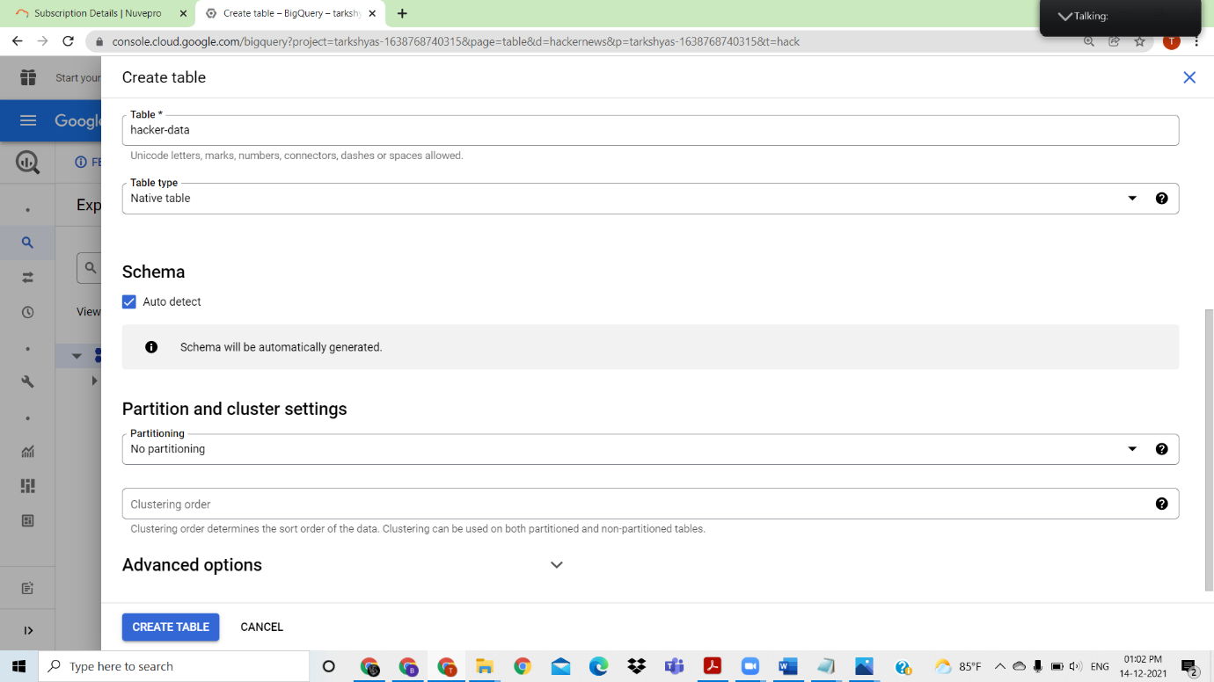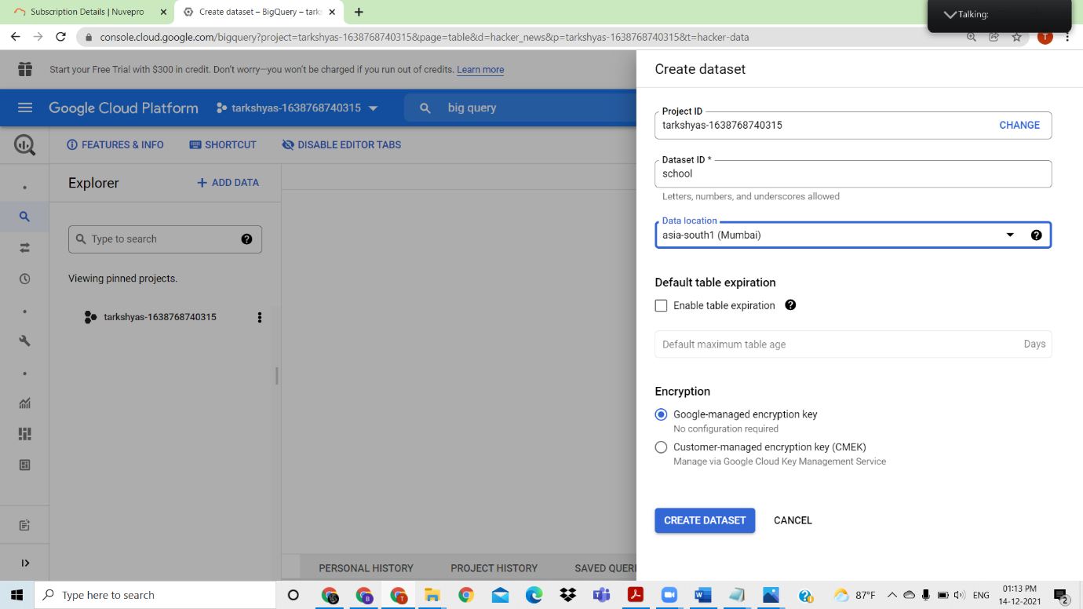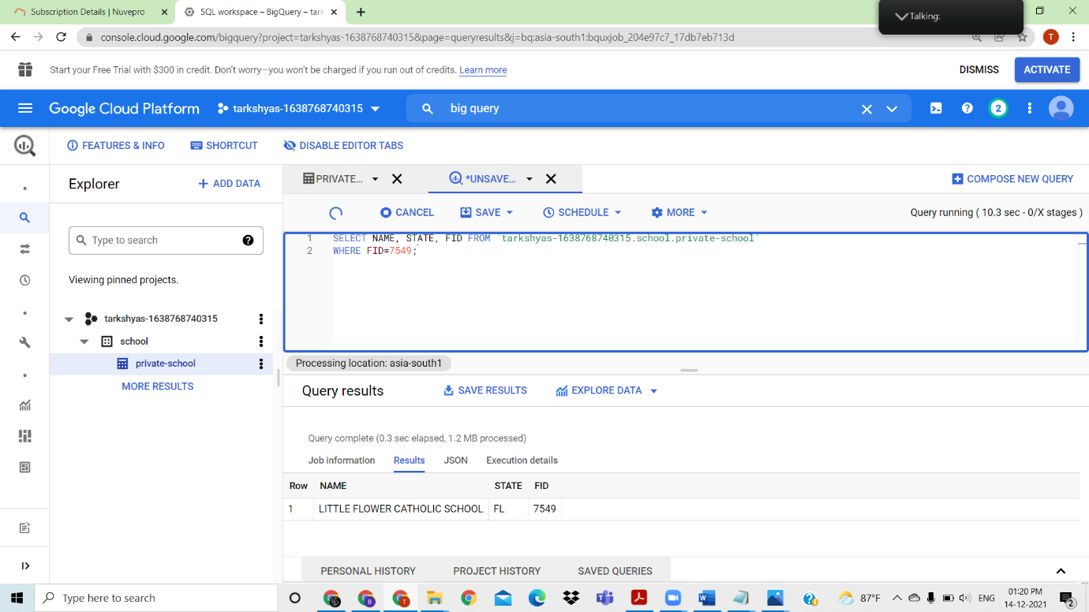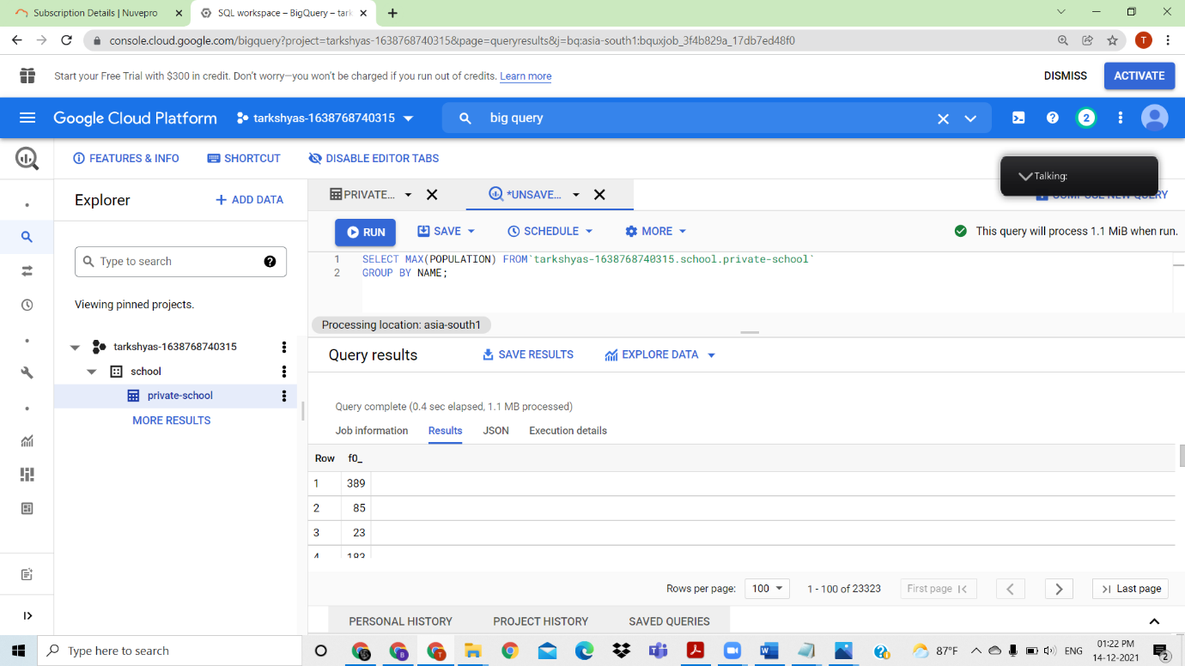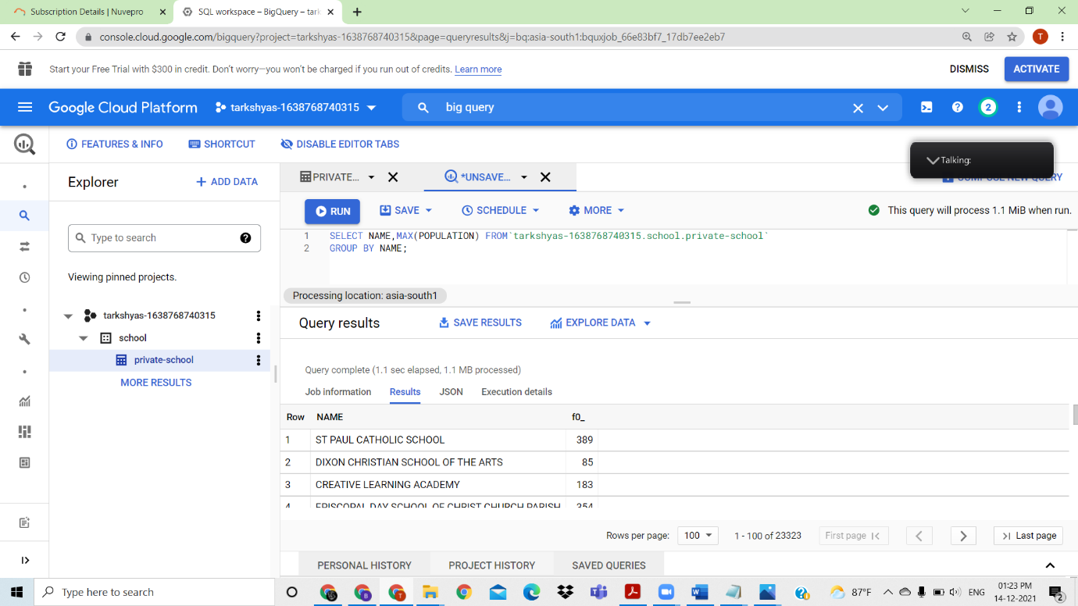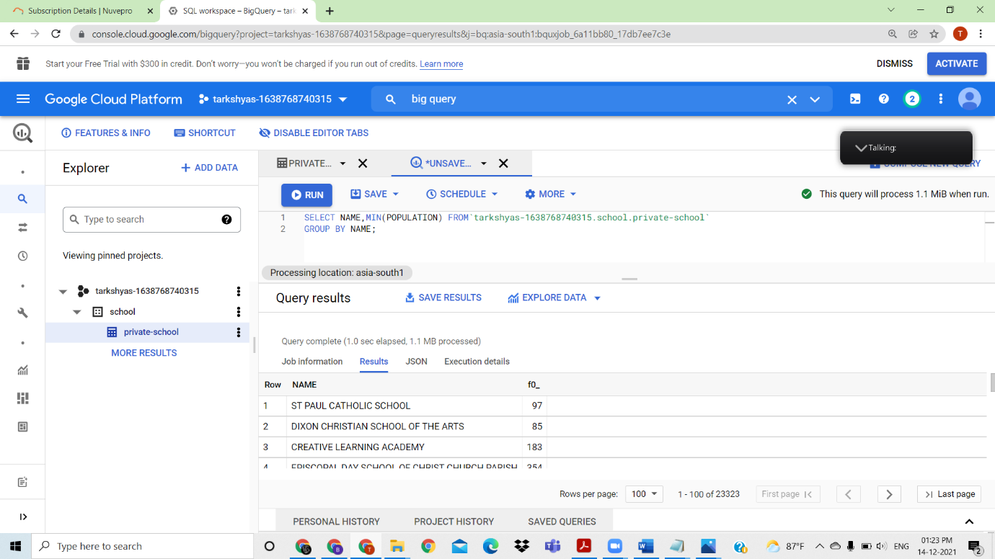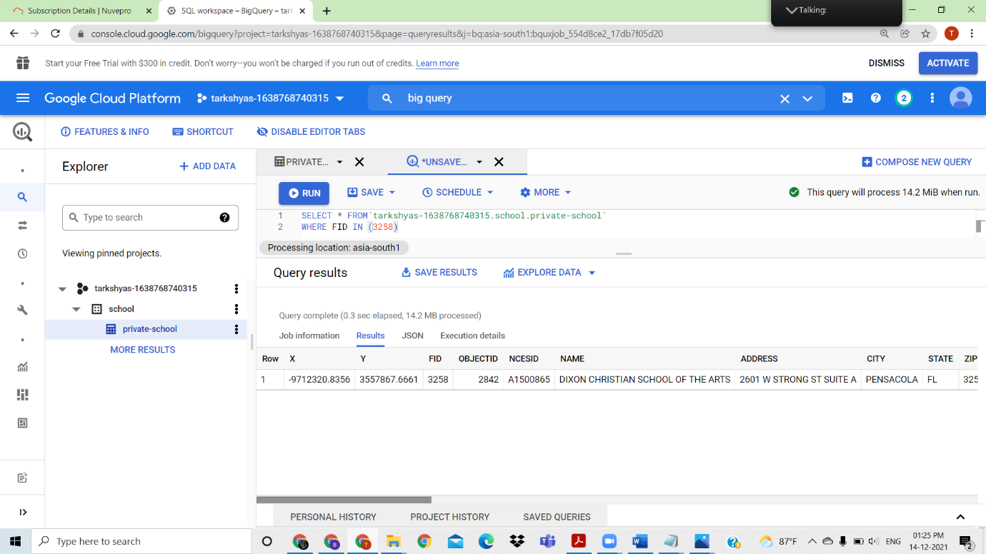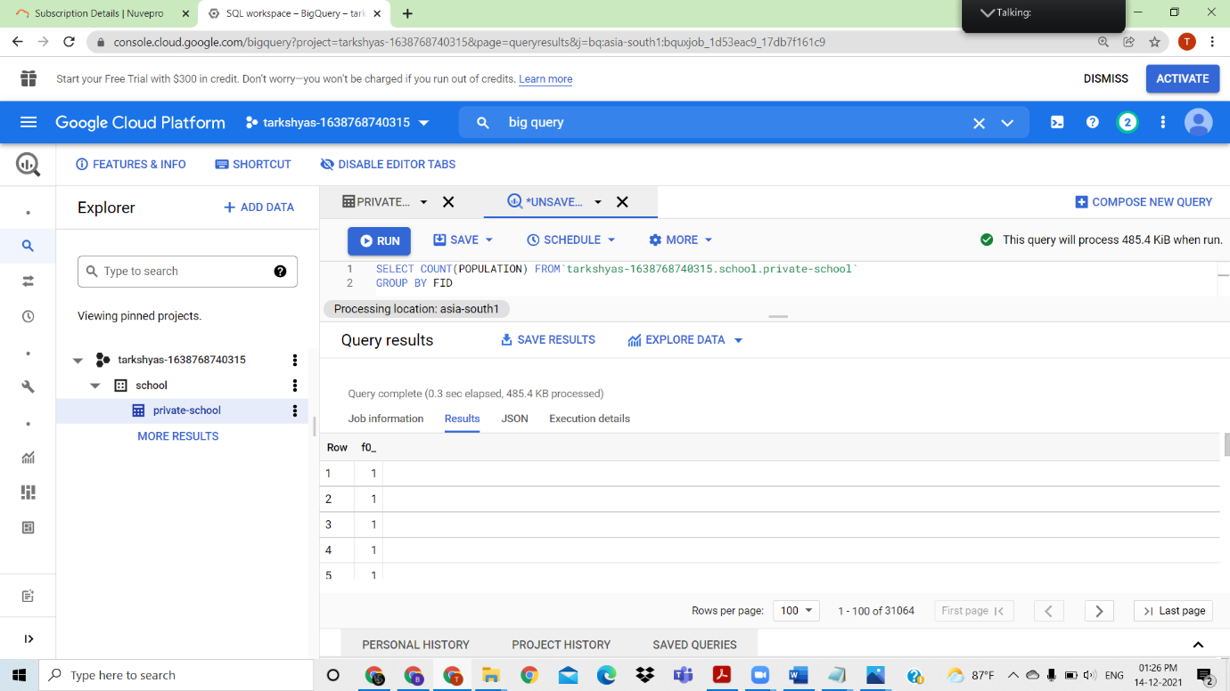

Performed max,min,groupby, where inside bigquuery .BigQuery ML performed with <https://www.qwiklabs.com/focuses/2157?parent=catalog> .Used the dataset from above link and created a model that predicts whether a visitor will make a transaction

<https://console.cloud.google.com/bigquery?p=data-to-insights&d=ecommerce&t=web_analytics&page=table>

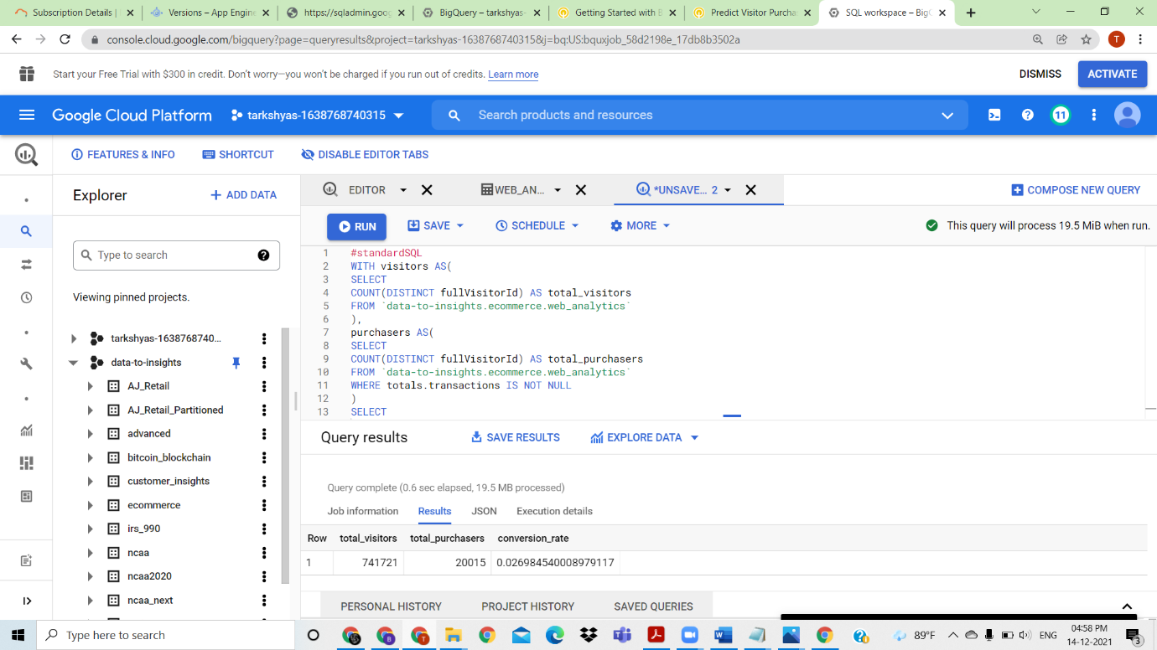

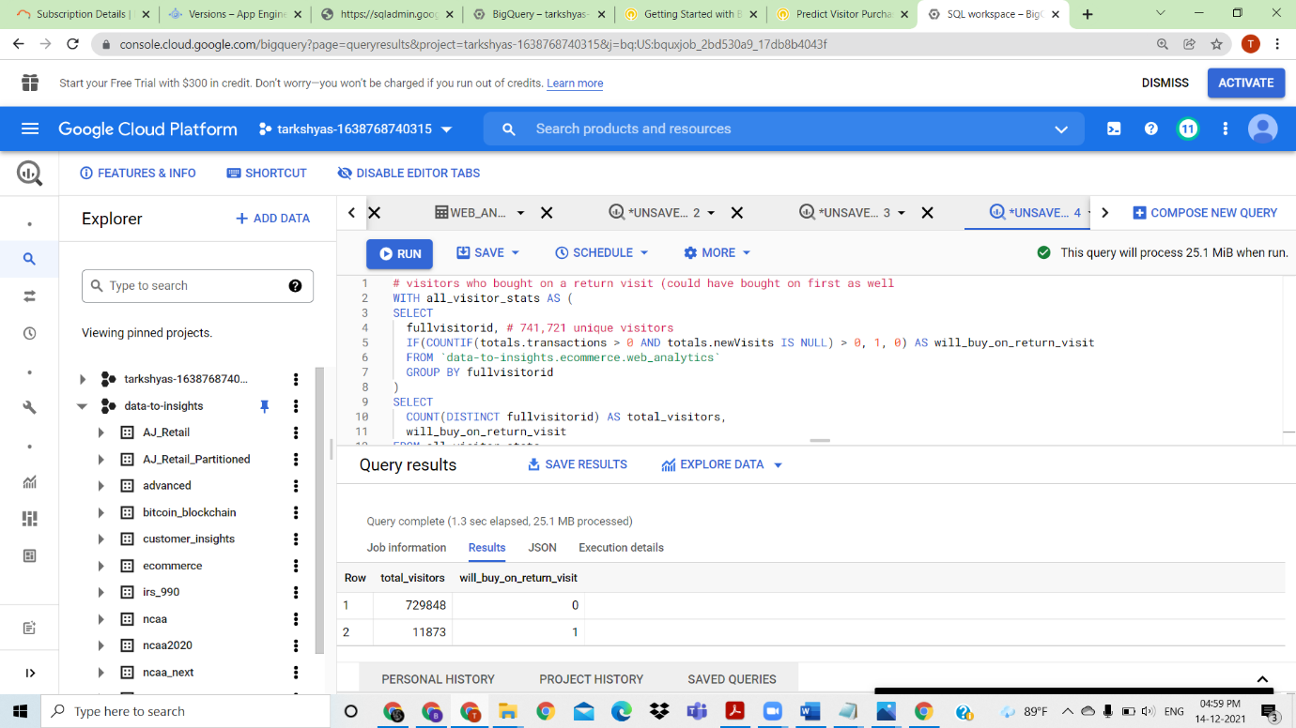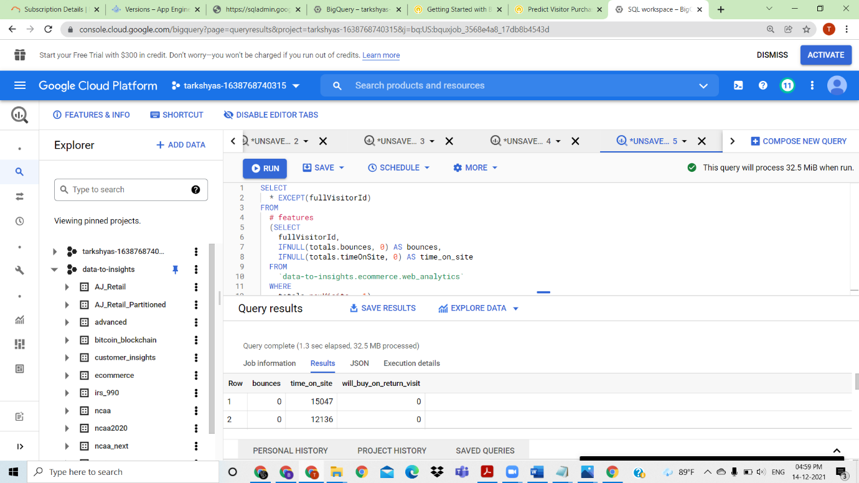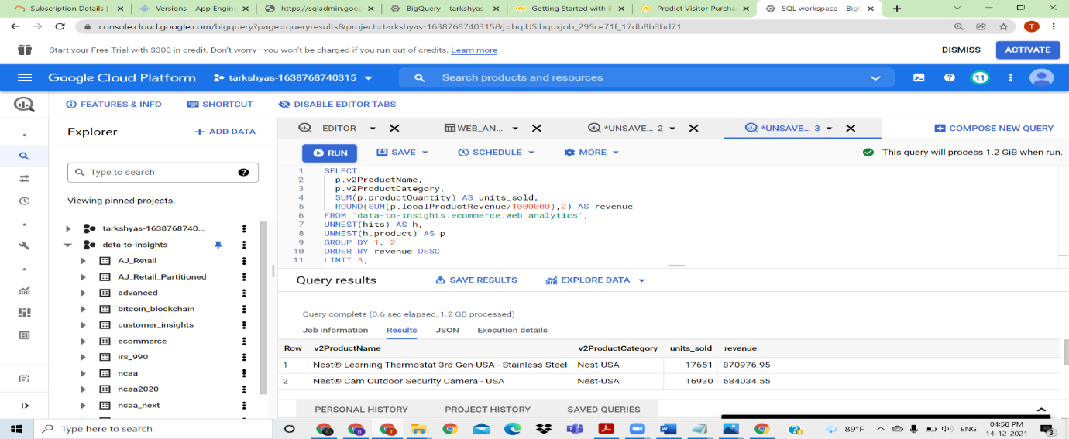

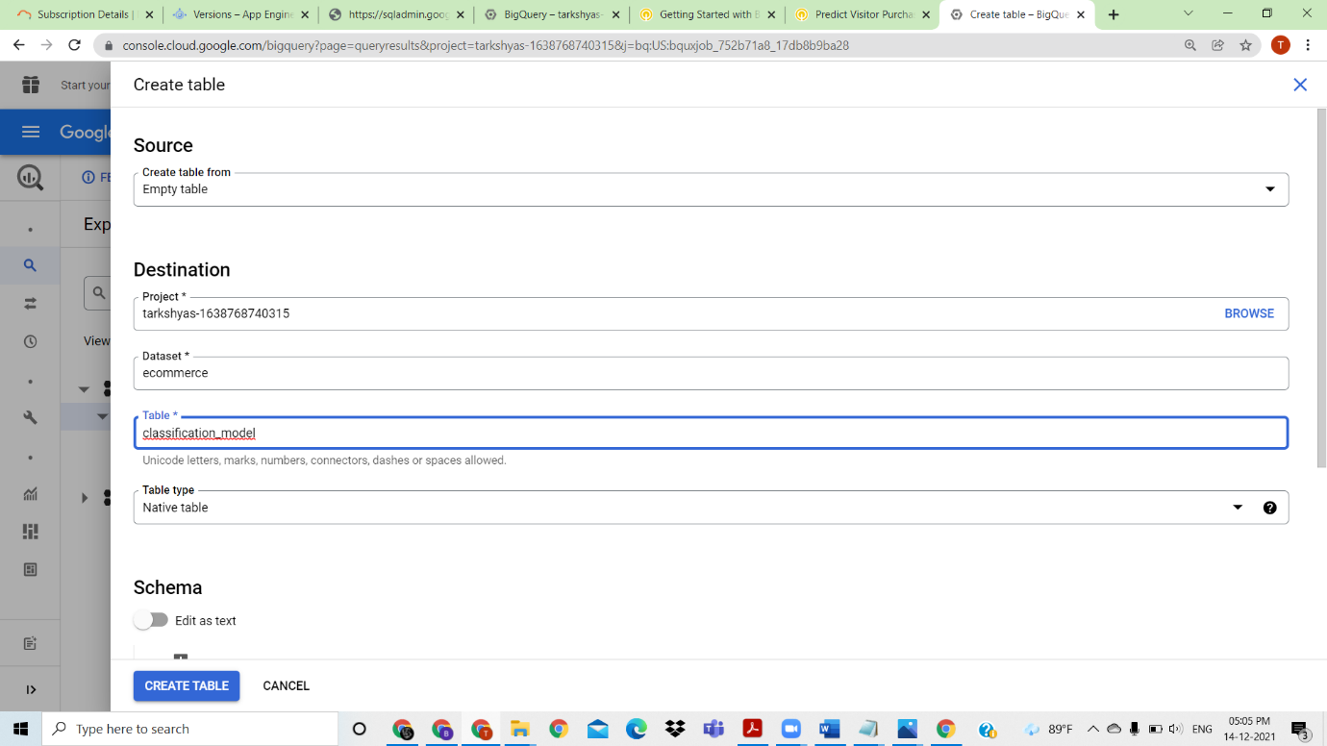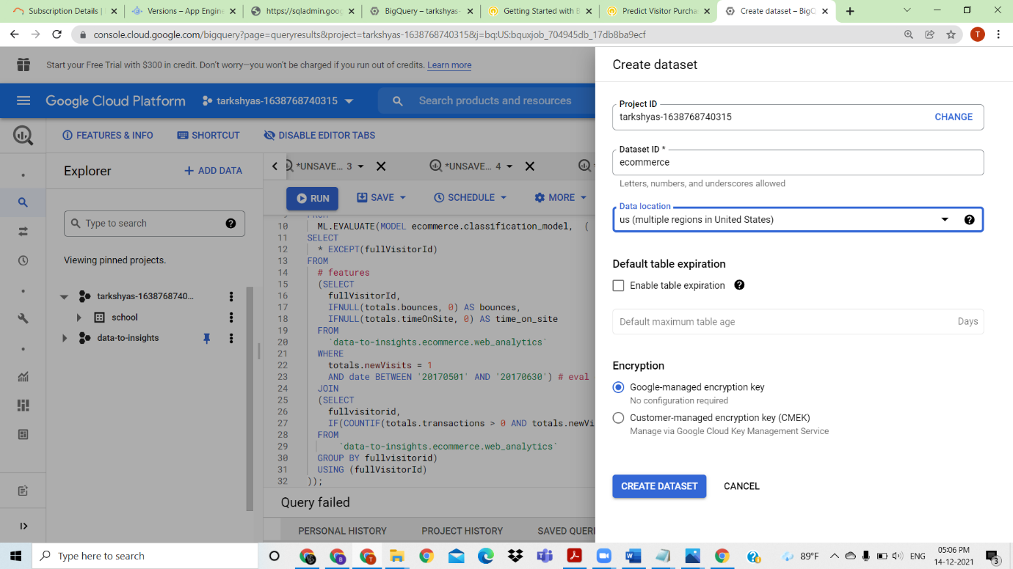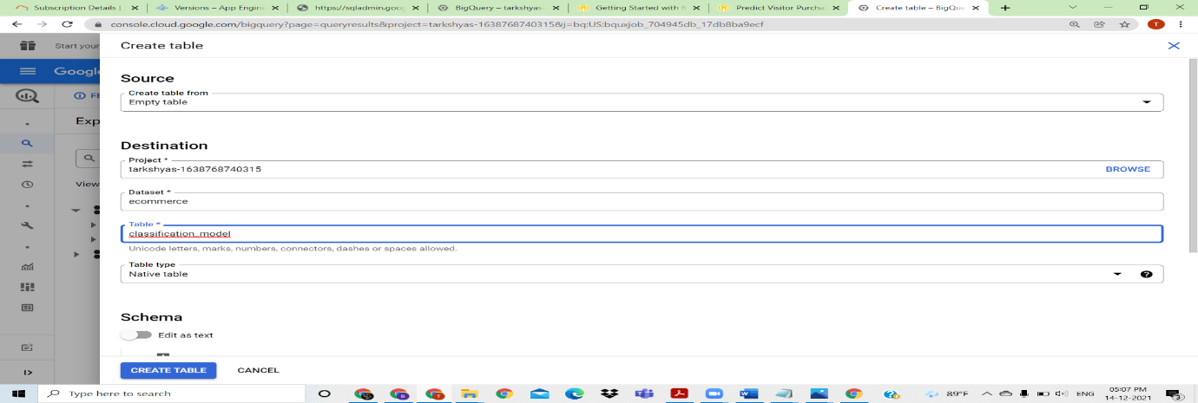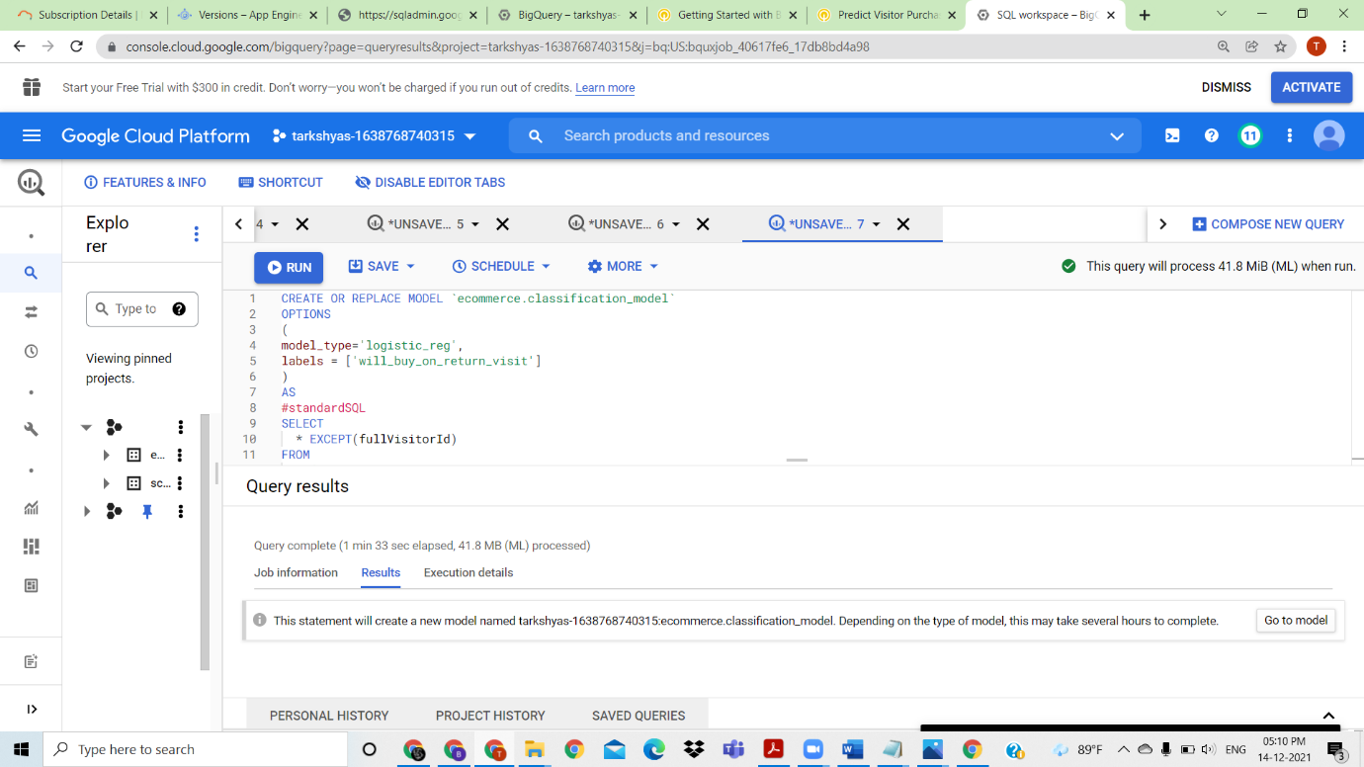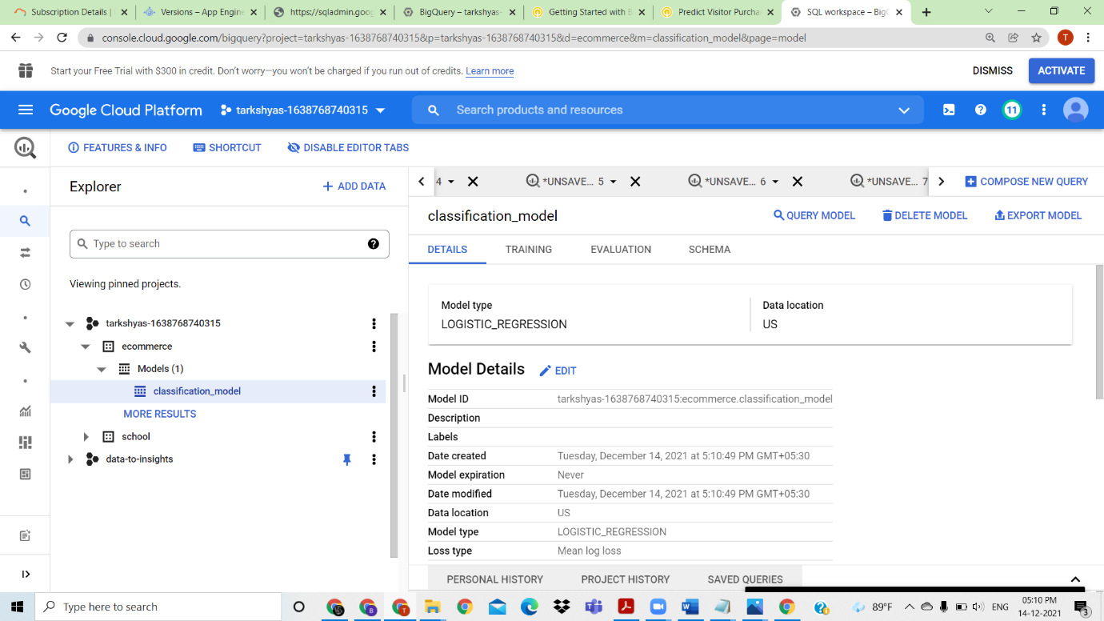

BigQuery ML to perform classification model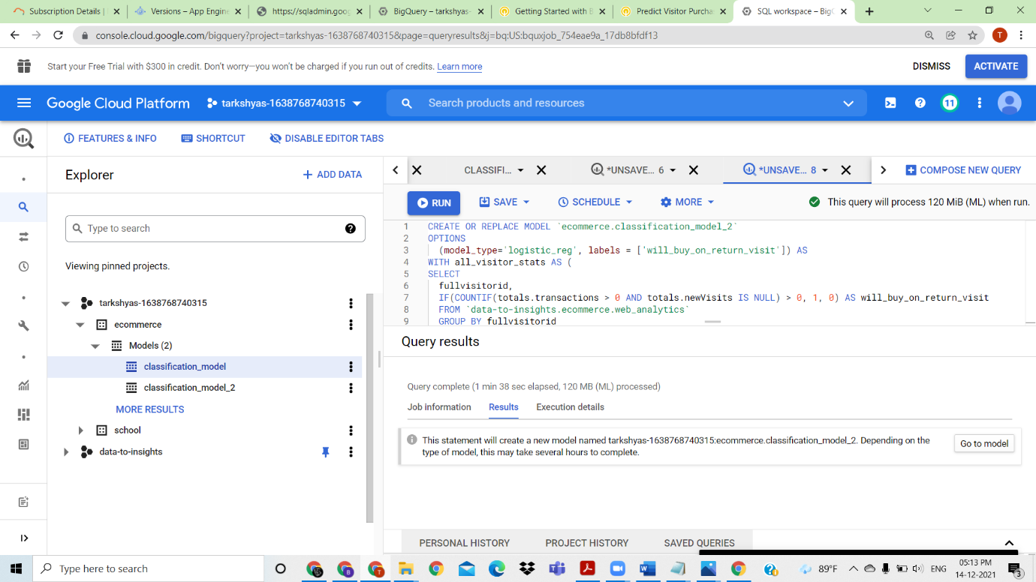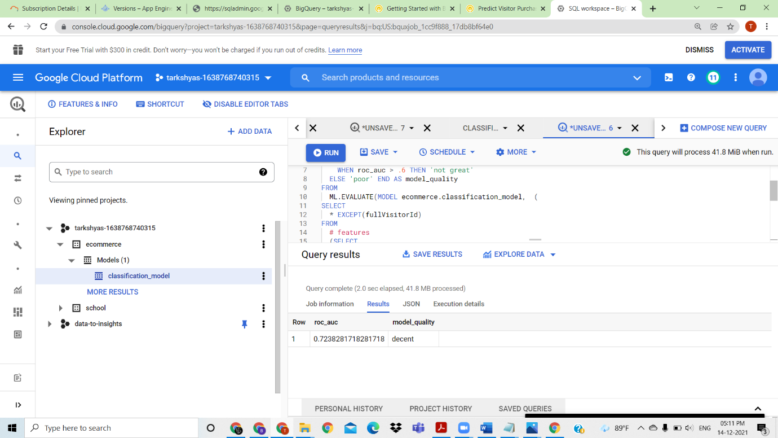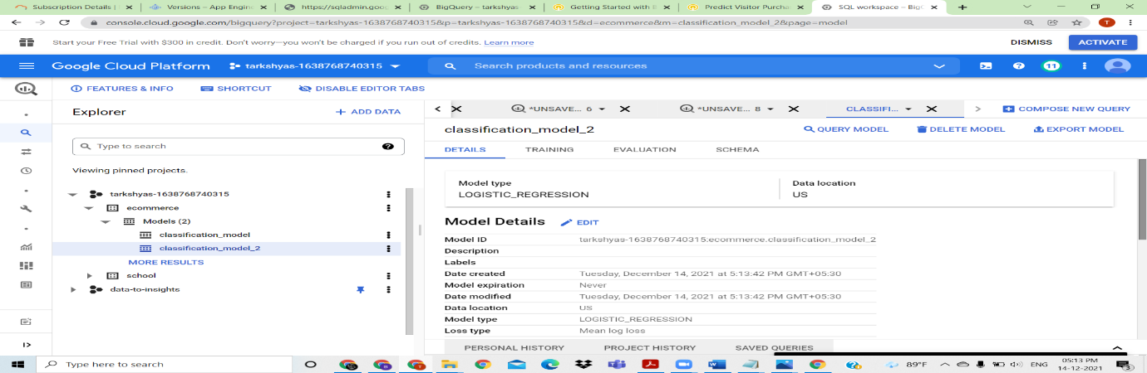

Logistic regression is performed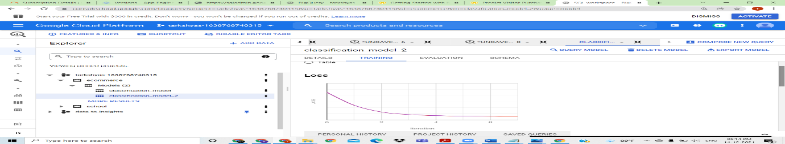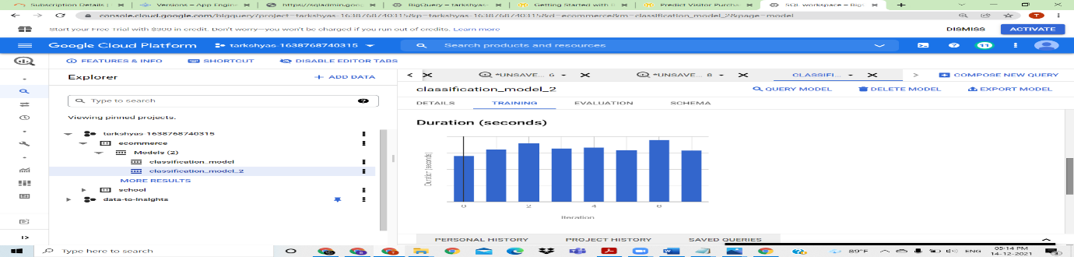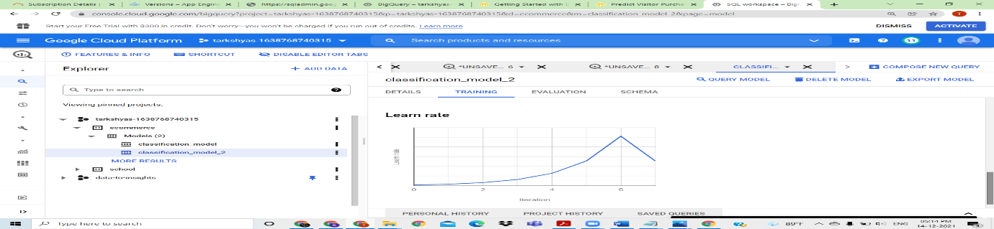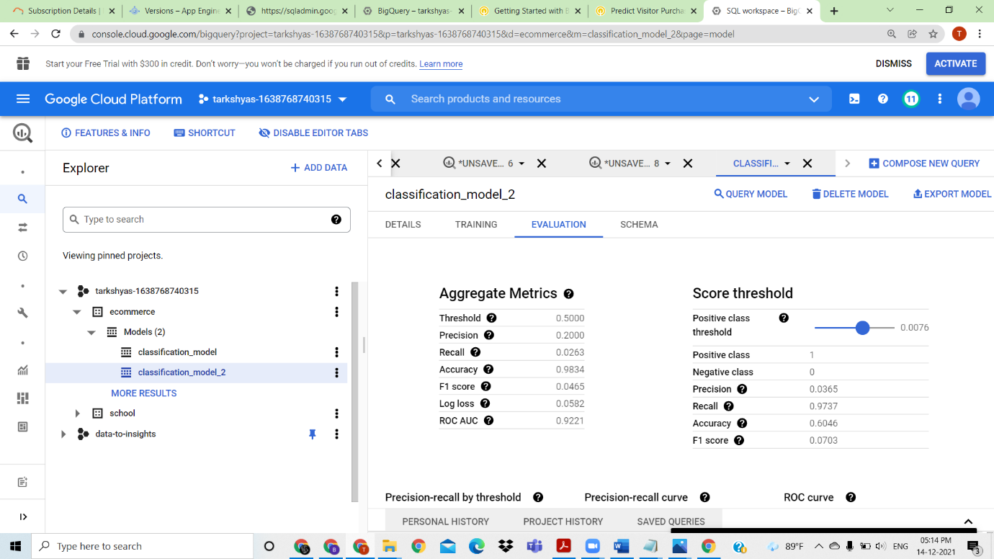

Performed the classification model and evaluated the performances